

Department of CSIT

Title: User Manual

By: Rishikumar Patel

Email: [patelr99@montclair.edu](mailto:patelr99@montclair.edu)

CSIT - 697

Master’s Project [Robotics]

Instructor: Prof. Weitian Wang

Email: [wangw@montclair.edu](mailto:wangw@montclair.edu)

# Table of Contents

**Table of Contents** **2**

**Prerequisites:** **3**

**MoveIt Setup Assistant Overview** **4**

**Creating .URDF.XACRO file** **4**

**MoveIt Setup Assistant** **7**

Step 1: Start 7

Step 2: Generate Self-Collision Matrix 9

Step 3: Add Virtual Joints 11

Step 4: Add Planning Groups 11

Step 5: Add Robot Poses 17

Step 6: Label End Effectors 19

Step 7: Add Passive Joints 21

Step 8: ROS Control 21

Step 9: Gazebo Simulation 26

Step 10: 3D Perception 26

Step 11: Author Information 27

Step 12: Generate Configuration Files 27

Build and Source the Workspace 29

Run Demo.launch 30

**Run a Python Script** **30**

Create Directory 31

Python Script : To Add Objects 31

Make Python Script Executable 35

Running Python Script: To Add Objects in The Scene 37

Python Script : To Move Arm-1 38

Python Script : To Pick and Place 48

**Complete the Collaborative Ring Stack Task** **67**

Start the Triple-Panda Simulation System 67

Load Rings (Collision Objects) into the Workspace 68

Run the Merge-Sort approach to complete ring stack task 76

Additional Information 107

Edit Arm’s facing direction 107

Master’s Project - ROS Packages.zip 107

## Prerequisites:

* Install “ROS Noetic”: <http://wiki.ros.org/noetic/Installation/Ubuntu> on Ubuntu 20.04.
* Install “MoveIt and create a workspace”: [https://ros-planning.github.io/moveit_tutorials/doc/getting_started/getting_started.html#](https://ros-planning.github.io/moveit_tutorials/doc/getting_started/getting_started.html)
* Go through basic “ROS tutorials”: <http://wiki.ros.org/ROS/Tutorials> to get a basic understanding of how to use ROS commands to achieve different tasks.

* Go through “Getting Started”: <https://ros-planning.github.io/moveit_tutorials/doc/getting_started/getting_started.html#install-ros-and-catkin> to get the setup ready with workspace.

* Go through “MoveIt Quickstart in RViz”: [https://ros-planning.github.io/moveit_tutorials/doc/quickstart_in_rviz/quickstart_in_rviz_tutorial.html#](https://ros-planning.github.io/moveit_tutorials/doc/quickstart_in_rviz/quickstart_in_rviz_tutorial.html) to get familiar with motion planning using Moveit via RViz and the MoveIt plugin.
* Go through the “Move Group Python Interface” tutorial: <https://ros-planning.github.io/moveit_tutorials/doc/move_group_python_interface/move_group_python_interface_tutorial.html> to get familiar with using python scripts to create motion plans, moving the robot, adding objects into the environment and attaching/detaching objects from the robot.

## MoveIt Setup Assistant Overview

The MoveIt Setup Assistant is a graphical user interface for configuring any robot for use with MoveIt. Its primary function is to generate a Semantic Robot Description Format (SRDF) file for your robot. Additionally, it generates other necessary configuration files for use with the MoveIt pipeline.

* Go through the “URDF and SRDF” tutorials: <https://ros-planning.github.io/moveit_tutorials/doc/urdf_srdf/urdf_srdf_tutorial.html> to learn about what does URDF files contains and how to use/change it.

* Download “Franka description package” for Noetic, to do that run the following command:

sudo apt install ros-noetic-franka-description

##### 

* Next, we’ll need to delete the panda_moveit_config that was git-cloned from the *Getting Started* page. To do that run the following commands:

cd **~/**ws_moveit**/**src

rm **-**rf panda_moveit_config

catkin clean panda_moveit_config

## Creating .URDF.XACRO file

* Before Starting the “MoveIt Setup Assistant”, we’ll need to make our URDF file for three panda arm robots
* To do that, copy the following code block and save the file as *“<file_name>.urdf.xacro”* in the “robots” directory of the ROS package named *“franda_description”*.
* **Note**: In my case, all “URDF” and “URDF.XACRO” files are stored inside the “3_panda_moveit_config” package’s “robots” directory.

<?xml version="1.0" encoding="utf-8"?>

<robot xmlns:xacro="http://www.ros.org/wiki/xacro" name="panda">

<xacro:arg name="arm_id_1" default="panda_1" />

<xacro:arg name="arm_id_2" default="panda_2" />

<xacro:arg name="arm_id_3" default="panda_3" />

<xacro:include filename="panda_arm.xacro"/>

<xacro:include filename="hand.xacro"/>

<!-- box shaped table as base for the 3 Pandas -->

<link name="base">

<visual>

<origin xyz="0 0 0.975" rpy="0 0 0"/>

<geometry>

<box size="2 2 0.05" />

</geometry>

<material name="White">

<color rgba="1.0 1.0 1.0 1.0"/>

</material>

</visual>

<collision>

<origin xyz="0 0 0.975" rpy="0 0 0"/>

<geometry>

<box size="2 2 0.03" />

</geometry>

</collision>

<visual>

<origin xyz="0.8 0.8 0.475" rpy="0 0 0"/>

<geometry>

<box size="0.08 0.08 0.95" />

</geometry>

<material name="White">

<color rgba="1.0 1.0 1.0 1.0"/>

</material>

</visual>

<collision>

<origin xyz="0.8 0.8 0.475" rpy="0 0 0"/>

<geometry>

<box size="0.08 0.08 0.95" />

</geometry>

</collision>

<visual>

<origin xyz="0.8 -0.8 0.475" rpy="0 0 0"/>

<geometry>

<box size="0.08 0.08 0.95" />

</geometry>

<material name="White">

<color rgba="1.0 1.0 1.0 1.0"/>

</material>

</visual>

<collision>

<origin xyz="0.8 -0.8 0.475" rpy="0 0 0"/>

<geometry>

<box size="0.08 0.08 0.95" />

</geometry>

</collision>

<visual>

<origin xyz="-0.8 -0.8 0.475" rpy="0 0 0"/>

<geometry>

<box size="0.08 0.08 0.95" />

</geometry>

<material name="White">

<color rgba="1.0 1.0 1.0 1.0"/>

</material>

</visual>

<collision>

<origin xyz="-0.8 -0.8 0.475" rpy="0 0 0"/>

<geometry>

<box size="0.08 0.08 0.95" />

</geometry>

</collision>

<visual>

<origin xyz="-0.8 0.8 0.475" rpy="0 0 0"/>

<geometry>

<box size="0.08 0.08 0.95" />

</geometry>

<material name="White">

<color rgba="1.0 1.0 1.0 1.0"/>

</material>

</visual>

<collision>

<origin xyz="-0.8 0.8 0.475" rpy="0 0 0"/>

<geometry>

<box size="0.08 0.08 0.95" />

</geometry>

</collision>

</link>

<!-- right arm with gripper -->

<xacro:panda_arm arm_id="$(arg arm_id_1)" connected_to="base" xyz="0 -0.6 1" rpy="0 0 ${pi/2}" safety_distance="0.03"/>

<xacro:hand ns="$(arg arm_id_1)" rpy="0 0 ${-pi/4}" connected_to="$(arg arm_id_1)_link8" safety_distance="0.00"/>

<!-- left arm with gripper -->

<xacro:panda_arm arm_id="$(arg arm_id_2)" connected_to="base" xyz="0 0.6 1" rpy="0 0 ${-pi/2}" safety_distance="0.03"/>

<xacro:hand ns="$(arg arm_id_2)" rpy="0 0 ${-pi/4}" connected_to="$(arg arm_id_2)_link8" safety_distance="0.00"/>

<!-- middle arm with gripper -->

<xacro:panda_arm arm_id="$(arg arm_id_3)" connected_to="base" xyz="-0.6 0 1" safety_distance="0.03"/>

<xacro:hand ns="$(arg arm_id_3)" rpy="0 0 ${-pi/4}" connected_to="$(arg arm_id_3)_link8" safety_distance="0.00"/>

</robot>

* Once you save the file as a “.urdf.xacro” file. We can start moveit setup assistant.

## MoveIt Setup Assistant

### Step 1: Start

* To start the MoveIt Setup Assistant run following command:

roslaunch moveit_setup_assistant setup_assistant**.**launch

* This will bring up the MoveIt’s start screen with two choices: “*Create New MoveIt Configuration Package”* or “*Edit Existing MoveIt Configuration Package”* as shown below.

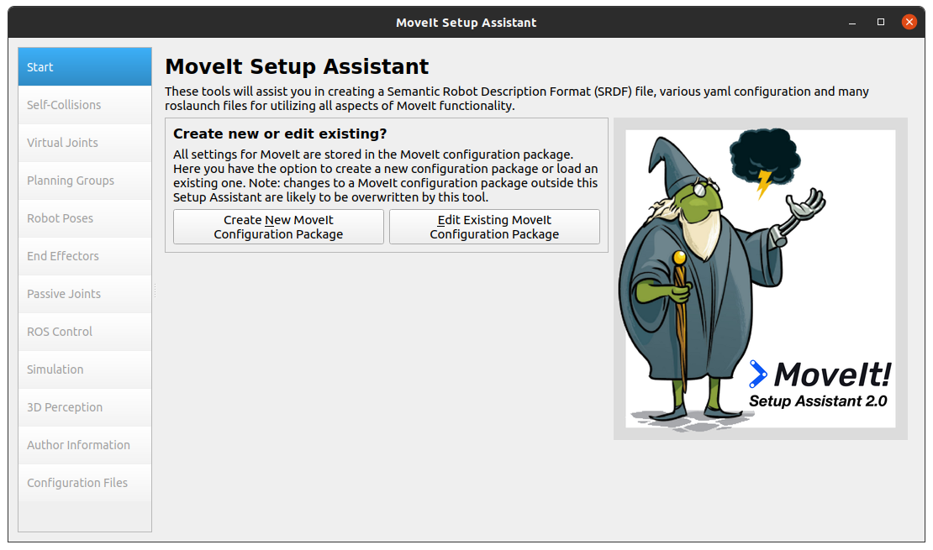

* Click on the *Create New MoveIt Configuration Package* button to bring up the following screen:

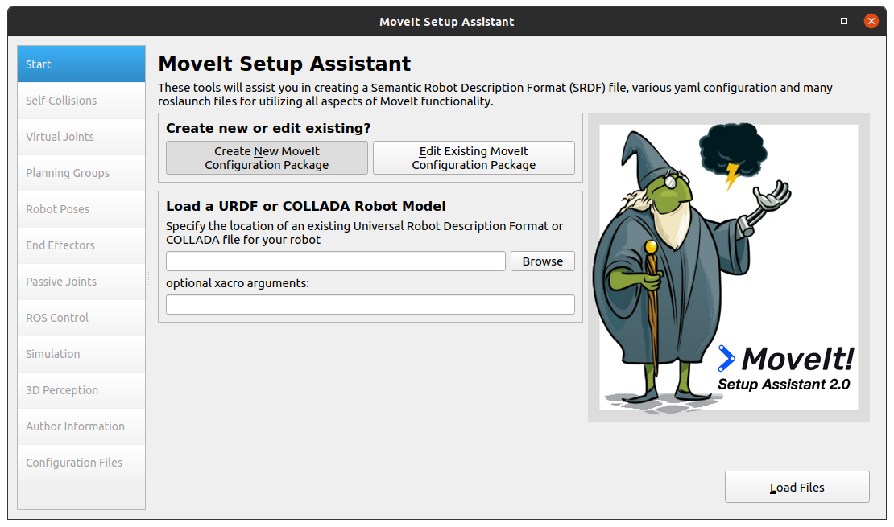

* Click on the browse button and navigate to the “<file_name>.urdf.xacro” file we created above. Choose the file and click *Load Files*.
* The Setup Assistant will load the files and present you with this screen: 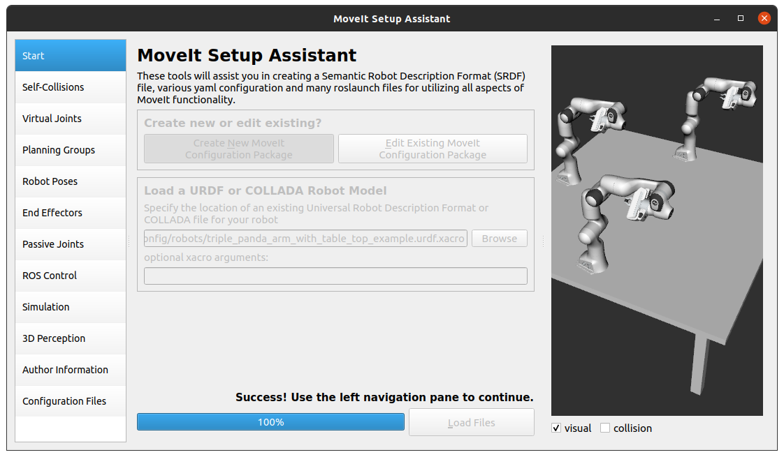

### Step 2: Generate Self-Collision Matrix

The Default Self-Collision Matrix Generator searches for pairs of links on the robots that can safely be disabled from collision checking, decreasing motion planning processing time.

These pairs of links are disabled when they are always in a collision, never in a collision, in collision in the robot’s default position or when the links are adjacent to each other on the kinematic chain.

The sampling density specifies how many random robot positions to check for self-collision. Higher densities require more computation time while lower densities have a higher possibility of disabling pairs that should not be disabled. The default value is 10,000 collision checks. Collision checking is done in parallel to decrease processing time.

* Click on the *“Self-Collisions”* pane selector on the left side of the window and click on the “*Generate Collision Matrix*” button. You’ll see the following screens:

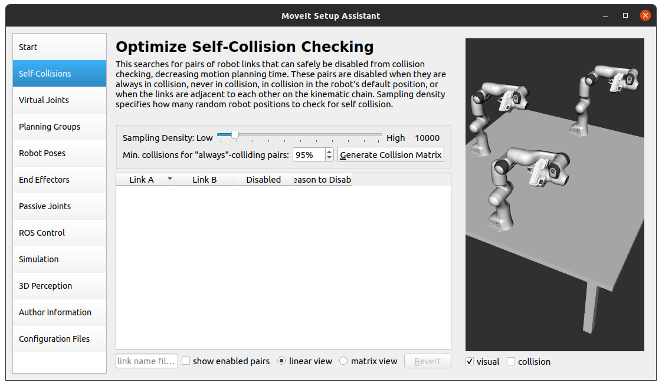

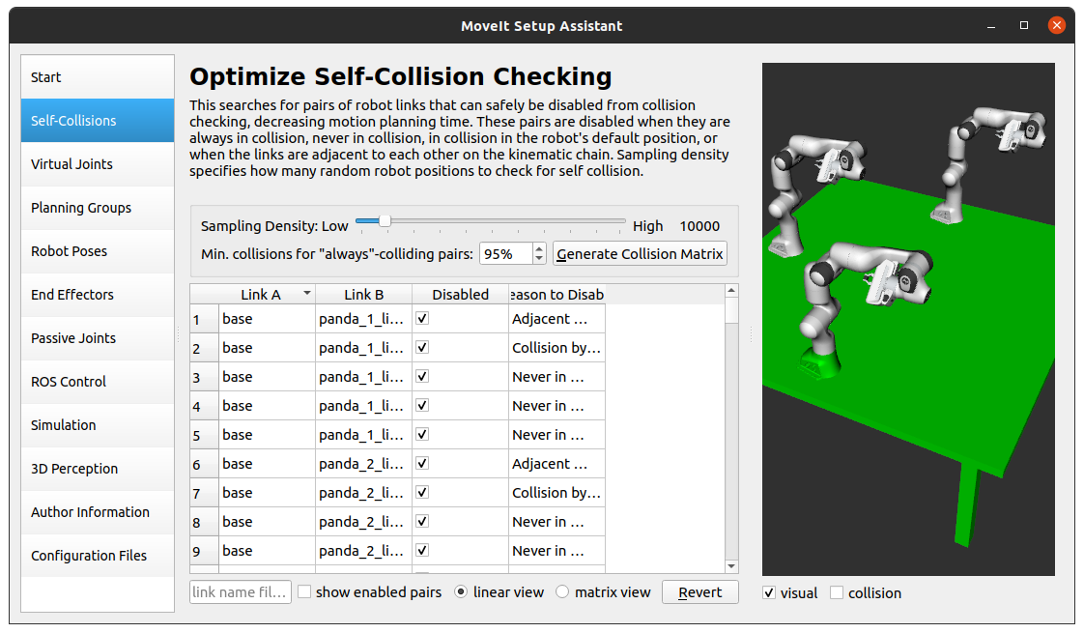

### Step 3: Add Virtual Joints

Virtual joints are used primarily to attach the robots to the world. For three Pandas we will define only one virtual joint attaching the base link of three Pandas to the world parent frame. This virtual joint represents the motion of the base of the robot in a plane.

* Click on *Virtual Joints* pane selector. Click on *Add Virtual Joint* button.
* Set the joint name as “virtual_joint”
* Set the child link as “base” and the parent frame name as “world”.
* Set the Joint Type as “fixed”.
* Click *Save* and you should see the following screen:

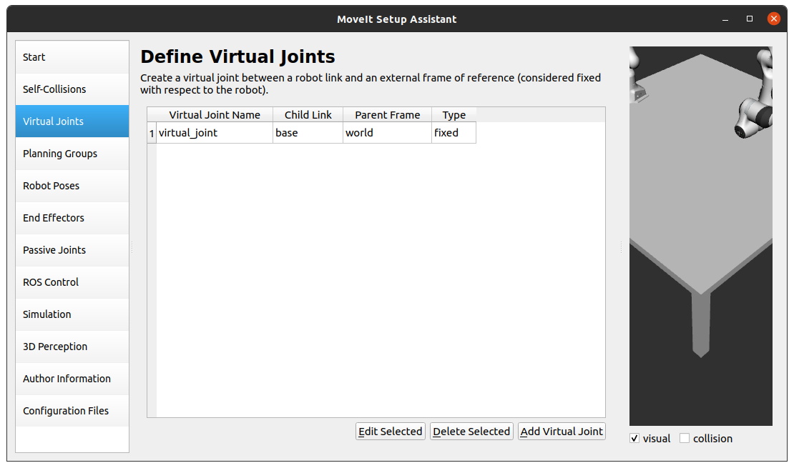

### Step 4: Add Planning Groups

Planning groups are used for semantically describing different parts of your robot/robots, such as defining what an arm is, or an end effector.

* Click on the *Planning Groups* pane selector.
* Click on *Add Group* and you should see the following screen:

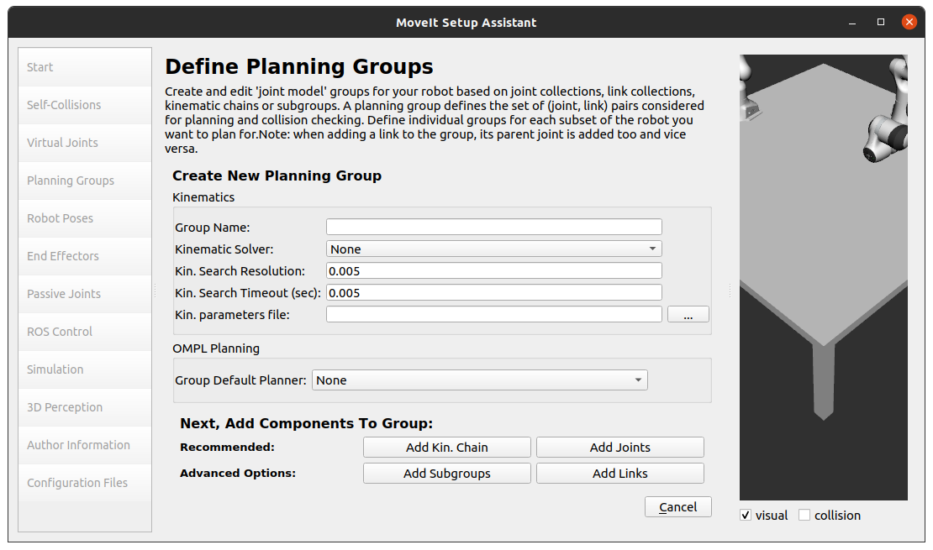

* We will first add one Panda arm as a planning group
  + Enter *Group Name* as **panda_arm_1**
  + Choose **kdl_kinematics_plugin/KDLKinematicsPlugin** as the *Kinematics Solver*.
  + Let *Kin. Search Resolutions* and *Kin. Search Timeout* stay at their default values.

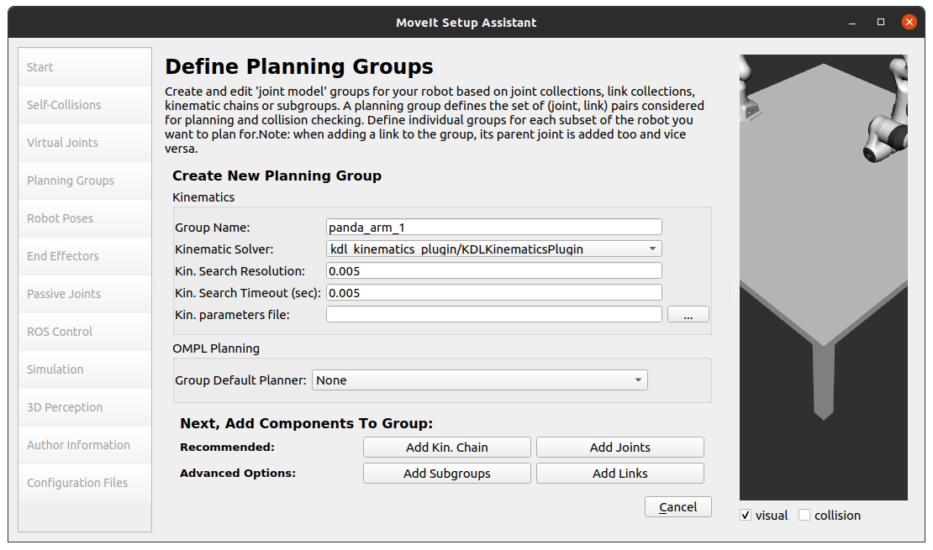

* + Click on the *Add Joints* button. You will see a list of joints on the left-hand side. You need to choose all the joints that belong to the *panda_arm_1* and add them to the right-hand side. The joints are arranged in the order that they are stored in an internal tree structure. This makes it easy to select a serial chain of joints.
  + Click on *panda_1_joint_base*, hold down the **Shift** button on your keyboard and then click on the *panda_1_joint8*.
  + Click on the > button to add these joints to the list of selected joints on the right.

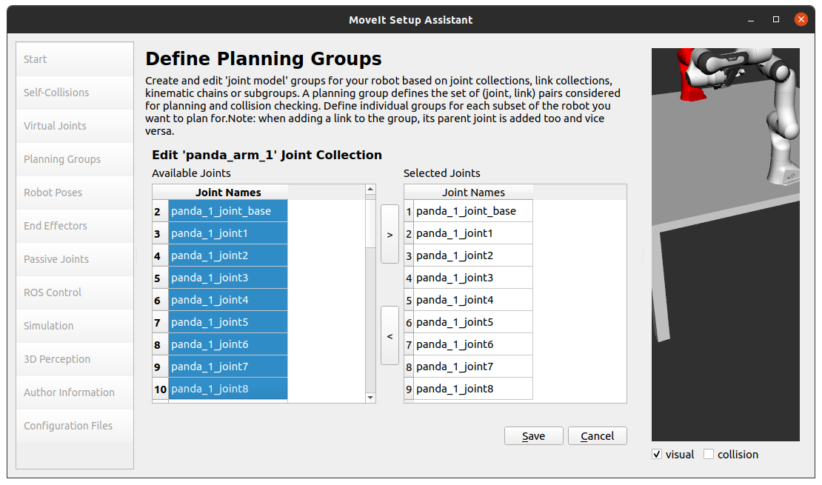

* + Click *Save* to save the selected group, and you will see the following screen:

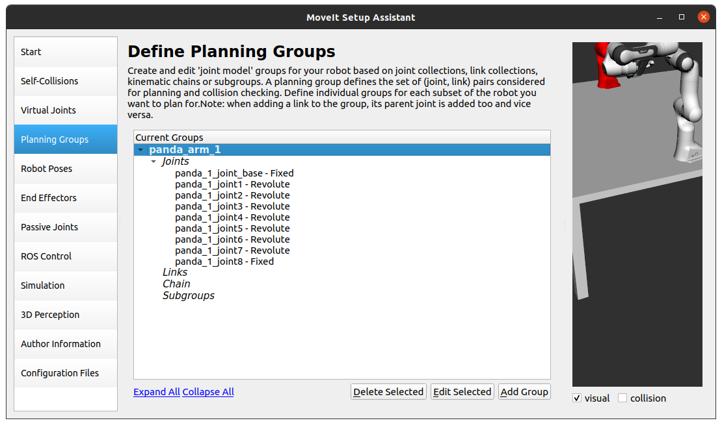

* We will also add a group for the end effector for Panda arm one.
  + Click on the *Add Group* Button.
  + Enter *Group Name* as **hand_1.**
  + Let Kinematic Solver stay at its default value; None.
  + Let Kin. Search Resolution and Kin. Search Timeout stay at their default values.
  + Click on the *Add Links* button.
  + Choose **panda_1_hand, panda_1_leftfinger,** and **panda_1_rightfinger** and add them to the list of *Selected Links* on the right-hand side.\
  + Click *Save* and you will see the following screen:

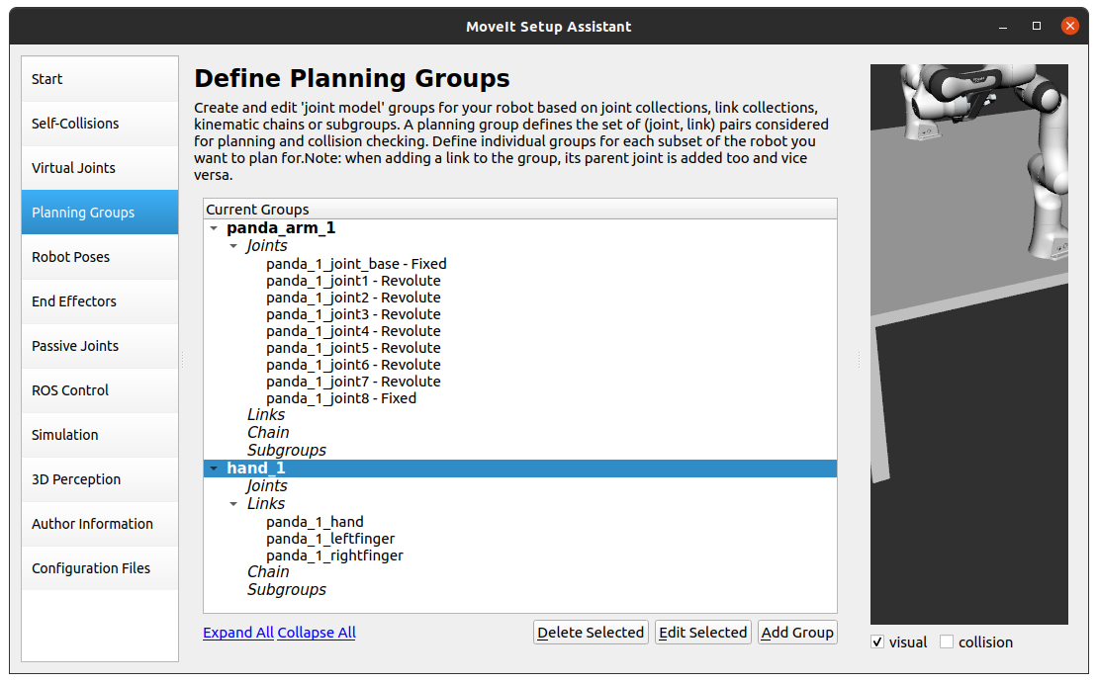

* Repeat the above steps mentioned in step 4, to add **panda_arm_2**, **hand_2**, **panda_arm_3**, and **hand_3** planning groups.

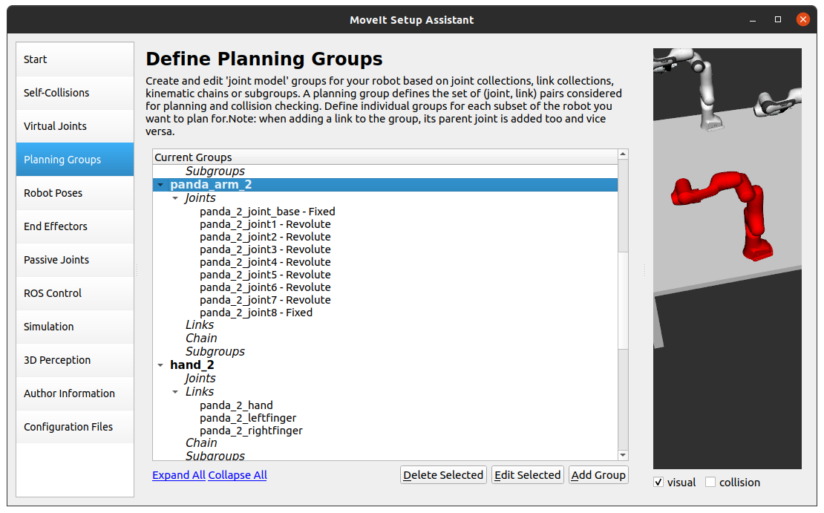

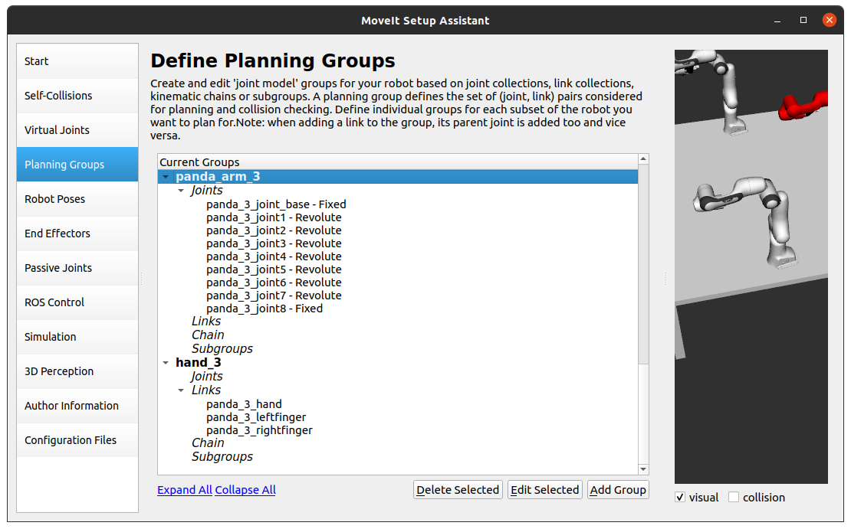

### Step 5: Add Robot Poses

The Setup Assistant allows you to add certain fixed poses into the configuration.

* Click on the *Robot Poses* pane.
* Click on *Add Pose.*
* Choose the *Planning Group* as **panda_arm_1**.
* Choose a name for the pose, in our case, it’s “*Home*”. Move the individual joints around until you reach the desired pose for the panda arm and then *Save* the pose.

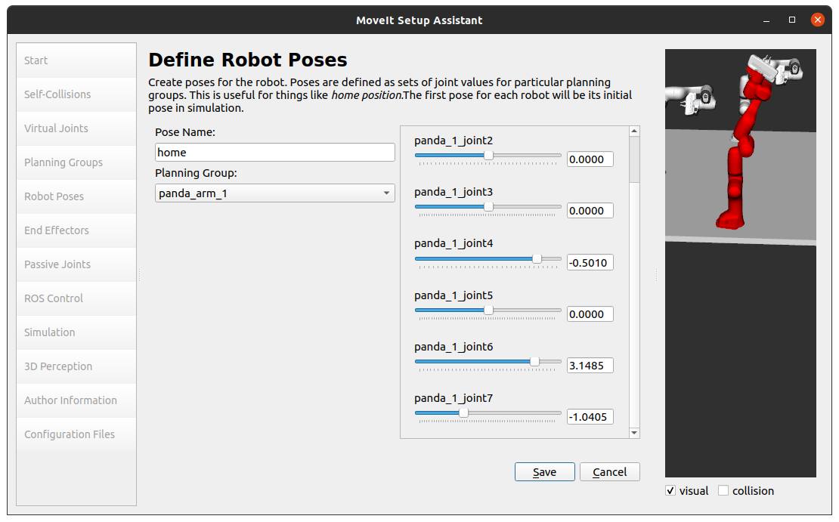

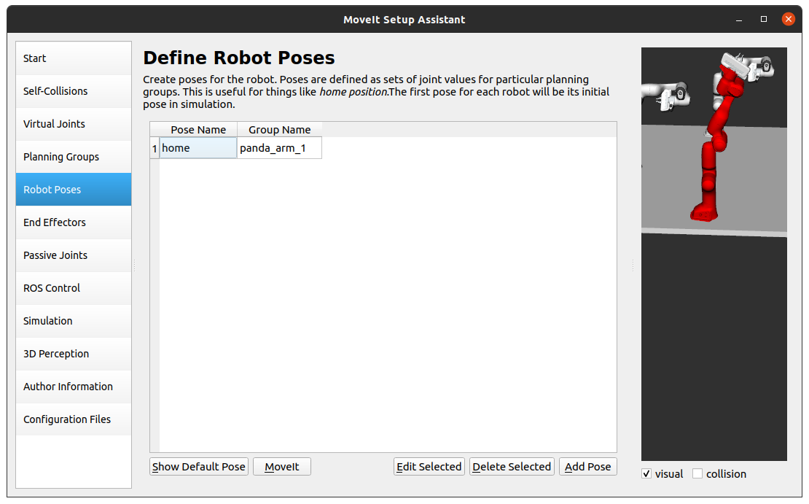

* **Note:** How poses are associated with particular groups. You can save multiple poses for each group.
* Add at least two poses for each group and you’ll see the following screen after you *Save*, names and joint angles might differ depending upon your desired poses.

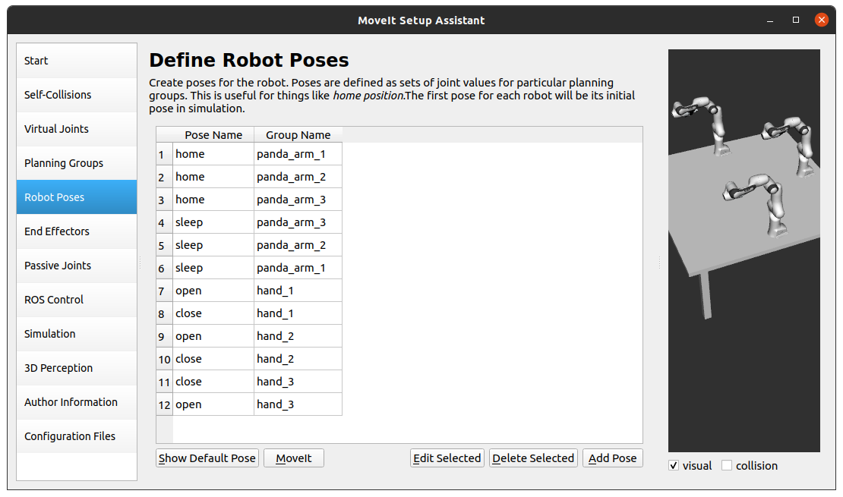

### Step 6: Label End Effectors

We have already added grippers for three panda robot arms. Now, we will designate this group as a special group: **end_effectors**. Designating this group as end effectors allows some special operations to happen on them internally.

* Click on the *End Effectors* pane.
* Click *Add End Effector*.
* Choose **hand_1** as the *End Effector Name* for the gripper.
* Select **hand_1** as the *End Effector Group.*
* Select **panda_1_link8** as the *Parent Link* for this end-effector.
* Select **panda_arm_1** as *Parent Group* for this end-effector.

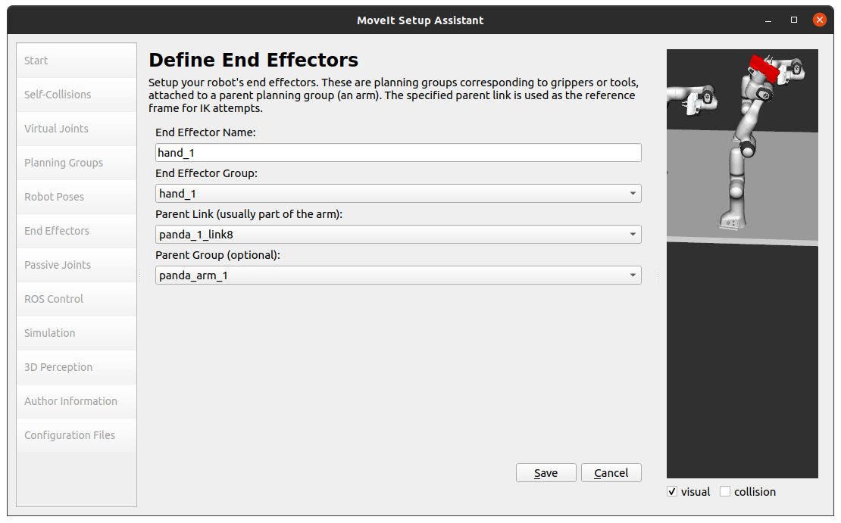

* Click *Save*.

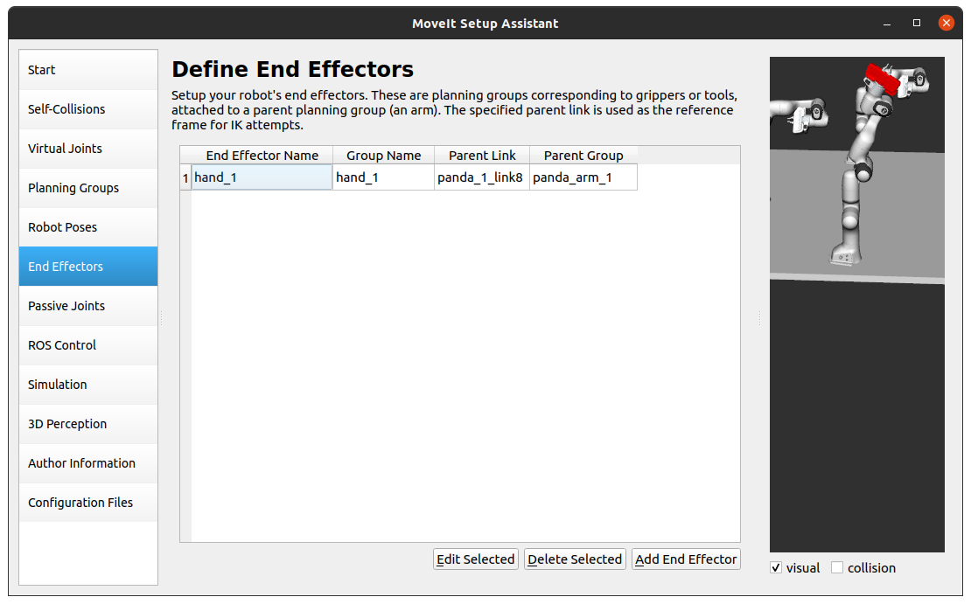

* Follow the same steps to add **hand_2** & **hand_3**.

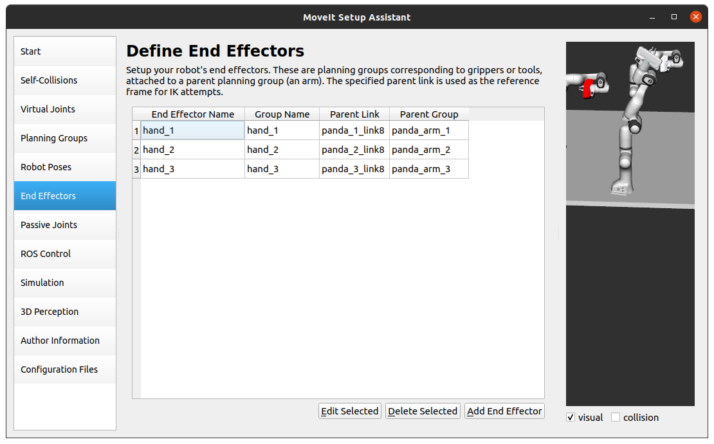

### Step 7: Add Passive Joints

The passive joints tab is meant to allow specification of any passive joints that might exist in a robot. These are joints that are unactuated on a robot (e.g. passive casters.) This tells the planners that they cannot (kinematically) plan for these joints because they can’t be directly controlled. The Panda robots do not have any passive joints so we will skip this step.

### Step 8: ROS Control

ROS Controls is a set of packages that include controller interfaces, controller managers, transmissions, and hardware_interfaces, for more details please look at *ros_control* [documentation](http://wiki.ros.org/ros_control).

* Click on the *ROS Control* pane selector.

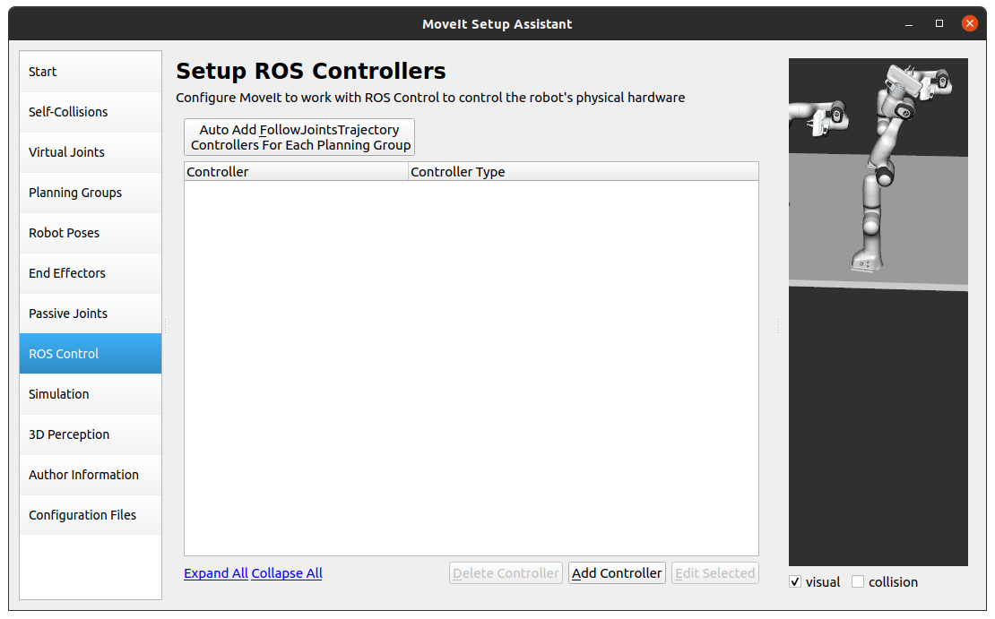

* Click on *Add Controller* and you should see the following screen:
* We will add Panda arm one’s position controller.
* Enter *Controller Name* as **arm_1_position_controller**.
* Choose **position_controller/JointPositionController** as the controller type.

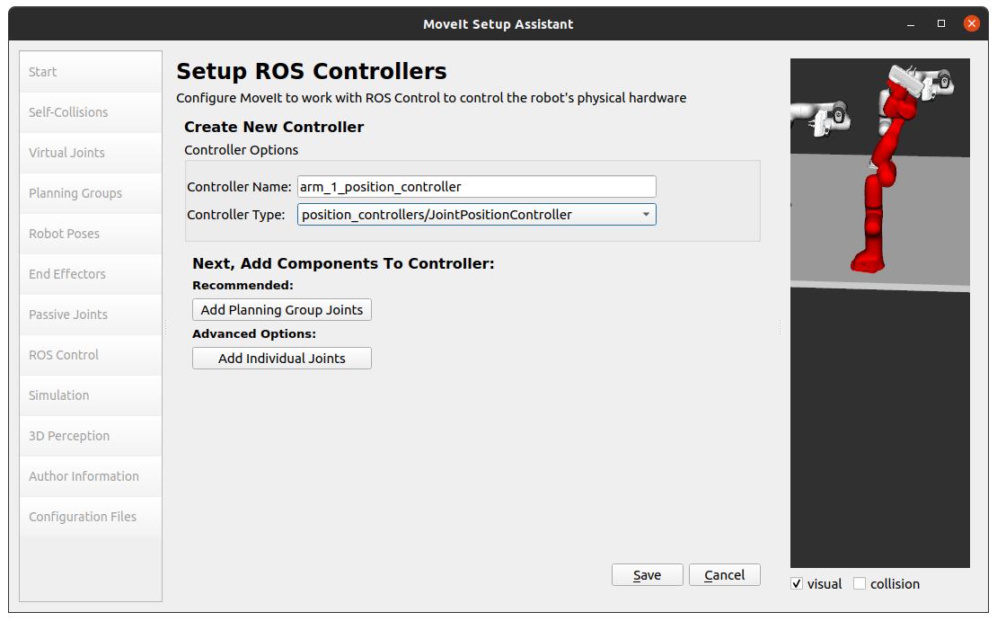

* Click on *Add planning Group Joints*.
* Choose the **panda_arm_1** planning group to add the joint in that group to the **arm_1_position_controller**.

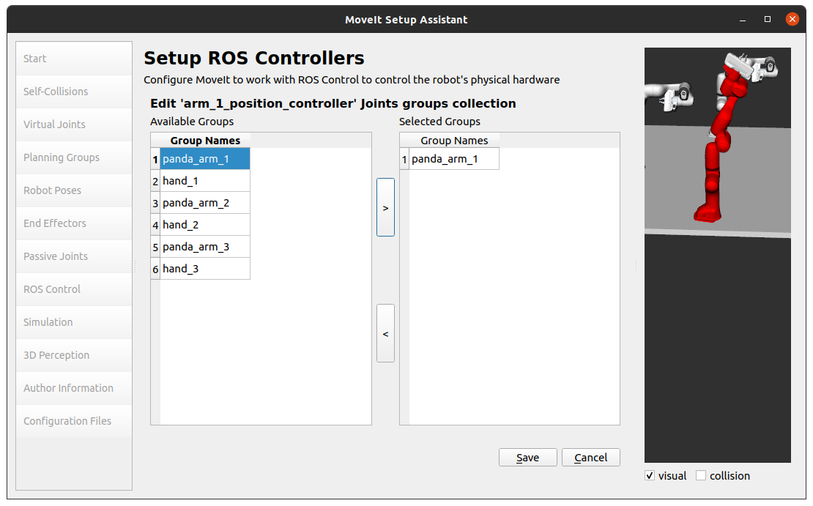

* Click *Save* and you should see the following screen.

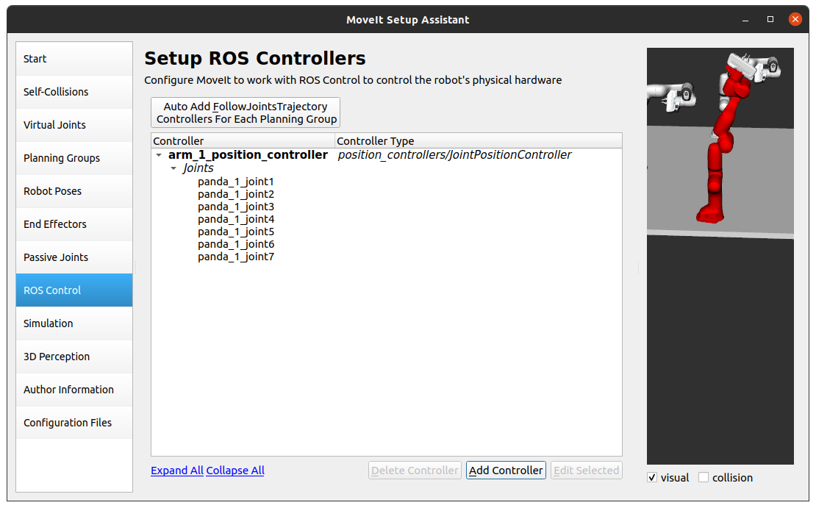

* Follow the same steps to add and *Save* **arm_2_position_controller**.

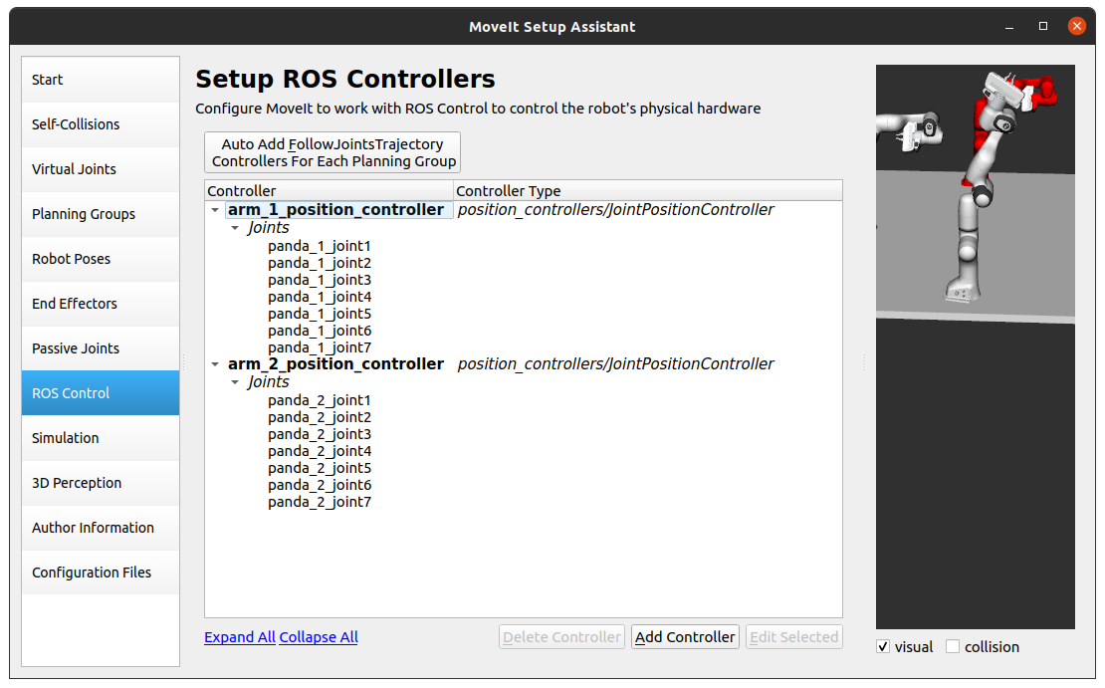

* Similarly add & *Save* **arm_3_position_controller**.

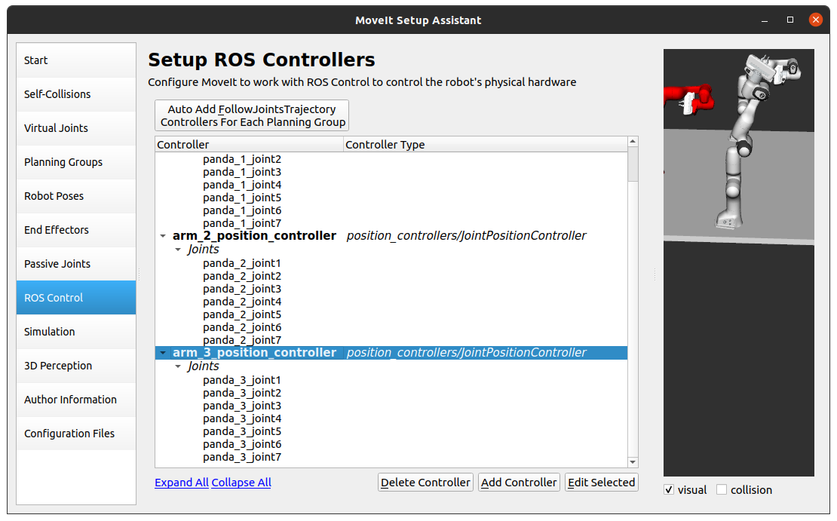

### Step 9: Gazebo Simulation

The Simulation tab can be used to help you simulate your robot with Gazebo by generating a new Gazebo compatible urdf **if needed**.

Since we are not trying to work with Gazebo simulation, we are going to skip this step.

### Step 10: 3D Perception

The 3D Perception tab is meant to set the parameters of the YAML configuration file for configuring the 3D sensors *sensors_3d.yaml*.

* Click on *3D Perception* from the pane selector.
* Since we are not planning to use any sensors in our environment, we’ll choose **None** for *Optionally choose a type of 3D sensor plugin to configure*:

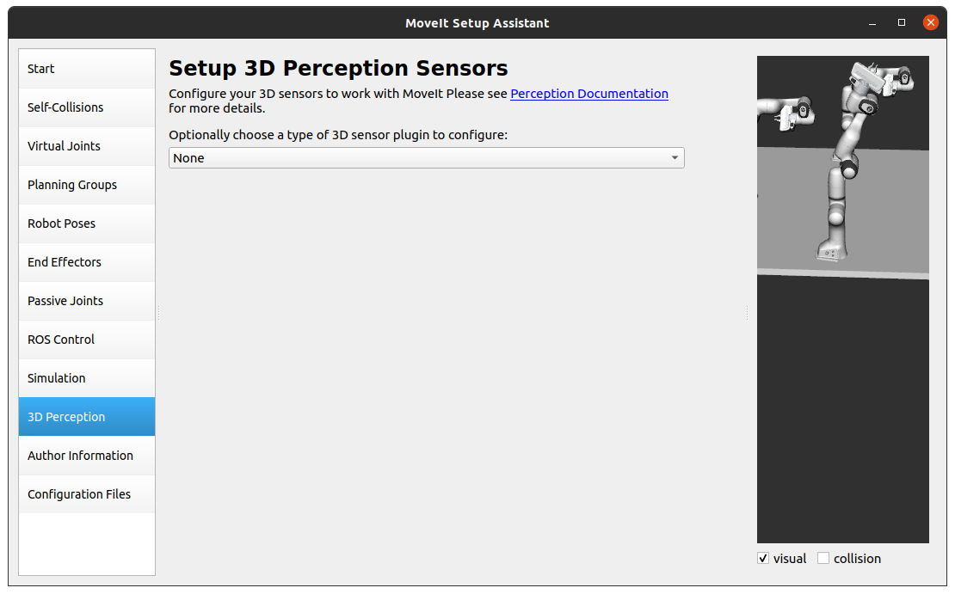

### Step 11: Author Information

Catkin requires author information for publishing purposes.

* Click on the *Author Information* pane.
* Enter your name and email address.

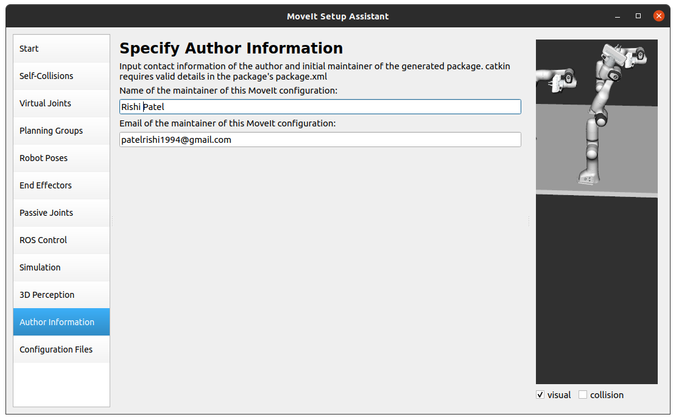

### Step 12: Generate Configuration Files

Generating all the configuration files that you will need to start using MoveIt.

* Click on the *Configuration Files* pane.
* Click on the *Browse* button.
* Navigate to **“Home/ws_moveit/src/”** and create a folder named “*triple_panda_moveit_config*”, Later this will be your ROS package.
  + All generated files will go directly into the directory you have chosen.

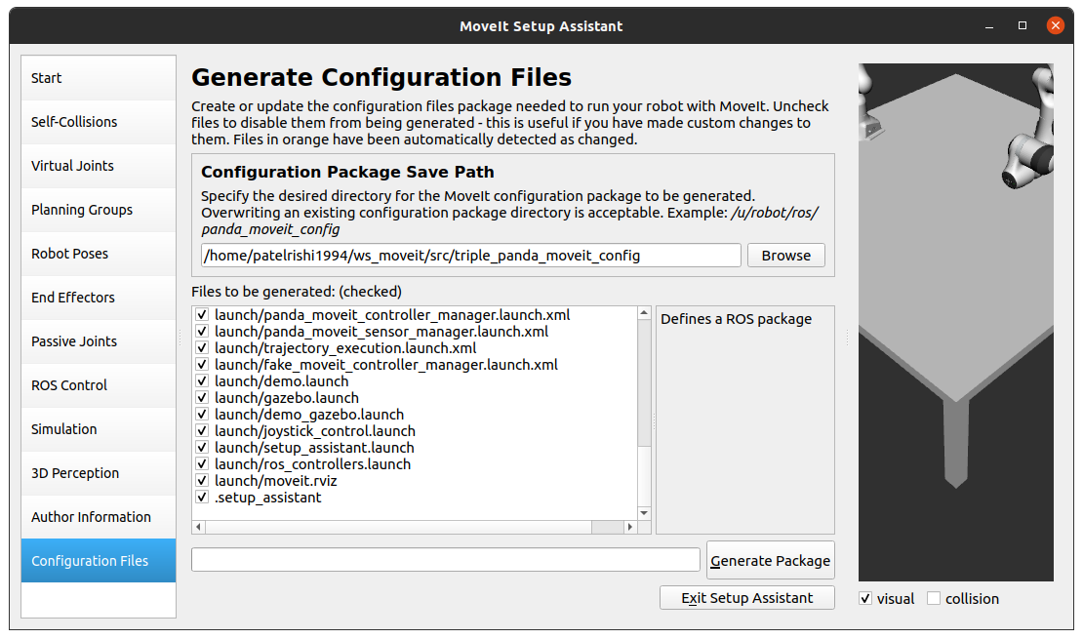

* Click on the *Generate Package* button.
  + The Setup Assistant will now generate and write a set of launch and config files into the directory of your choosing.
  + **Important:** All the generated files will appear in the Generated Files/Folders tab and you can click on each of them for a **description** of what they contain.

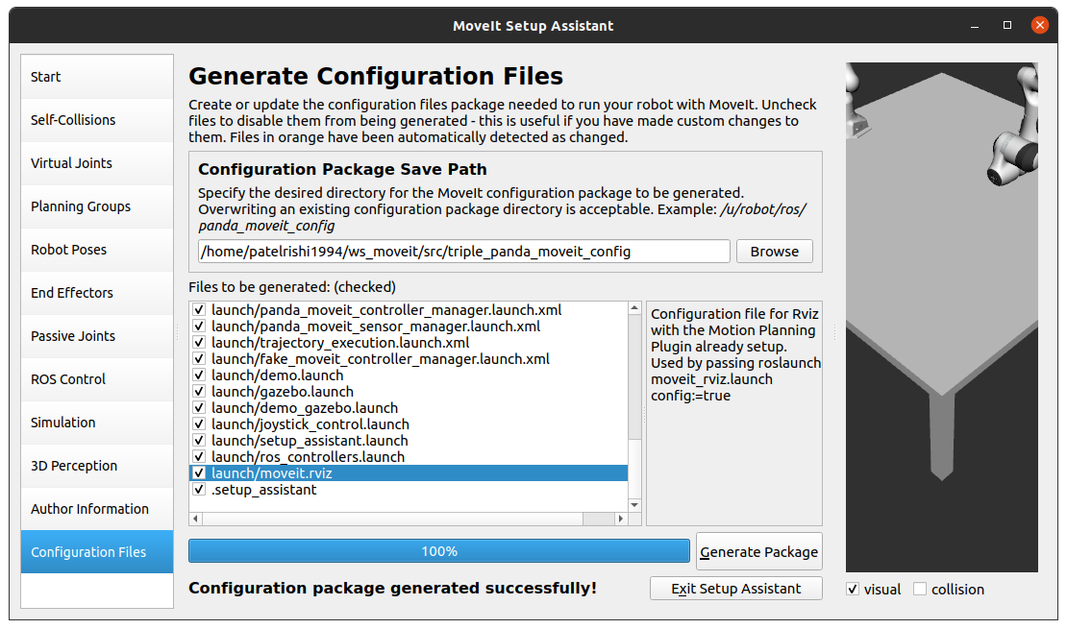

* Once you receive the message **“Configuration package generated successfully!”**, click on the *Exit Setup Assistant* button to exit.

## Build and Source the Workspace

* Whenever you create a new package inside the workspace you’ll need to build and source the workspace.
* First, we will open a terminal window and navigate to the **“ws_moveit”** workspace and run the following command to source your workspace and configure ROS packages:

catkin build

source devel/setup.bash

## Run Demo.launch

* Once the build process is complete without any errors, we can go ahead and run the following command in the terminal:

roslaunch triple_panda_moveit_config demo.launch

* You’ll see the following screen:

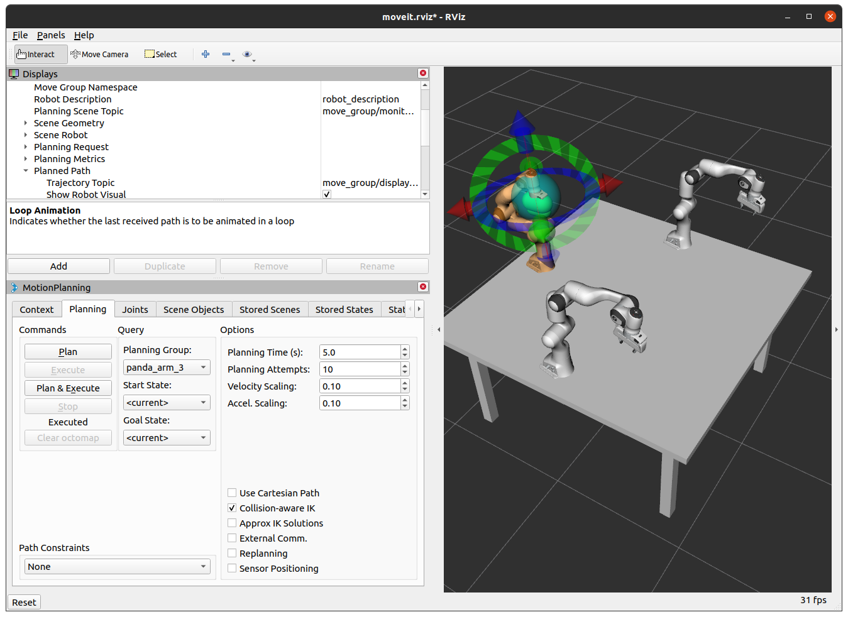

## Run a Python Script

To run python scripts first we’ll have to create a directory to store these python scripts inside the ROS package.

### Create Directory

* To create a directory open a terminal and navigate to the directory by entering the following commands:

roscd triple_panda_moveit_config/

* Now, to create a folder named “**scripts**” run the following command:

mkdir scripts

### Python Script : To Add Objects

* To create a python script copy the following code and save it inside the *“scripts”* folder we created above, as “**add_objects_tutorial.py**”

#!/usr/bin/env python3

##

# To use the Python MoveIt! interfaces, we will import the `moveit_commander`_ namespace.

# This namespace provides us with a `MoveGroupCommander`_ class, a `PlanningSceneInterface`_ class,

# and a `RobotCommander`_ class. (More on these below)

##

# We also import `rospy`_ and some messages that we will use:

##

# Python 2/3 compatibility imports

from __future__ import print_function

from six.moves import input

import sys

import csv

import copy

import numpy

import rospy

import tf

import rospkg

import rosparam

import moveit_commander

import moveit_msgs.msg

import geometry_msgs.msg

import numpy as np

from std_msgs.msg import Bool

from moveit_msgs.msg import MoveGroupAction, MoveGroupGoal

from moveit_msgs.msg import Constraints, JointConstraint, PositionConstraint, OrientationConstraint, BoundingVolume

from shape_msgs.msg import SolidPrimitive

from geometry_msgs.msg import Pose, PoseStamped

from moveit_commander import *

from math import pi, dist, fabs, cos

try:

from math import tau

except: # For Python 2 compatibility

from math import pi

tau = 2.0*pi

from std_msgs.msg import String

from moveit_commander.conversions import pose_to_list

def all_close(goal, actual, tolerance):

# """

# Convenience method for testing if the values in two lists are within a tolerance of each other.

# For Pose and PoseStamped inputs, the angle between the two quaternions is compared (the angle

# between the identical orientations q and -q is calculated correctly).

# @param: goal A list of floats, a Pose or a PoseStamped

# @param: actual A list of floats, a Pose or a PoseStamped

# @param: tolerance A float

# @returns: bool

# """

if type(goal) is list:

for index in range(len(goal)):

if abs(actual[index] - goal[index]) > tolerance:

return False

elif type(goal) is geometry_msgs.msg.PoseStamped:

return all_close(goal.pose, actual.pose, tolerance)

elif type(goal) is geometry_msgs.msg.Pose:

x0, y0, z0, qx0, qy0, qz0, qw0 = pose_to_list(actual)

x1, y1, z1, qx1, qy1, qz1, qw1 = pose_to_list(goal)

# Euclidean distance

d = dist((x1, y1, z1), (x0, y0, z0))

# phi = angle between orientations

cos_phi_half = fabs(qx0*qx1 + qy0*qy1 + qz0*qz1 + qw0*qw1)

return d <= tolerance and cos_phi_half >= cos(tolerance / 2.0)

return True

class Panda_arm_scene_MoveGroupPythonInterface(object):

"""MoveGroupPythonIntefaceTutorial"""

def __init__(self):

super(Panda_arm_scene_MoveGroupPythonInterface, self).__init__()

# BEGIN_SUB_TUTORIAL setup

##

# First initialize `moveit_commander`_ and a `rospy`_ node:

# global robot

# global scene

# global p

# global group

moveit_commander.roscpp_initialize(sys.argv)

rospy.init_node('Panda_arm_scene_move_group_python_interface', anonymous=True)

# Instantiate a `RobotCommander`_ object. This object is the outer-level interface to

# the robot:

robot = moveit_commander.RobotCommander()

# Instantiate a `PlanningSceneInterface`_ object. This object is an interface

# to the world surrounding the robot:

scene = moveit_commander.PlanningSceneInterface()

rospy.sleep(1)

# Instantiate a `MoveGroupCommander`_ object. This object is an interface

# to one group of joints. In this case the group is the joints in the Panda

# arm so we set ``group_name = panda_arm``. If you are using a different robot,

# you should change this value to the name of your robot arm planning group.

# This interface can be used to plan and execute motions on the Panda:

# group_name = "panda_arm"

# # group_name = "panda_arm_hand"

# group_name = "panda_arm_hand"

# group = moveit_commander.MoveGroupCommander(group_name)

p = PoseStamped()

p.header.frame_id = robot.get_planning_frame()

# Misc variables

self.box_name = ''

self.robot = robot

self.scene = scene

# self.group = group

self.p = p

self.obj_name = ''

def wait_for_state_update(self, obj_is_known=False, obj_is_attached=False, timeout=1):

#Ensure the collision update are received

# This function is called after adding,

# removing, attaching or detaching an object in the planning scene.

# Wait until the updates have been made or "timeout" seconds have passed.

scene = self.scene

# Record the start time

t_start = rospy.get_time()

t_seconds = rospy.get_time()

# Wait for the state update

while (t_seconds - t_start < timeout) and not rospy.is_shutdown():

# Test if the object is in attached object list

attached_objects = scene.get_attached_objects(

[self.obj_name])

is_attached = len(attached_objects.keys()) > 0

# Test if the attaching box is in the scene

is_known = scene.get_known_object_names()

if (obj_is_attached == is_attached) and (obj_is_known == is_known):

return True

# Sleep so that we give other threads time on the processor

rospy.sleep(0.1)

t_seconds = rospy.get_time()

return False

def main():

try:

rospy.loginfo("***********Start loading scene for panda************")

pandascenego = Panda_arm_scene_MoveGroupPythonInterface()

# pandascenego.scene.remove_world_object("part_to_be_removed")

pandascenego.scene.remove_world_object("box")

pandascenego.scene.remove_world_object("cylinder")

pandascenego.scene.remove_world_object("sphere")

# Adding 4 solid Cubes.

# Box position

pandascenego.p.pose.position.x = -0.20

pandascenego.p.pose.position.y = -0.25

pandascenego.p.pose.position.z = 1.020

# Adding box in the scene

pandascenego.scene.add_box("box", pandascenego.p, size=(0.075,0.030,0.040))

# Cylinder position

pandascenego.p.pose.position.x = 0.10

pandascenego.p.pose.position.y = 0.25

pandascenego.p.pose.position.z = 1.040

# Adding cylinder in the scene

pandascenego.scene.add_cylinder("cylinder", pandascenego.p, 0.04, 0.031 )

# Sphere position

pandascenego.p.pose.position.x = -0.30

pandascenego.p.pose.position.y = 0.15

pandascenego.p.pose.position.z = 1.030

# Adding sphere in the scene

pandascenego.scene.add_sphere("sphere", pandascenego.p, radius=0.030)

# Need to update, or it cannot successfully conduct the scene

pandascenego.wait_for_state_update(obj_is_known=True, timeout=4)

rospy.loginfo("**********Loading done!!!!!!**********")

except rospy.ROSInterruptException:

return

except KeyboardInterrupt:

return

if __name__ == '__main__':

main()

### Make Python Script Executable

* Once you save the file, open a terminal and navigate to the “*scripts*” folder inside the ROS package by typing the following command:

roscd triple_panda_moveit_config/

cd scripts

* Enter the following command to see if the files are executable or not.

ls

* If you see the python script’s name **“add_objects_tutorial.py”** written in white-colored text as shown in the image, that means the Python script is not yet executable:

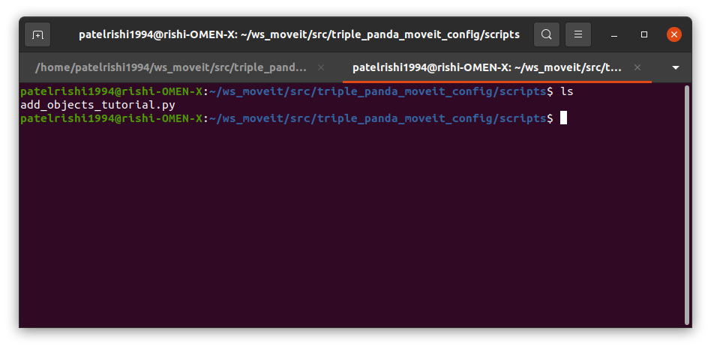

* To make the Python file executable, type following command in the shell:

chmod +x add_objects_tutorial.py

* Enter the command shown below to see what was changed in the output to make us understand how the shell shows executable files, in the image.

ls

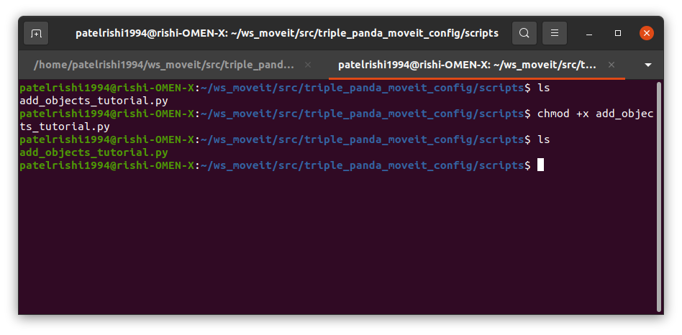

* Now, we’ll need to source the ROS package again, to do so navigate to the **“ws_moveit”** workspace and enter the following command in the terminal:

source devel/setup.bash

* Now, we have a python script named “**add_objects_tutorial.py**” ready and executable.

### Running Python Script: To Add Objects in The Scene

* We are ready to run this python script, which adds objects into the planning scene.
* To run the Python script we created earlier, run the following command in the shell:

rosrun triple_panda_moveit_config add_objects_tutorial.py

* Running the Python script **“add_objects_tutorial.py”** will add a cube, a sphere, and a cylinder in to the scene between three panda arms as shown in the image below:

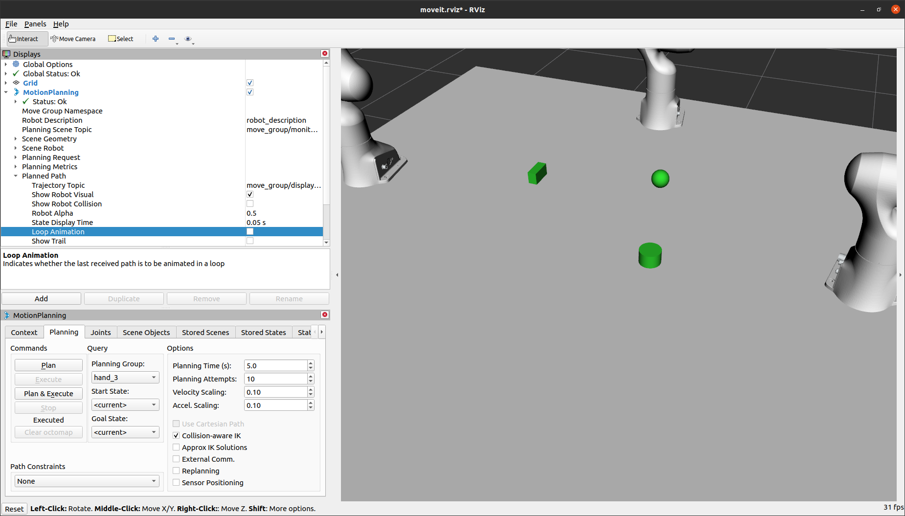

### Python Script : To Move Arm-1

* To create a Python script to move *“Panda_1_arm”* around, copy the following code block and save it in the file named **“panda_arm_1_tutorial.py”** inside the *“scripts”* folder we created earlier.

#!/usr/bin/env python3

# To use the Python MoveIt! interfaces, we will import the `moveit_commander`_ namespace.

# This namespace provides us with a `MoveGroupCommander`_ class, a `PlanningSceneInterface`_ class,

# and a `RobotCommander`_ class. (More on these below)

##

# We also import `rospy`_ and some messages that we will use:

##

# Python 2/3 compatibility imports

from __future__ import print_function

from six.moves import input

import sys

import csv

import copy

import numpy

import rospy

import tf

import rospkg

import rosparam

import moveit_commander

import moveit_msgs.msg

import geometry_msgs.msg

import numpy as np

from math import pi

from std_msgs.msg import String

from std_msgs.msg import Bool

from moveit_commander.conversions import pose_to_list

from moveit_msgs.msg import MoveGroupAction, MoveGroupGoal

from moveit_msgs.msg import Constraints, JointConstraint, PositionConstraint, OrientationConstraint, BoundingVolume

from shape_msgs.msg import SolidPrimitive

from geometry_msgs.msg import Pose

from moveit_commander import *

from math import pi, dist, fabs, cos

try:

from math import tau

except: # For Python 2 compatibility

from math import pi

tau = 2.0*pi

def all_close(goal, actual, tolerance):

# """

# Convenience method for testing if the values in two lists are within a tolerance of each other.

# For Pose and PoseStamped inputs, the angle between the two quaternions is compared (the angle

# between the identical orientations q and -q is calculated correctly).

# @param: goal A list of floats, a Pose or a PoseStamped

# @param: actual A list of floats, a Pose or a PoseStamped

# @param: tolerance A float

# @returns: bool

# """

if type(goal) is list:

for index in range(len(goal)):

if abs(actual[index] - goal[index]) > tolerance:

return False

elif type(goal) is geometry_msgs.msg.PoseStamped:

return all_close(goal.pose, actual.pose, tolerance)

elif type(goal) is geometry_msgs.msg.Pose:

x0, y0, z0, qx0, qy0, qz0, qw0 = pose_to_list(actual)

x1, y1, z1, qx1, qy1, qz1, qw1 = pose_to_list(goal)

# Euclidean distance

d = dist((x1, y1, z1), (x0, y0, z0))

# phi = angle between orientations

cos_phi_half = fabs(qx0*qx1 + qy0*qy1 + qz0*qz1 + qw0*qw1)

return d <= tolerance and cos_phi_half >= cos(tolerance / 2.0)

return True

class Single_arm_1_MoveGroupPythonInterface(object):

"""MoveGroupPythonIntefaceTutorial"""

def __init__(self):

super(Single_arm_1_MoveGroupPythonInterface, self).__init__()

##

# First initialize `moveit_commander`_ and a `rospy`_ node:

moveit_commander.roscpp_initialize(sys.argv)

rospy.init_node('Single_arm_1_move_group_python_interface', anonymous=True)

# Instantiate a `RobotCommander`_ object. This object is the outer-level interface to

# the robot:

robot = moveit_commander.RobotCommander()

# Instantiate a `PlanningSceneInterface`_ object. This object is an interface

# to the world surrounding the robot:

scene = moveit_commander.PlanningSceneInterface()

# Instantiate a `MoveGroupCommander`_ object. This object is an interface

# to one group of joints. In this case the group is the joints in the Panda

# arm so we set ``group_name = panda_arm``. If you are using a different robot,

# you should change this value to the name of your robot arm planning group.

# This interface can be used to plan and execute motions on the Panda:

# group_name = "panda_arm_1"

group = moveit_commander.MoveGroupCommander("panda_arm_1")

# group_hand_name = "hand_1"

group_hand = moveit_commander.MoveGroupCommander("hand_1")

group.set_planner_id("RRTConnectkConfigDefault")

# We create a `DisplayTrajectory`_ publisher which is used later to publish

# trajectories for RViz to visualize:

display_trajectory_publisher = rospy.Publisher('/move_group/display_planned_path',

moveit_msgs.msg.DisplayTrajectory,

queue_size=20)

##

# Getting Basic Information

# ^^^^^^^^^^^^^^^^^^^^^^^^^

# We can get the name of the reference frame for this robot:

planning_frame = group.get_planning_frame()

print("============ Planning frame: %s" % planning_frame)

# # We can also print the name of the end-effector link for this group:

eef_link = group.get_end_effector_link()

print("============ End effector link: %s" % eef_link)

# # We can get a list of all the groups in the robot:

group_names = robot.get_group_names()

print("============ Available Planning Groups:", robot.get_group_names())

# # Sometimes for debugging it is useful to print the entire state of the

# # robot:

print("============ Printing robot state")

print(robot.get_current_state())

print("")

# #

# self.trigger = String()

# trigger_listener = rospy.Subscriber('robot_trigger', String, self.trigger_callback, queue_size=3)

self.trigger = Bool()

trigger_listener = rospy.Subscriber('robot_trigger', Bool, self.trigger_callback, queue_size=3)

# Misc variables

self.box_name = ''

self.robot = robot

self.scene = scene

self.group = group

self.group_hand = group_hand

# self.display_trajectory_publisher = display_trajectory_publisher

# self.planning_frame = planning_frame

self.eef_link = eef_link

self.group_names = group_names

self.obj_name = ''

self.hand_close = [0.001, 0.001]

self.hand_open = [0.03, 0.03]

self.arm_joint_home = [6.275755446404221e-06, -8.630365110002458e-05, -0.05996775570060126, -1.6000211216069293, -6.323688132688403e-05, 1.4197929625608026, 7.157683521509172e-05]

self.arm_joint_sleep = [7.13184257503599e-05, -1.6999555053686723, 1.2333666998893026e-05, -2.4999417485582174, 5.258084847591819e-05, 0.9000862957747653, -0.7500080423361621]

self.arm_joint_cargobed = [-1.4921706601406963, 0.006656820429686526, -0.06000246210722252, -1.5999801670573186, -1.1203406890854242e-05, 1.400074690864468, -0.7500653156319167]

self.arm_joint_middleback = [0.0, -0.5, 0.0, -1.356, 0.0, 1.571, 0.785]

self.arm_pose_home = [-0.2705915832, 0.4273952206, 0.4319420529, 0.5005813056, 0.4989520427, -0.5045318412, 0.4958959938]

self.arm_pose_home = [-0.4104083372, 0.9893530345, 0.065450354, 0.5006462257, 0.4989756174, -0.5045000602, 0.4958390658]

def go_to_joint_state(self, joint_goal):

# Copy class variables to local variables to make the web tutorials more clear.

# In practice, you should use the class variables directly unless you have a good

# reason not to.

group = self.group

# BEGIN_SUB_TUTORIAL plan_to_joint_state

##

# Planning to a Joint Goal

# ^^^^^^^^^^^^^^^^^^^^^^^^

# The Panda's zero configuration is at a `singularity <https://www.quora.com/Robotics-What-is-meant-by-kinematic-singularity>`_ so the first

# thing we want to do is move it to a slightly better configuration.

# We can get the joint values from the group and adjust some of the values:

# joint_goal = group.get_current_joint_values()

# joint_goal[0] = 0

# joint_goal[1] = -pi/4

# joint_goal[2] = 0

# joint_goal[3] = -pi/2

# joint_goal[4] = 0

# joint_goal[5] = pi/3

# joint_goal[6] = 0

# The go command can be called with joint values, poses, or without any

# parameters if you have already set the pose or joint target for the group

group.go(joint_goal, wait=True)

# Calling ``stop()`` ensures that there is no residual movement

group.stop()

# END_SUB_TUTORIAL

# For testing:

# Note that since this section of code will not be included in the tutorials

# we use the class variable rather than the copied state variable

current_joints = self.group.get_current_joint_values()

return all_close(joint_goal, current_joints, 0.01)

def go_to_hand_pose_goal(self, hand_joint_goal):

# Copy class variables to local variables to make the web tutorials more clear.

# In practice, you should use the class variables directly unless you have a good reason not to.

group_hand = self.group_hand

group_hand.go(hand_joint_goal, wait=True)

# Calling ``stop()`` ensures that there is no residual movement

group_hand.stop()

# For testing:

# Note that since this section of code will not be included in the tutorials

# we use the class variable rather than the copied state variable

hand_current_joints = self.group_hand.get_current_joint_values()

return all_close(hand_joint_goal, hand_current_joints, 0.01)

def go_to_pose_goal(self, posegoal):

# posegoal = (x_p, y_p, z_p, roll_rad, pitch_rad, yaw_rad)

# Copy class variables to local variables to make the web tutorials more clear.

# In practice, you should use the class variables directly unless you have a good

# reason not to.

group = self.group

# BEGIN_SUB_TUTORIAL plan_to_pose

##

# Planning to a Pose Goal

# ^^^^^^^^^^^^^^^^^^^^^^^

# We can plan a motion for this group to a desired pose for the

# end-effector:

# geometry_msgs/Point position

# float64 x

# float64 y

# float64 z

# geometry_msgs/Quaternion orientation

# float64 x

# float64 y

# float64 z

# float64 w

quaternion_pose = tf.transformations.quaternion_from_euler(posegoal[3], posegoal[4], posegoal[5])

pose_goal = geometry_msgs.msg.Pose()

pose_goal.position.x = posegoal[0]

pose_goal.position.y = posegoal[1]

pose_goal.position.z = posegoal[2]

pose_goal.orientation.x = quaternion_pose[0]

pose_goal.orientation.y = quaternion_pose[1]

pose_goal.orientation.z = quaternion_pose[2]

pose_goal.orientation.w = quaternion_pose[3]

group.set_pose_target(pose_goal)

# group.

# c1 = Constraints()

# c1.position_constraints.header.fram

# # c1.position

# group.set_path_constraints

# Now, we call the planner to compute the plan and execute it.

plan = group.go(wait=True)

# Calling `stop()` ensures that there is no residual movement

group.stop()

# It is always good to clear your targets after planning with poses.

# Note: there is no equivalent function for clear_joint_value_targets()

group.clear_pose_targets()

# END_SUB_TUTORIAL

# For testing:

# Note that since this section of code will not be included in the tutorials

# we use the class variable rather than the copied state variable

current_pose = self.group.get_current_pose().pose

# print "********************************************"

# print current_pose

# print "********************************************"

return all_close(pose_goal, current_pose, 0.01)

def plan_cartesian_path(self, scale=1):

# Copy class variables to local variables to make the web tutorials more clear.

# In practice, you should use the class variables directly unless you have a good

# reason not to.

group = self.group

# BEGIN_SUB_TUTORIAL plan_cartesian_path

##

# Cartesian Paths

# ^^^^^^^^^^^^^^^

# You can plan a Cartesian path directly by specifying a list of waypoints

# for the end-effector to go through:

##

waypoints = []

wpose = group.get_current_pose().pose

wpose.position.z -= scale * 0.1 # First move up (z)

wpose.position.y += scale * 0.2 # and sideways (y)

waypoints.append(copy.deepcopy(wpose))

wpose.position.x += scale * 0.1 # Second move forward/backwards in (x)

waypoints.append(copy.deepcopy(wpose))

wpose.position.y -= scale * 0.1 # Third move sideways (y)

waypoints.append(copy.deepcopy(wpose))

# We want the Cartesian path to be interpolated at a resolution of 1 cm

# which is why we will specify 0.01 as the eef_step in Cartesian

# translation. We will disable the jump threshold by setting it to 0.0 disabling:

(plan, fraction) = group.compute_cartesian_path(

waypoints, # waypoints to follow

0.01, # eef_step

0.0) # jump_threshold

# Note: We are just planning, not asking move_group to actually move the robot yet:

return plan, fraction

# END_SUB_TUTORIAL

def wait_for_state_update(self, obj_is_known=False, obj_is_attached=False, timeout=1):

#Ensure the collision update are received

# This function is called after adding,

# removing, attaching or detaching an object in the planning scene.

# Wait until the updates have been made or "timeout" seconds have passed.

scene = self.scene

# Record the start time

t_start = rospy.get_time()

t_seconds = rospy.get_time()

# Wait for the state update

while (t_seconds - t_start < timeout) and not rospy.is_shutdown():

# Test if the object is in attached object list

attached_objects = scene.get_attached_objects(

[self.obj_name])

is_attached = len(attached_objects.keys()) > 0

# Test if the attaching box is in the scene

is_known = scene.get_known_object_names()

if (obj_is_attached == is_attached) and (obj_is_known == is_known):

return True

# Sleep so that we give other threads time on the processor

rospy.sleep(0.1)

t_seconds = rospy.get_time()

return False

def trigger_callback(self, data):

# rospy.loginfo(rospy.get_caller_id() + 'I heard %s', data.data)

# self.trigger = data.data

self.trigger = data

def main():

try:

rospy.loginfo("Start panda_1 move.")

pandago = Single_arm_1_MoveGroupPythonInterface()

print("********************************************")

print("ready to go!")

print("********************************************")

start_time = rospy.get_time()

loop_rate = rospy.Rate(10)

while not rospy.is_shutdown():

pandago.go_to_joint_state(pandago.arm_joint_home)

pandago.go_to_hand_pose_goal(pandago.hand_close)

pandago.go_to_joint_state(pandago.arm_joint_sleep)

pandago.go_to_hand_pose_goal(pandago.hand_open)

loop_rate.sleep()

# The motion planning end here

end_time = rospy.get_time()

rospy.loginfo("==== motion planning complete!")

# rospy.loginfo("Total cleaning time is: %.2f" % (end_time - start_time))

except rospy.ROSInterruptException:

return

except KeyboardInterrupt:

return

if __name__ == '__main__':

main()

* In the command shell, Navigate to the “*scripts*” folder and make the file executable by typing following commands:

roscd triple_panda_moveit_config

cd scripts/

chmod +x panda_arm_1_tutorial.py

* Then execute the file by entering the following command:

rosrun triple_panda_moveit_config panda_arm_1_tutorial.py

* You will see the *“Panda_arm_1”* moving in a loop of two states shown in the images:

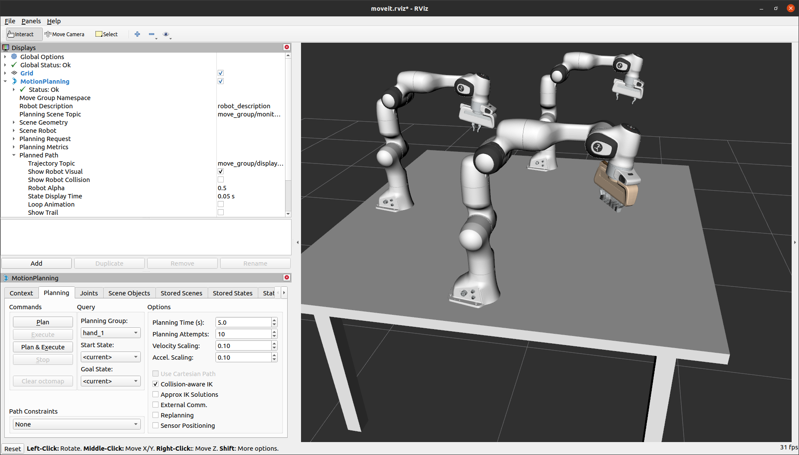

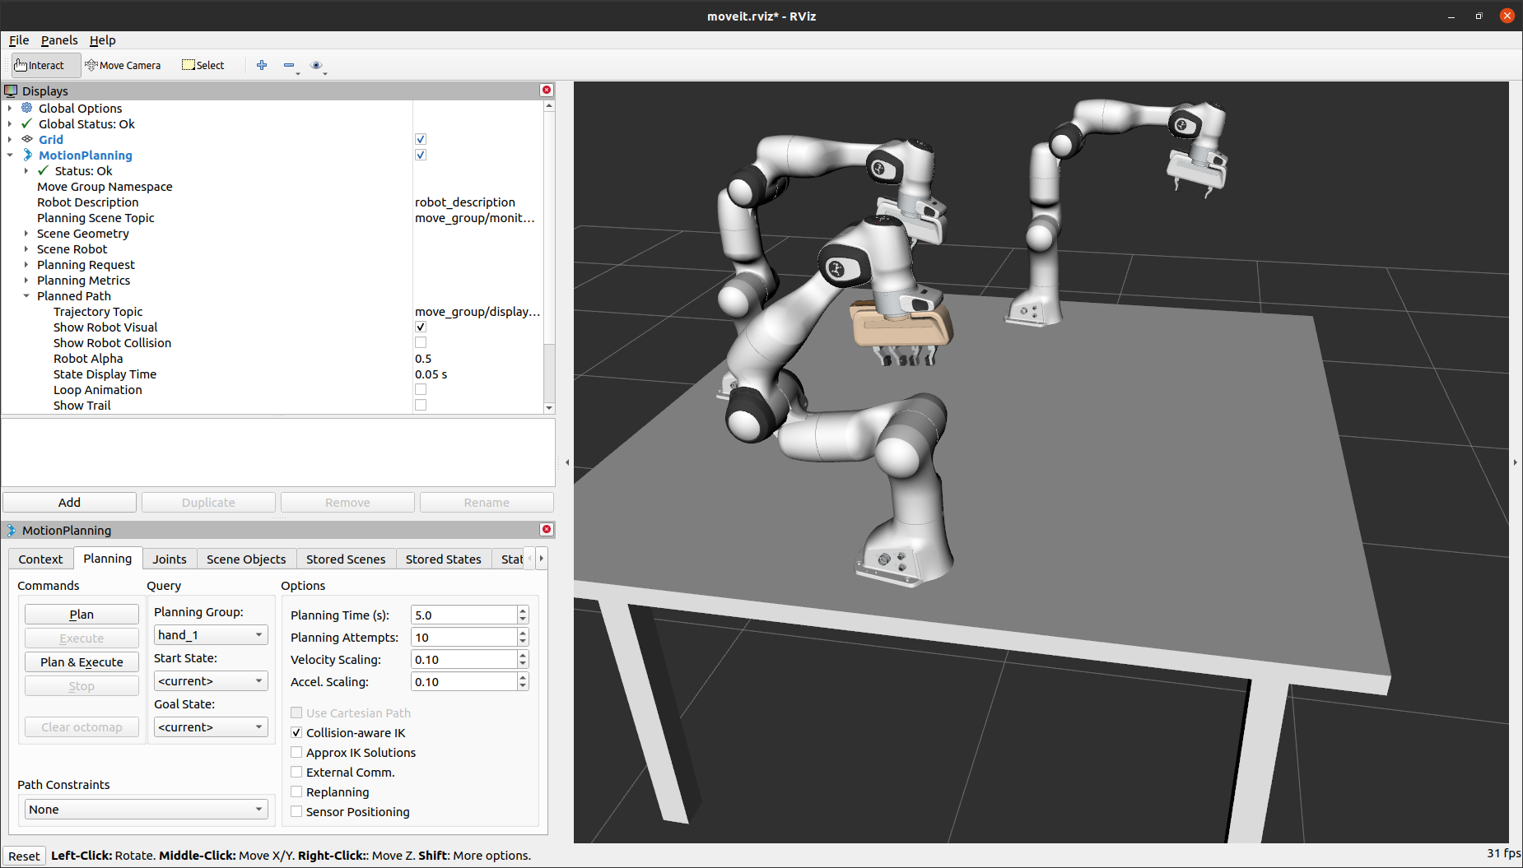

### Python Script : To Pick and Place

* To do *“Pick and Place”* using a Python script, you will need to have objects in the planning scene, to add objects in the planning scene run the following command:

rosrun triple_panda_moveit_config add_objects_tutorial.py

* It’ll add the objects in the planning scene as shown below:

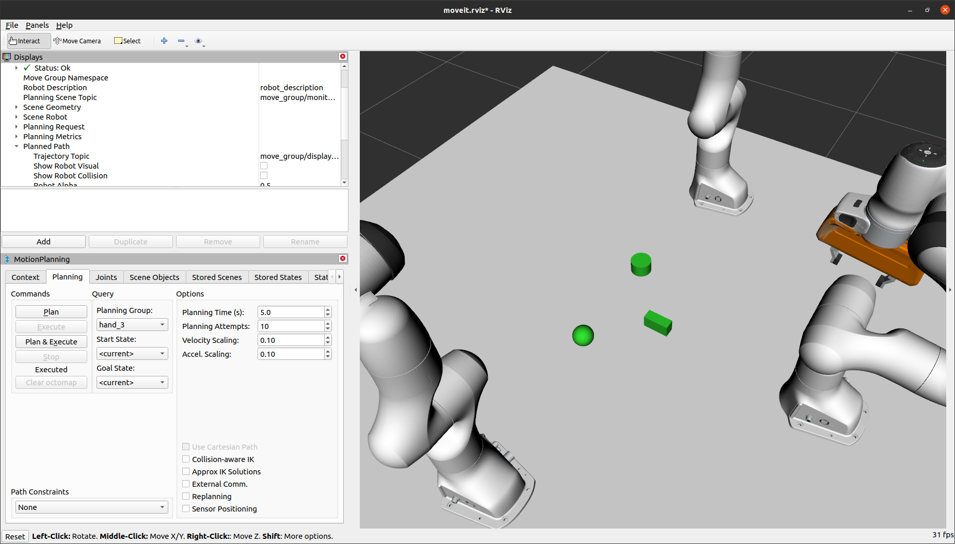

* Now copy, the following codes to a text file and save it as **“arm_1_pick_and_place_tutorial.py”** into the *“scripts”* folder inside the ROS package named *“triple_panda_moveit_config”*

#! /usr/bin/env python3

# Python 2/3 compatibility imports

from __future__ import print_function

from six.moves import input

import sys

import csv

import copy

import numpy

import rospy

import tf

import rospkg

import rosparam

import moveit_commander

import moveit_msgs.msg

import geometry_msgs.msg

import numpy as np

from math import pi

from std_msgs.msg import String

from std_msgs.msg import Bool

from moveit_commander.conversions import pose_to_list

from moveit_msgs.msg import MoveGroupAction, MoveGroupGoal

from moveit_msgs.msg import Constraints, JointConstraint, PositionConstraint, OrientationConstraint, BoundingVolume

from shape_msgs.msg import SolidPrimitive

from geometry_msgs.msg import Pose

from moveit_commander import *

from math import pi, dist, fabs, cos

try:

from math import tau

except: # For Python 2 compatibility

from math import pi

tau = 2.0*pi

def all_close(goal, actual, tolerance):

# """

# Convenience method for testing if the values in two lists are within a tolerance of each other.

# For Pose and PoseStamped inputs, the angle between the two quaternions is compared (the angle

# between the identical orientations q and -q is calculated correctly).

# @param: goal A list of floats, a Pose or a PoseStamped

# @param: actual A list of floats, a Pose or a PoseStamped

# @param: tolerance A float

# @returns: bool

# """

if type(goal) is list:

for index in range(len(goal)):

if abs(actual[index] - goal[index]) > tolerance:

return False

elif type(goal) is geometry_msgs.msg.PoseStamped:

return all_close(goal.pose, actual.pose, tolerance)

elif type(goal) is geometry_msgs.msg.Pose:

x0, y0, z0, qx0, qy0, qz0, qw0 = pose_to_list(actual)

x1, y1, z1, qx1, qy1, qz1, qw1 = pose_to_list(goal)

# Euclidean distance

d = dist((x1, y1, z1), (x0, y0, z0))

# phi = angle between orientations

cos_phi_half = fabs(qx0*qx1 + qy0*qy1 + qz0*qz1 + qw0*qw1)

return d <= tolerance and cos_phi_half >= cos(tolerance / 2.0)

return True

class Single_arm_1_PickAndPlacePythonInterface(object):

"""MoveGroupPythonIntefaceTutorial"""

def __init__(self):

super(Single_arm_1_PickAndPlacePythonInterface, self).__init__()

# BEGIN_SUB_TUTORIAL setup

##

# First initialize `moveit_commander`_ and a `rospy`_ node:

moveit_commander.roscpp_initialize(sys.argv)

rospy.init_node('Single_arm_1_pick_and_place_python_tutorial', anonymous=True)

# Instantiate a `RobotCommander`_ object. This object is the outer-level interface to

# the robot:

robot = moveit_commander.RobotCommander()

# Instantiate a `PlanningSceneInterface`_ object. This object is an interface

# to the world surrounding the robot:

scene = moveit_commander.PlanningSceneInterface()

# Instantiate a `MoveGroupCommander`_ object. This object is an interface

# to one group of joints. In this case the group is the joints in the Panda

# arm so we set ``group_name = panda_arm``. If you are using a different robot,

# you should change this value to the name of your robot arm planning group.

# This interface can be used to plan and execute motions on the Panda:

# group_name = "panda_arm"

# group_name = "panda_arm_hand"

# group_name = "panda_arm_1"

group = moveit_commander.MoveGroupCommander("panda_arm_1")

group_hand_name = "hand_1"

group_hand = moveit_commander.MoveGroupCommander("hand_1")

group.set_planner_id("RRTConnect")

p = geometry_msgs.msg.PoseStamped()

p.header.frame_id = "hand_1"

# pose_goal for go_to_pose_goal

pose_goal = geometry_msgs.msg.Pose()

# We create a `DisplayTrajectory`_ publisher which is used later to publish

# trajectories for RViz to visualize:

display_trajectory_publisher = rospy.Publisher('/move_group/display_planned_path',

moveit_msgs.msg.DisplayTrajectory,

queue_size=20)

# END_SUB_TUTORIAL

# BEGIN_SUB_TUTORIAL basic_info

##

# Getting Basic Information

# ^^^^^^^^^^^^^^^^^^^^^^^^^

# We can get the name of the reference frame for this robot:

planning_frame = group.get_planning_frame()

print("============ Planning frame: %s" % planning_frame)

# # We can also print the name of the end-effector link for this group:

eef_link = group.get_end_effector_link()

print("============ End effector link: %s" % eef_link)

# # We can get a list of all the groups in the robot:

group_names = robot.get_group_names()

print("============ Available Planning Groups:", robot.get_group_names())

# # Sometimes for debugging it is useful to print the entire state of the

# # robot:

print("============ Printing robot state")

print(robot.get_current_state())

print("")

# # END_SUB_TUTORIAL

# self.trigger = String()

# trigger_listener = rospy.Subscriber('robot_trigger', String, self.trigger_callback, queue_size=3)

self.trigger = Bool()

trigger_listener = rospy.Subscriber('robot_trigger', Bool, self.trigger_callback, queue_size=3)

# Misc variables

self.box_name = ''

self.robot = robot

self.scene = scene

self.group = group

self.group_hand = group_hand

self.p = p

self.pose_goal = pose_goal

# self.display_trajectory_publisher = display_trajectory_publisher

# self.planning_frame = planning_frame

self.eef_link = eef_link

self.group_names = group_names

self.obj_name = ''

# "go_to_hand_pose_goal" for hand_1/2/3

self.hand_close = [0.001, 0.001]

self.hand_open = [0.04, 0.04]

# Arm "go_to_joint_state" known "sleep" position

self.arm_joint_sleep = [7.13184257503599e-05, -1.6999555053686723, 1.2333666998893026e-05, -2.4999417485582174, 5.258084847591819e-05, 0.9000862957747653, -0.7500080423361621]

# Arm "go_to_joint_state" known "Home" position before pick & after place.

self.arm_joint_home = [-9.753063633106649e-05, 2.5760776037350304e-05, -0.060084970084624365, -1.5999810877252372, 2.9359157197177423e-05, 1.4000858290793374, -0.7500407013451215]

# Test for "go_to_pose_goal" position(xyz) followed by orientation(xyzw)

# posegoal (position (x=0, y=1, z=2) & orientation (x=3,y=4,z=5,w=6))

# "home" Known Position for "panda_arm_1"

self.arm_pose_home = [0.5327730325579362, -0.6320047969303356, 1.5979021807482512,-0.9363739951843837, -0.3365071025447404, 0.09175713255734949, 0.03933623907076268]

# "sleep" Known Position for "panda_arm_1"

self.arm_pose_sleep = [-0.007756151603123613, -0.6000006560533259, 1.6031614476996794, 0.9293459496341587, 0.36581217723197973, 0.046518066474322654, 0.018265442203049258]

# "go_to_pose_goal" to move panda_arm_1 over objects

self.arm_pose_over_box = [-0.15, 0.0, 1.35, 0.39528812946598124, 0.9185547552932436, 0.0020194965181487023, 0.0006147074655833032]

self.arm_pose_over_sphere = [0.0, 0.15, 1.35, 0.39528812946598124, 0.9185547552932436, 0.0020194965181487023, 0.0006147074655833032]

self.arm_pose_over_cylinder = [0.0, -0.15, 1.35, 0.39528812946598124, 0.9185547552932436, 0.0020194965181487023, 0.0006147074655833032]

# "go_to_pose_goal": To move arm near ring but not too close that, it would not plan

self.arm_pose_on_box = [-0.15, 0.0, 1.1701309345795943, 0.3956035181776749, 0.9184213801658667, 1.1506186413941219e-05, 0.0001572490960777418]

self.arm_pose_on_sphere = [0.0, 0.15, 1.1701309345795943, 0.3956035181776749, 0.9184213801658667, 1.1506186413941219e-05, 0.0001572490960777418]

self.arm_pose_on_cylinder = [0.0, -0.15, 1.1701309345795943, 0.3956035181776749, 0.9184213801658667, 1.1506186413941219e-05, 0.0001572490960777418]

# ON PLACE

self.arm_pose_on_place_1 = [0.534011544869845, -0.6201861917350276, 1.1701309345795943, -0.9405295150632486, -0.3397018906201843, 0.0014467799759505496, 0.0021825745494838122]

self.arm_pose_on_place_2 = [0.534011544869845, -0.6201861917350276, 1.2151309345795943, -0.9405295150632486, -0.3397018906201843, 0.0014467799759505496, 0.0021825745494838122]

self.arm_pose_on_place_3 = [0.534011544869845, -0.6201861917350276, 1.2601309345795943, -0.9405295150632486, -0.3397018906201843, 0.0014467799759505496, 0.0021825745494838122]

# Before and after place pose for the arm

self.arm_pose_over_place = [0.534011544869845, -0.6201861917350276, 1.3501309345795943, -0.9405295150632486, -0.3397018906201843, 0.0014467799759505496, 0.0021825745494838122]

# go_to_joint_state to place rings

self.arm_joint_place = [2.074746629135332, -0.9591763378151135, -2.1723355134407907, -2.1324361480758967, -1.2229189006089685, 2.3422870238938347, 0.03230886379858974]

def go_to_joint_state(self, joint_goal):

# Copy class variables to local variables to make the web tutorials more clear.

# In practice, you should use the class variables directly unless you have a good

# reason not to.

group = self.group

# BEGIN_SUB_TUTORIAL plan_to_joint_state

##

# Planning to a Joint Goal

# ^^^^^^^^^^^^^^^^^^^^^^^^

# The Panda's zero configuration is at a `singularity <https://www.quora.com/Robotics-What-is-meant-by-kinematic-singularity>`_ so the first

# thing we want to do is move it to a slightly better configuration.

# We can get the joint values from the group and adjust some of the values:

# joint_goal = group.get_current_joint_values()

# joint_goal[0] = 0

# joint_goal[1] = -pi/4

# joint_goal[2] = 0

# joint_goal[3] = -pi/2

# joint_goal[4] = 0

# joint_goal[5] = pi/3

# joint_goal[6] = 0

# The go command can be called with joint values, poses, or without any

# parameters if you have already set the pose or joint target for the group

group.go(joint_goal, wait=True)

# Calling ``stop()`` ensures that there is no residual movement

group.stop()

# END_SUB_TUTORIAL

# For testing:

# Note that since this section of code will not be included in the tutorials

# we use the class variable rather than the copied state variable

current_joints = self.group.get_current_joint_values()

return all_close(joint_goal, current_joints, 0.01)

def go_to_hand_pose_goal(self, hand_joint_goal):

# Copy class variables to local variables to make the web tutorials more clear.

# In practice, you should use the class variables directly unless you have a good reason not to.

group_hand = self.group_hand

group_hand.go(hand_joint_goal, wait=True)

# Calling ``stop()`` ensures that there is no residual movement

group_hand.stop()

# For testing:

# Note that since this section of code will not be included in the tutorials

# we use the class variable rather than the copied state variable

hand_current_joints = self.group_hand.get_current_joint_values()

return all_close(hand_joint_goal, hand_current_joints, 0.01)

def go_to_pose_goal(self, posegoal):

# posegoal = (x_p, y_p, z_p, roll_rad, pitch_rad, yaw_rad)

# Copy class variables to local variables to make the web tutorials more clear.

# In practice, you should use the class variables directly unless you have a good

# reason not to.

group = self.group

pose_goal = self.pose_goal

# BEGIN_SUB_TUTORIAL plan_to_pose

##

# Planning to a Pose Goal

# ^^^^^^^^^^^^^^^^^^^^^^^

# We can plan a motion for this group to a desired pose for the

# end-effector:

# geometry_msgs/Point position

# float64 x

# float64 y

# float64 z

# geometry_msgs/Quaternion orientation

# float64 x

# float64 y

# float64 z

# float64 w

#quaternion_pose = tf.transformations.quaternion_from_euler(posegoal[3], posegoal[4], posegoal[5])

#pose_goal = geometry_msgs.msg.Pose()

pose_goal.position.x = posegoal[0]

pose_goal.position.y = posegoal[1]

pose_goal.position.z = posegoal[2]

pose_goal.orientation.x = posegoal[3]

pose_goal.orientation.y = posegoal[4]

pose_goal.orientation.z = posegoal[5]

pose_goal.orientation.w = posegoal[6]

group.set_pose_target(pose_goal)

# group.

# c1 = Constraints()

# c1.position_constraints.header.fram

# # c1.position

# group.set_path_constraints

# Now, we call the planner to compute the plan and execute it.

plan = group.go(wait=True)

# Calling `stop()` ensures that there is no residual movement

group.stop()

# It is always good to clear your targets after planning with poses.

# Note: there is no equivalent function for clear_joint_value_targets()

group.clear_pose_targets()

# END_SUB_TUTORIAL

# For testing:

# Note that since this section of code will not be included in the tutorials

# we use the class variable rather than the copied state variable

current_pose = self.group.get_current_pose().pose

# print "********************************************"

# print current_pose

# print "********************************************"

return all_close(pose_goal, current_pose, 0.01)

def wait_for_state_update(self, obj_is_known=False, obj_is_attached=False, timeout=1):

# Ensure the collision update are received

# This function is called after adding,

# removing, attaching or detaching an object in the planning scene.

# Wait until the updates have been made or "timeout" seconds have passed.

scene = self.scene

box_name = self.box_name

obj_name = self.obj_name

# Record the start time

t_start = rospy.get_time()

t_seconds = rospy.get_time()

# Wait for the state update

while (t_seconds - t_start < timeout) and not rospy.is_shutdown():

# Test if the object is in attached object list

attached_objects = scene.get_attached_objects([self.obj_name])

is_attached = len(attached_objects.keys()) > 0

# Test if the attaching box is in the scene

is_known = scene.get_known_object_names()

if (obj_is_attached == is_attached) and (obj_is_known == is_known):

return True

# Sleep so that we give other threads time on the processor

rospy.sleep(0.1)

t_seconds = rospy.get_time()

return False

def trigger_callback(self, data):

# rospy.loginfo(rospy.get_caller_id() + 'I heard %s', data.data)

# self.trigger = data.data

self.trigger = data

def attach_box(self, obj_name, timeout=4):

# Copying local variable to class variable to get the name from the method from "main()"

self.obj_name = obj_name

# Copy class variables to local variables to make the web tutorials more clear.

# In practice, you should use the class variables directly unless you have a good

# reason not to.

box_name = self.box_name

obj_name = self.obj_name

robot = self.robot

scene = self.scene

eef_link = self.eef_link

group_names = self.group_names

## BEGIN_SUB_TUTORIAL attach_object

##

## Attaching Objects to the Robot

## ^^^^^^^^^^^^^^^^^^^^^^^^^^^^^^^^^^^^^^^^^^^^^^^^^^^^^^^

## Next, we will attach the box to the Panda wrist. Manipulating objects requires the

## robot be able to touch them without the planning scene reporting the contact as a

## collision. By adding link names to the ``touch_links`` array, we are telling the

## planning scene to ignore collisions between those links and the box. For the Panda

## robot, we set ``grasping_group = 'hand'``. If you are using a different robot,

## you should change this value to the name of your end effector group name.

grasping_group = "hand_1"

touch_links = robot.get_link_names(group=grasping_group)

scene.attach_box(eef_link, obj_name, touch_links=touch_links)

## END_SUB_TUTORIAL

# We wait for the planning scene to update.

return self.wait_for_state_update(obj_is_attached=True, obj_is_known=False, timeout=timeout)

def detach_box(self, obj_name , timeout=4):

# Copying local variable to class variable to get the name from the method from "main()"

self.obj_name = obj_name

# Copy class variables to local variables to make the web tutorials more clear.

# In practice, you should use the class variables directly unless you have a good

# reason not to.

obj_name = self.obj_name

box_name = self.box_name

scene = self.scene

eef_link = self.eef_link

## BEGIN_SUB_TUTORIAL detach_object

##

## Detaching Objects from the Robot

## ^^^^^^^^^^^^^^^^^^^^^^^^^^^^^^^^^^^^^^^^^^^^^^^^^^^^^^^

## We can also detach and remove the object from the planning scene:

scene.remove_attached_object(eef_link, name=obj_name)

## END_SUB_TUTORIAL

# We wait for the planning scene to update.

return self.wait_for_state_update(obj_is_known=True, obj_is_attached=False, timeout=timeout)

def main():

try:

rospy.loginfo("Start panda_1 move.")

pandago = Single_arm_1_PickAndPlacePythonInterface()

print("********************************************")

print("ready to go!")

print("********************************************")

start_time = rospy.get_time()

# Testing go_to_pose_goal

# Put the arm in starting AKA "HOME" position

pandago.go_to_joint_state(pandago.arm_joint_home)

# Put the arm over "rings" 1 through 9

pandago.go_to_pose_goal(pandago.arm_pose_over_box)

#pandago.go_to_pose_goal(pandago.arm_pose_over_sphere)

#pandago.go_to_pose_goal(pandago.arm_pose_over_cylinder)

# Open the Gripper

pandago.go_to_hand_pose_goal(pandago.hand_open)

# ON RING

pandago.go_to_pose_goal(pandago.arm_pose_on_box)

#pandago.go_to_pose_goal(pandago.arm_pose_on_sphere)

#pandago.go_to_pose_goal(pandago.arm_pose_on_cylinder)

# Close the Gripper

pandago.go_to_hand_pose_goal(pandago.hand_close)

# and

# Attach "object"

pandago.attach_box("box")

#pandago.attach_box("cylinder")

#pandago.attach_box("sphere")

# Go to pose over rings with ring attached to the arm

# Retract arm from ring position to little above.

pandago.go_to_pose_goal(pandago.arm_pose_over_box)

#pandago.go_to_pose_goal(pandago.arm_pose_over_sphere)

#pandago.go_to_pose_goal(pandago.arm_pose_over_cylinder)

# Go Above Place Position with ring attached and gripper closed

pandago.go_to_pose_goal(pandago.arm_pose_over_place)

# ON PLACE POSES

pandago.go_to_pose_goal(pandago.arm_pose_on_place_1)

#pandago.go_to_pose_goal(pandago.arm_pose_on_place_2)

#pandago.go_to_pose_goal(pandago.arm_pose_on_place_3)

# Open the Gripper

pandago.go_to_hand_pose_goal(pandago.hand_open)

# Detach the object

pandago.detach_box("box")

#pandago.detach_box("cylinder")

#pandago.detach_box("sphere")

# Retract Arm in Z position after Detaching the object 1 / 2 / 3

# Go Above Place Position with ring detached and gripper open

pandago.go_to_pose_goal(pandago.arm_pose_over_place)

# Retract the arm / Put the arm in starting AKA "HOME" position

pandago.go_to_joint_state(pandago.arm_joint_home)

rospy.sleep(10)

moveit_commander.roscpp_shutdown()

end_time = rospy.get_time()

rospy.loginfo("==== motion planning complete!")

except rospy.ROSInterruptException:

return

except KeyboardInterrupt:

return

if __name__ == '__main__':

main()

* Once the file is saved navigate to the *“scripts”* folder and make the file executable by entering the following commands:

Roscd triple_panda_moveit_config/scripts

Chmod +x arm_1_pick_and_place_tutorial.py

* Now when we execute the file by running following command in the shell:
* Let’s understand the steps we’ll go through to execute and complete the *“Pick and Place”* functionality from the pictures below:
  1. We’ll start with arm in “*home*” position

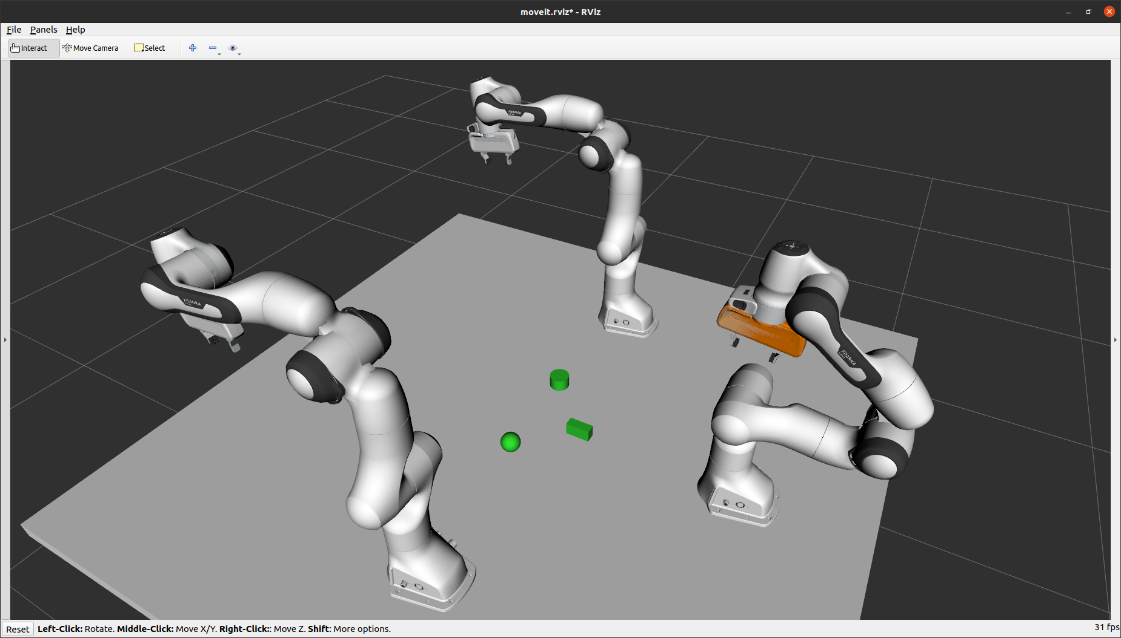

* 1. The arm will *go to pose over the object* (*“box”*)

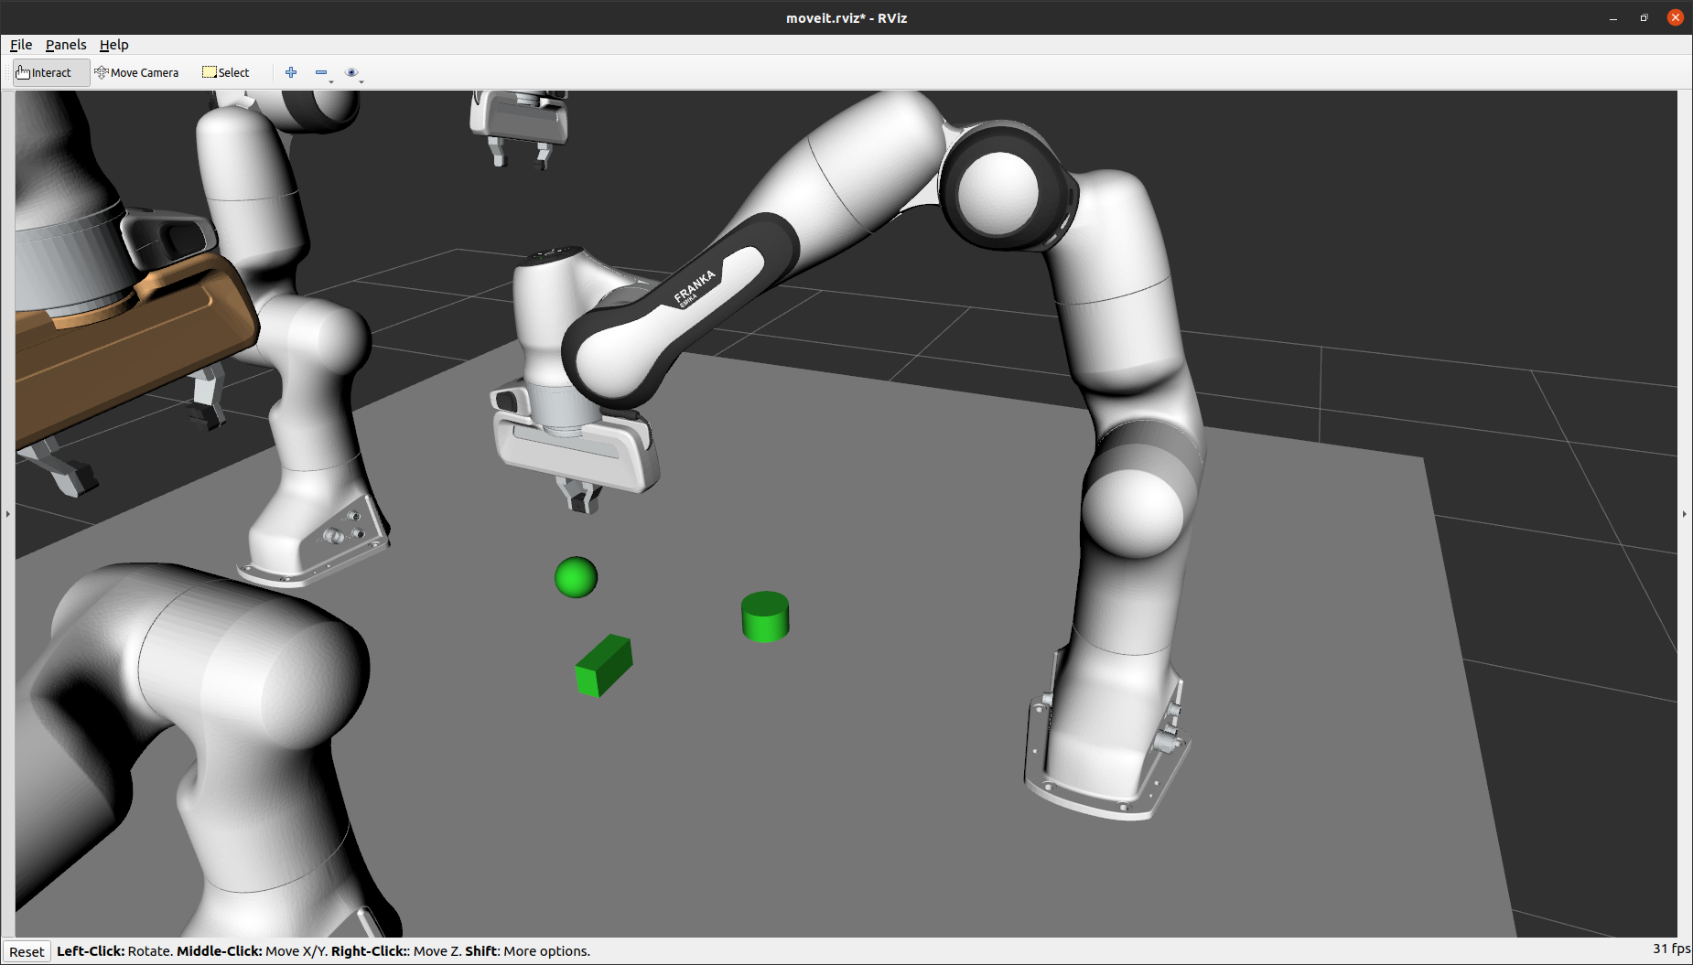

* 1. Gripper will *Open*

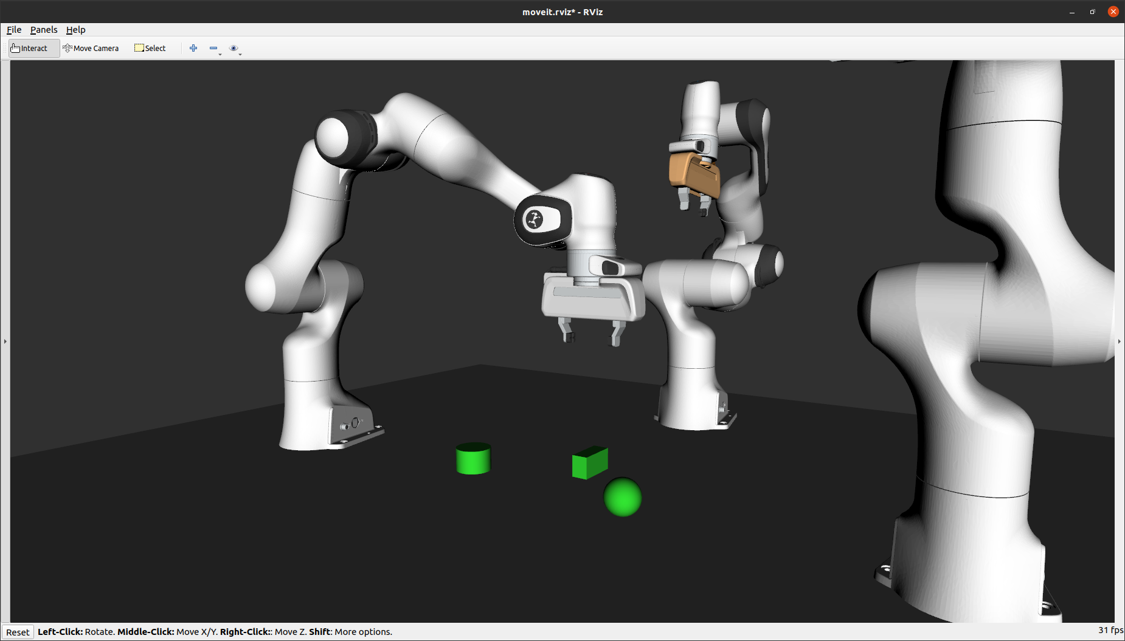

* 1. The arm will *go on the object* from above.

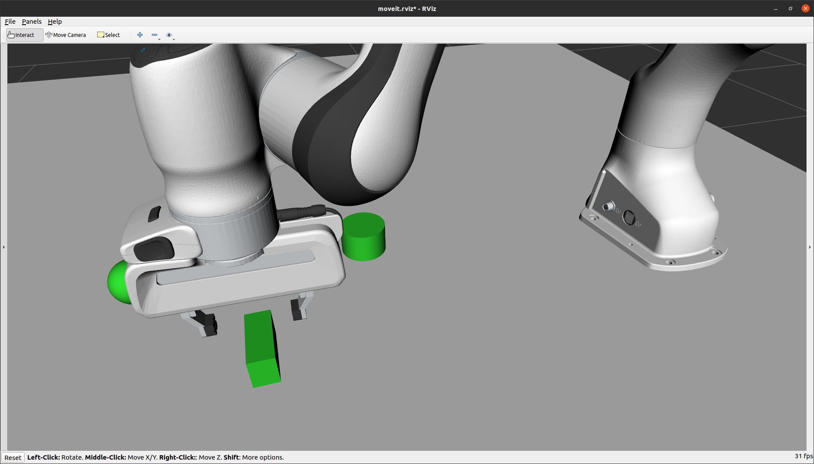

* 1. Gripper will *closes*

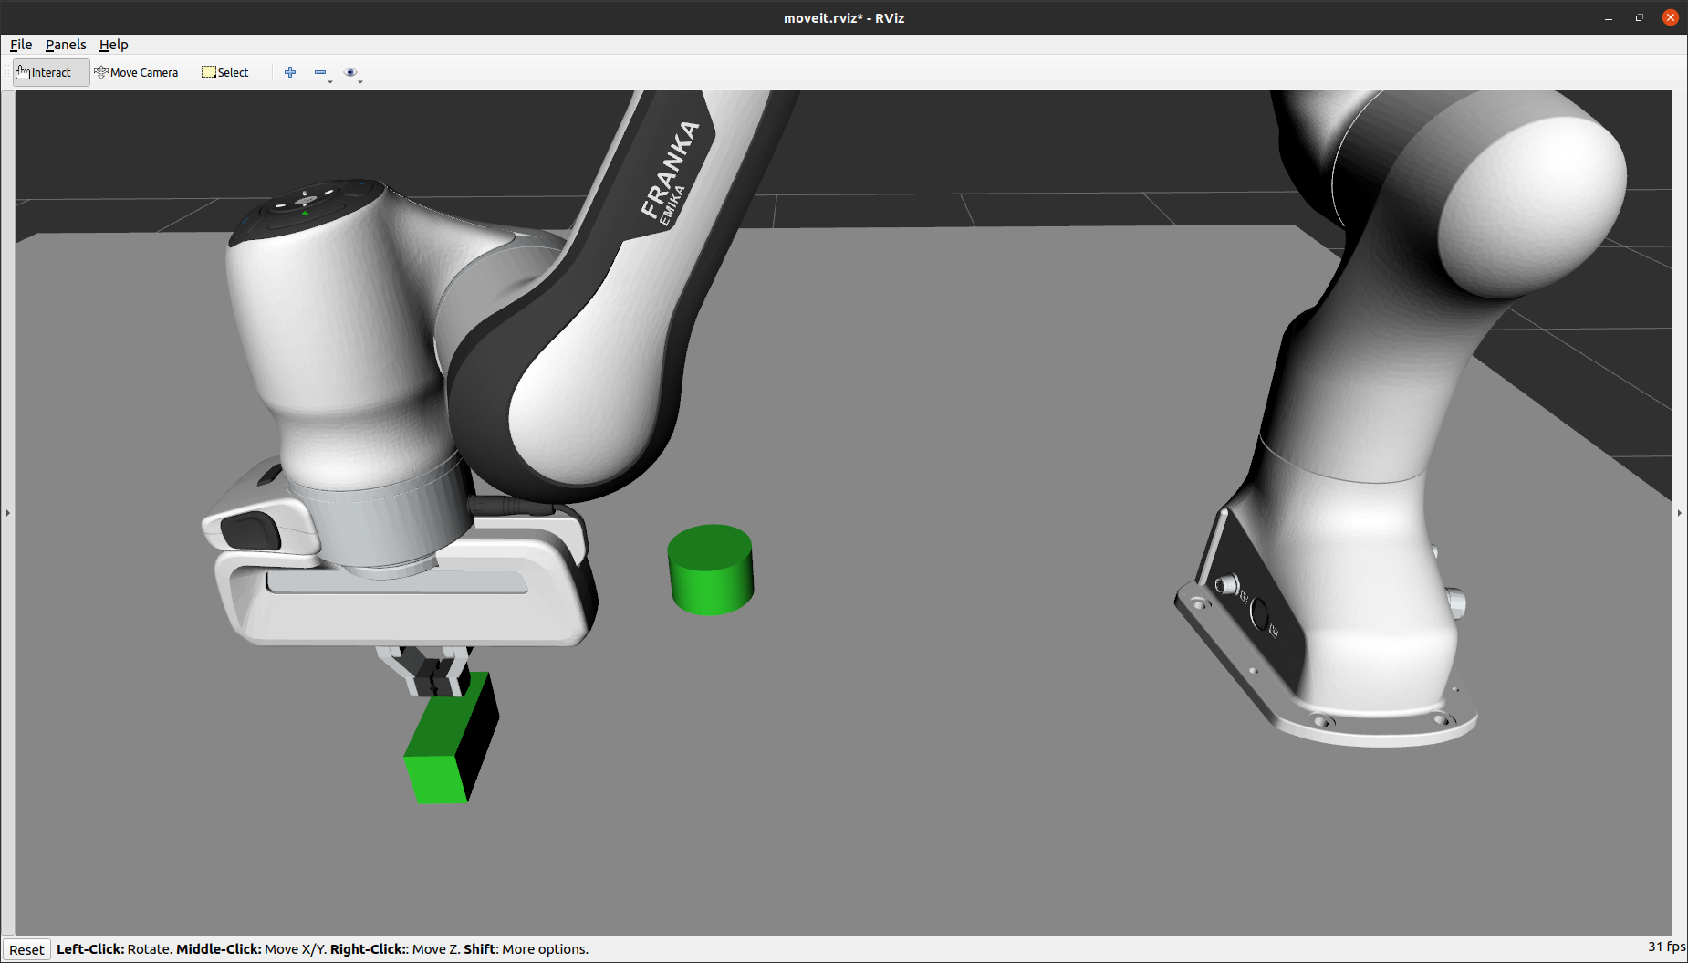

* 1. The object gets *attached* to the arm, and the color of the object gets *changed to show it’s attached* to the arm.

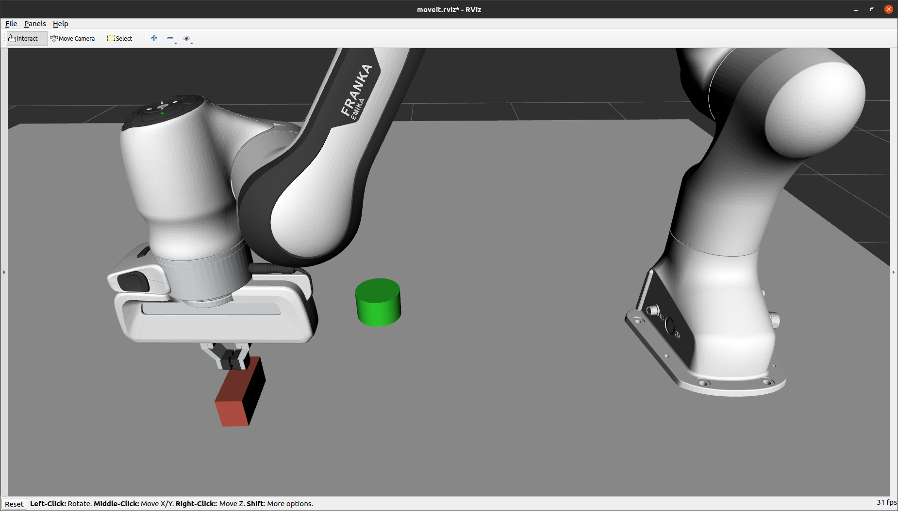

* 1. Arm moves up to *pose over the object* position with the *object attached*.

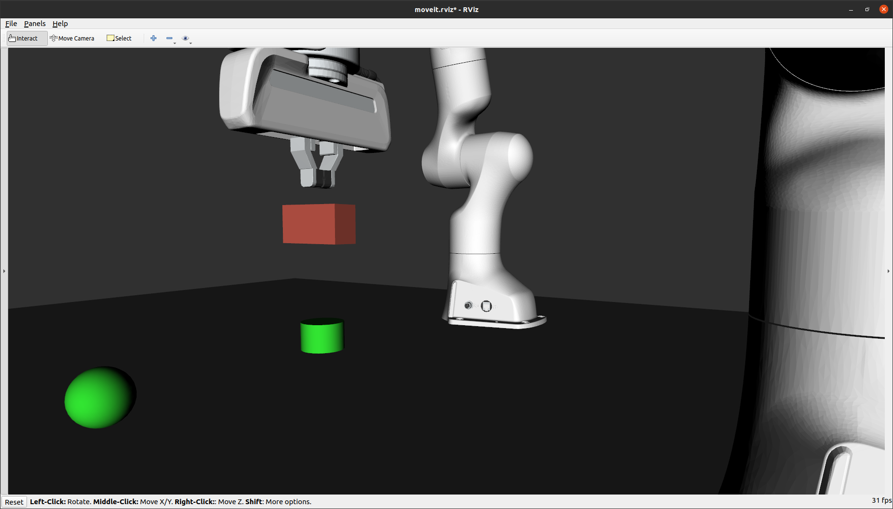

* 1. Arm will move in to *pose over place* position with the object

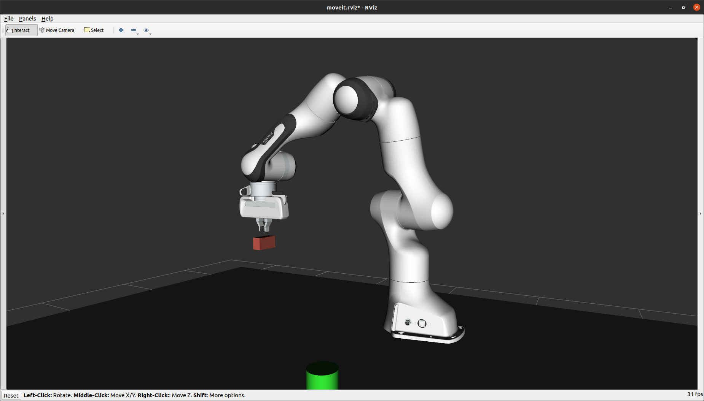

* 1. Arm will go down to *place position* to place the object on the table

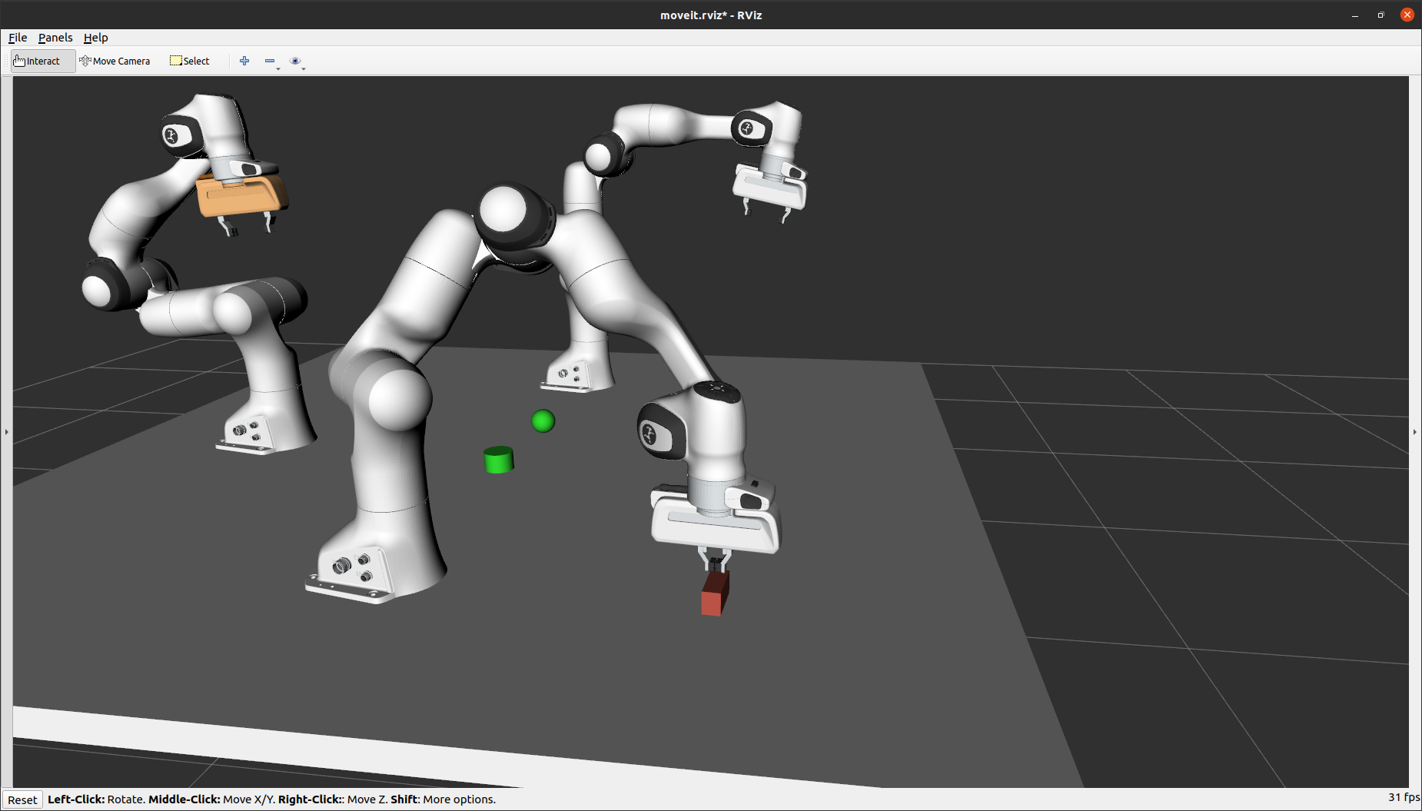

* 1. Gripper will *opens*

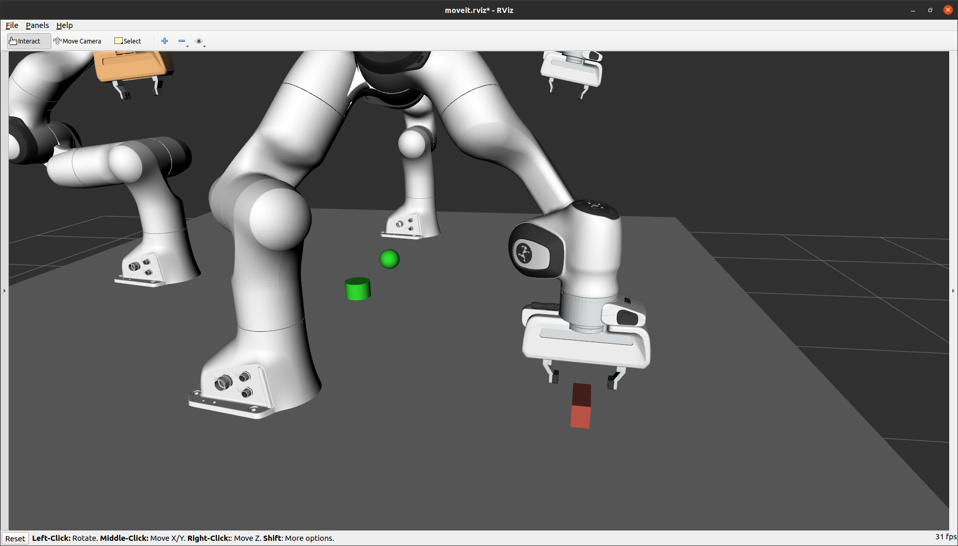

* 1. The object will get *detached* from the arm and *changes the color back to green* to show it has been detached

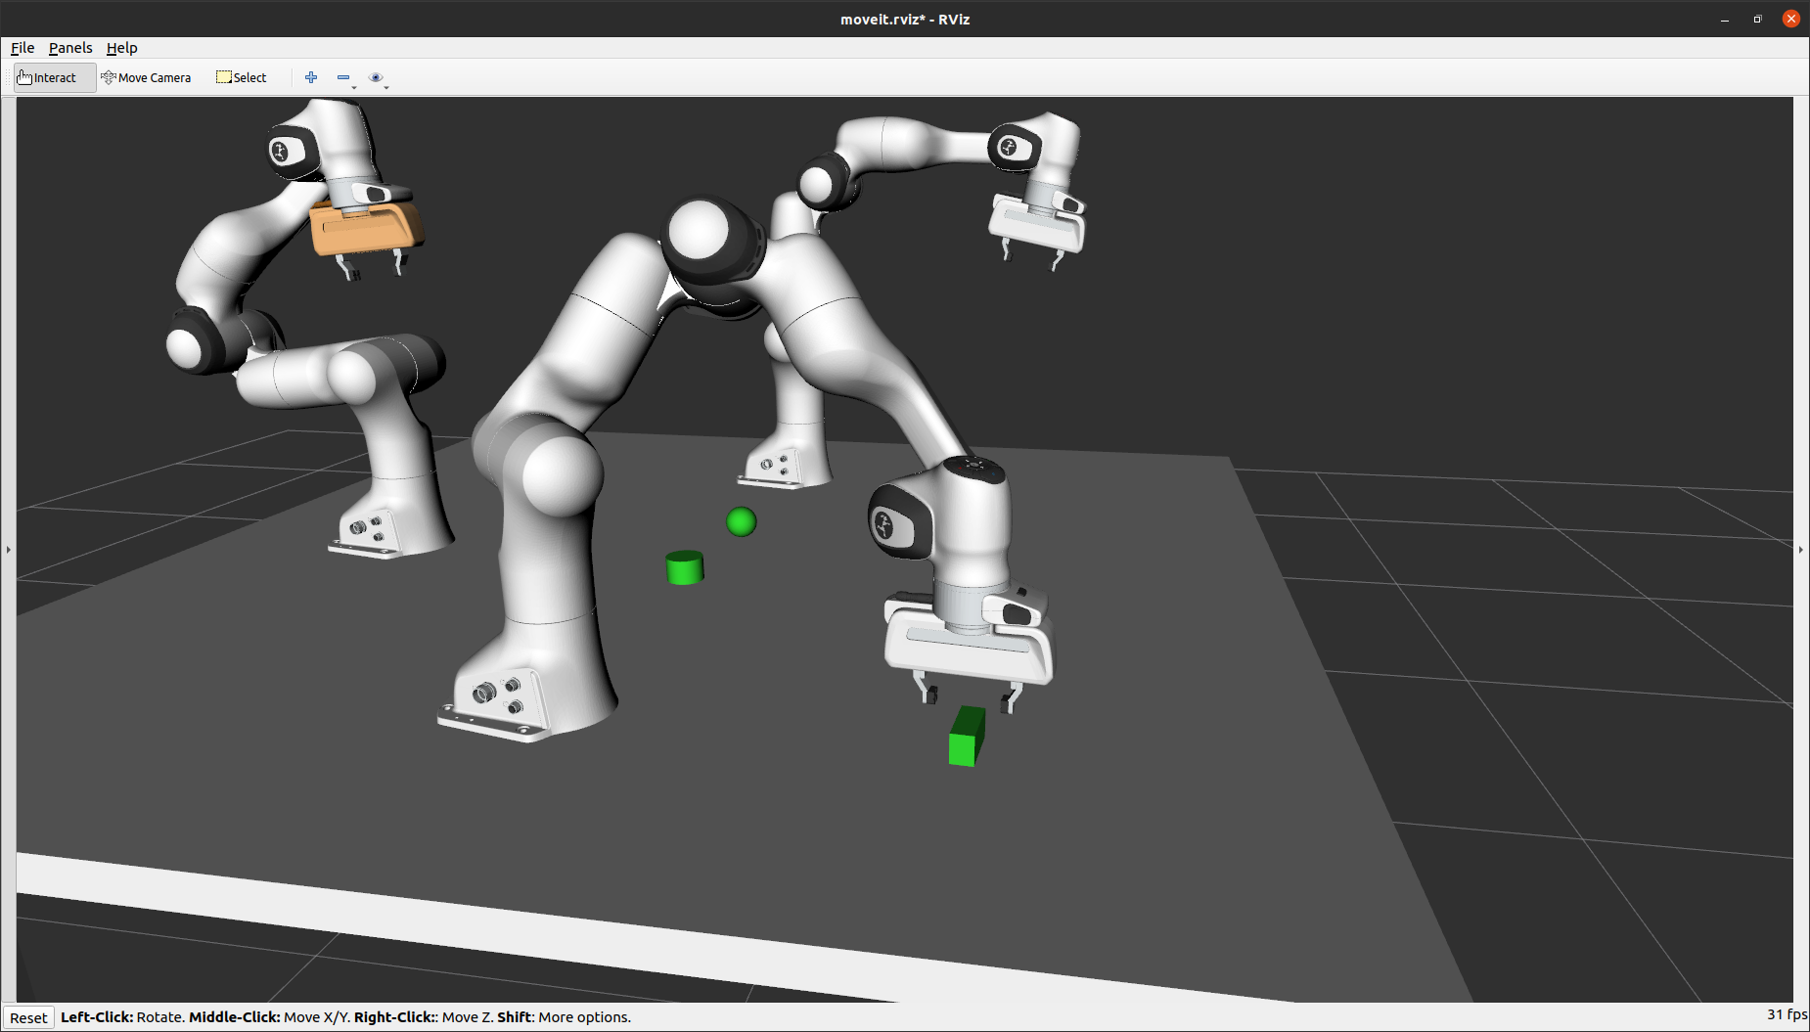

* 1. The arm will move up to *pose over place* position

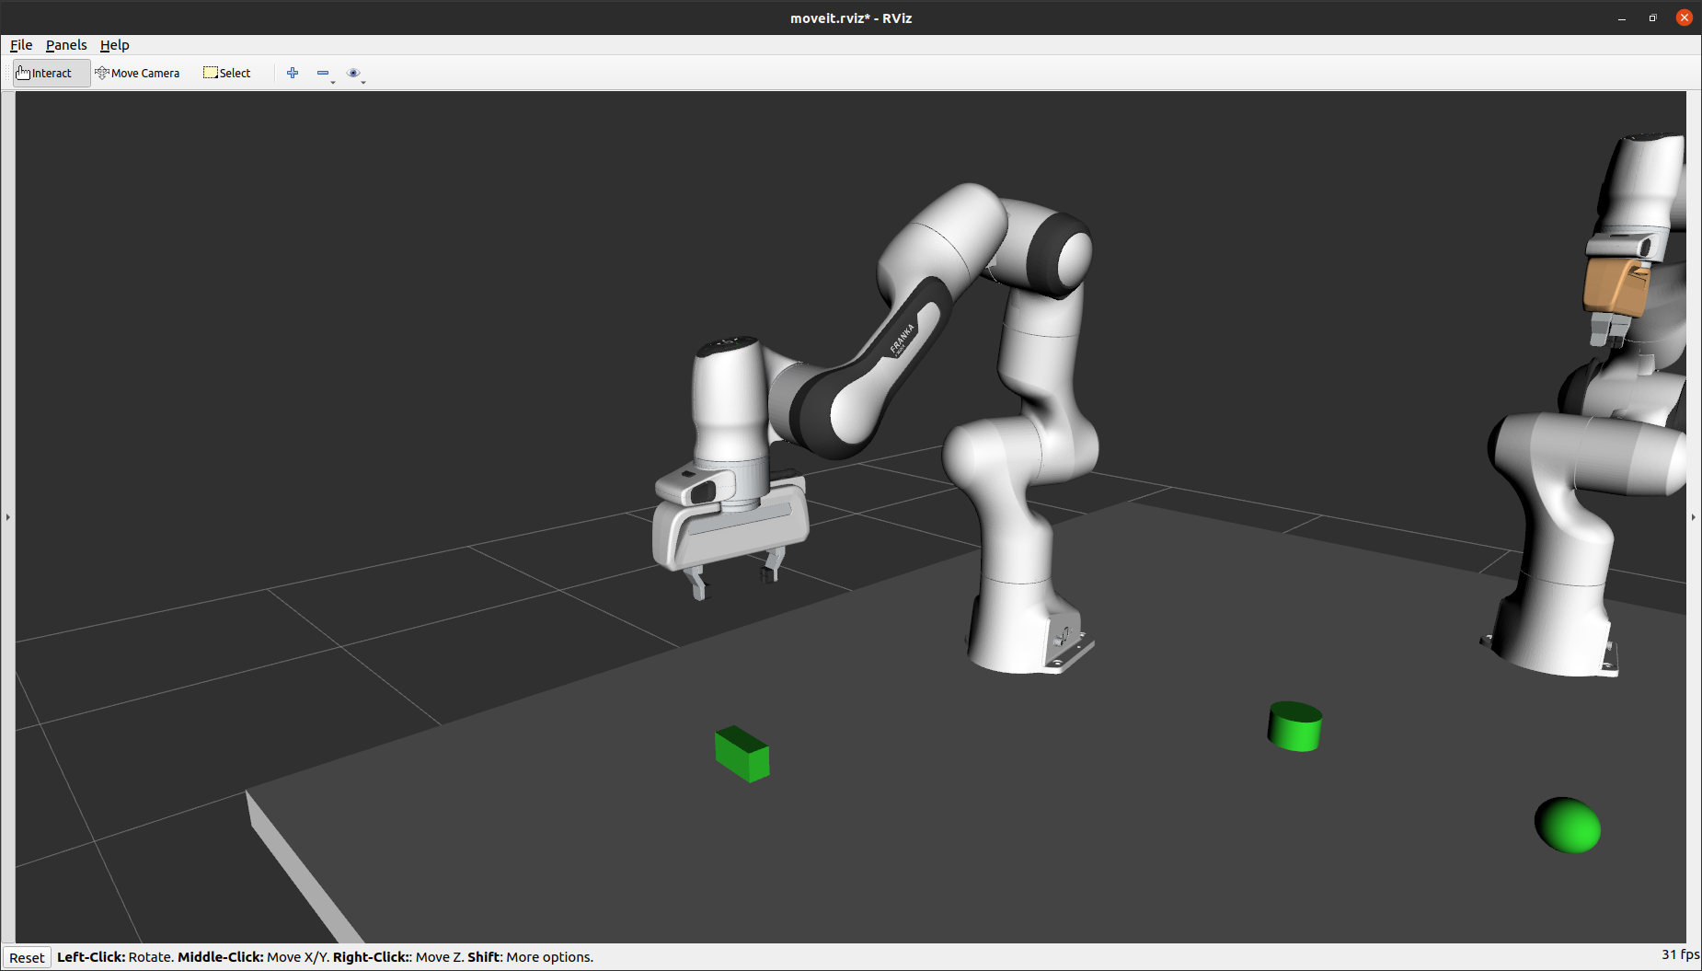

* 1. Arm return back to *“home”* position

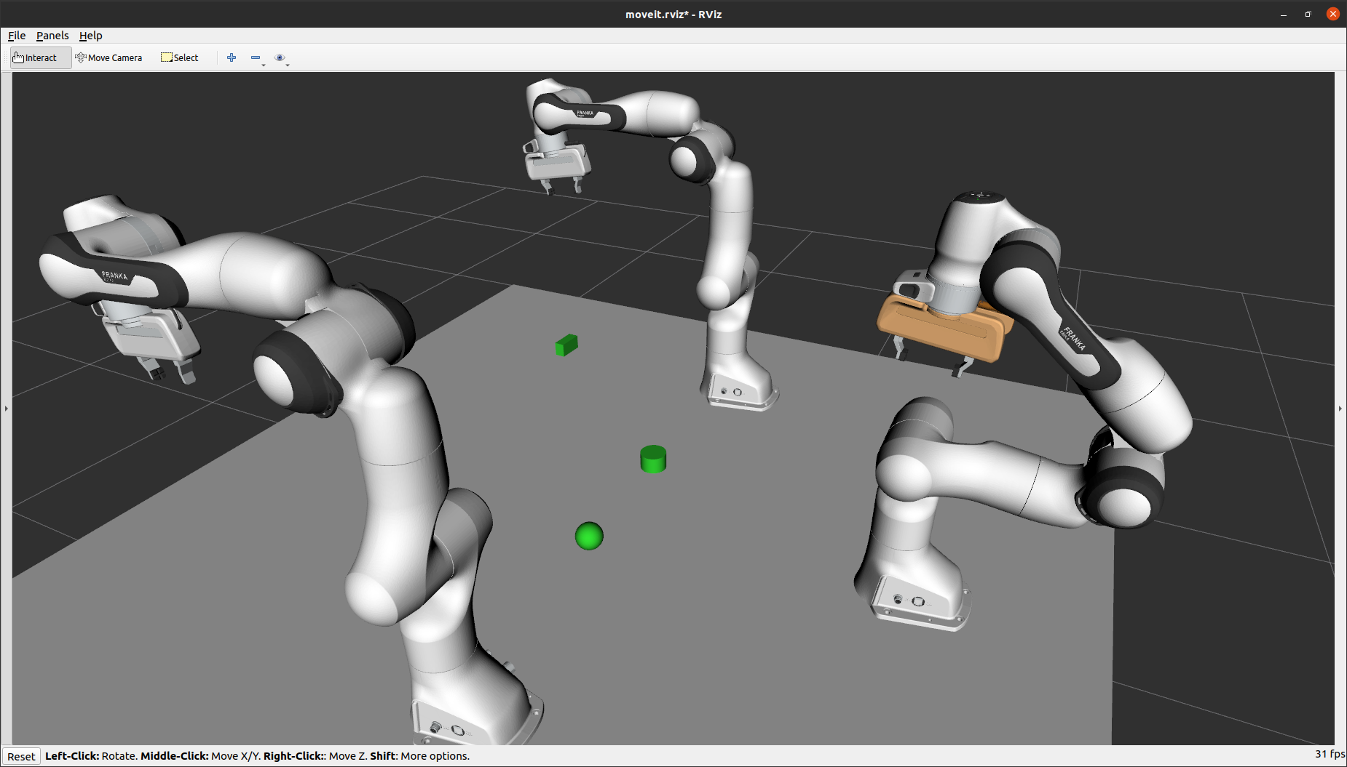

* This summarizes the Pick and Place functionality using Python scripts.
* Now, to close Rviz, select the terminal where we entered the **‘roslaunch’** command and press *“Ctrl + c”*.

# Complete the Collaborative Ring Stack Task

* This task displays the collaboration of three robot arms to complete one stack task in a shared workspace.
* Following three parts need to be completed to see the completed ring stack task using three panda arms.

1. We’ll have to launch three panda arms’ simulation in Rviz.
2. Load collision objects into the workspace using a python script.
3. Stack those objects in an ascending manner with implementation of the “Merge sort” sorting algorithm in a python script.

## Start the Triple-Panda Simulation System

* To start the Rviz simulation with the three Panda arm robots, enter the following command in to the terminal:

roslaunch triple_panda_moveit_config demo.launch

* You should see the following screen after a brief delay: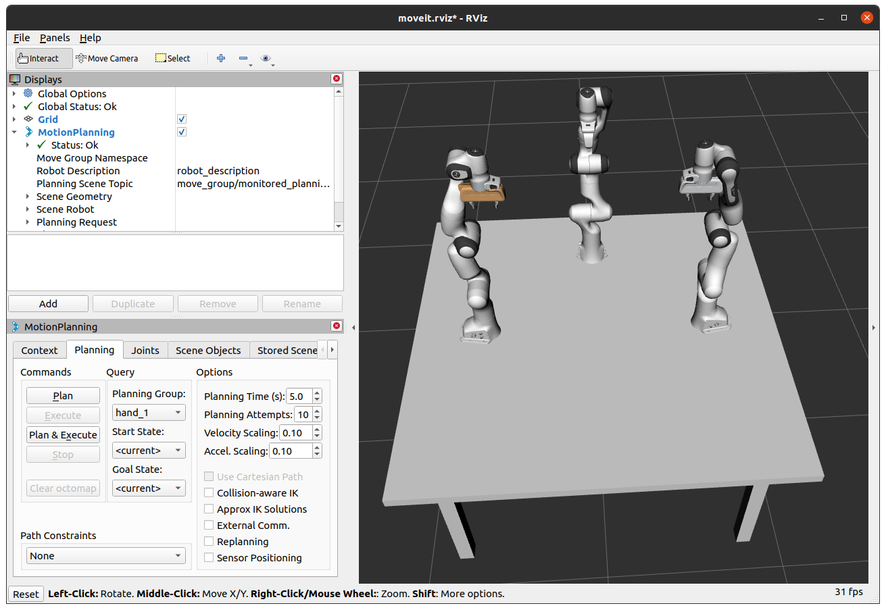

## Load Rings (Collision Objects) into the Workspace

* To Add rings into the workspace, we’ll have to create a python script for it.
* To do so, copy the following code and save it into the *“scripts”* directory inside the *“triple_panda_moveit_config”* ROS package as ***“scene_add_rings.py”***.

#!/usr/bin/env python3

# Python 2/3 compatibility imports

from __future__ import print_function

from six.moves import input

import sys

import csv

import copy

import numpy

import rospy

import tf

import rospkg

import rosparam

import moveit_commander

import moveit_msgs.msg

import geometry_msgs.msg

import numpy as np

from std_msgs.msg import Bool

from moveit_msgs.msg import MoveGroupAction, MoveGroupGoal

from moveit_msgs.msg import Constraints, JointConstraint, PositionConstraint, OrientationConstraint, BoundingVolume

from shape_msgs.msg import SolidPrimitive

from geometry_msgs.msg import Pose, PoseStamped

from moveit_commander import *

from math import pi, dist, fabs, cos

try:

from math import tau

except: # For Python 2 compatibility

from math import pi

tau = 2.0*pi

from std_msgs.msg import String

from moveit_commander.conversions import pose_to_list

## END_SUB_TUTORIAL

def all_close(goal, actual, tolerance):

# """

# Convenience method for testing if the values in two lists are within a tolerance of each other.

# For Pose and PoseStamped inputs, the angle between the two quaternions is compared (the angle

# between the identical orientations q and -q is calculated correctly).

# @param: goal A list of floats, a Pose or a PoseStamped

# @param: actual A list of floats, a Pose or a PoseStamped

# @param: tolerance A float

# @returns: bool

# """

if type(goal) is list:

for index in range(len(goal)):

if abs(actual[index] - goal[index]) > tolerance:

return False

elif type(goal) is geometry_msgs.msg.PoseStamped:

return all_close(goal.pose, actual.pose, tolerance)

elif type(goal) is geometry_msgs.msg.Pose:

x0, y0, z0, qx0, qy0, qz0, qw0 = pose_to_list(actual)

x1, y1, z1, qx1, qy1, qz1, qw1 = pose_to_list(goal)

# Euclidean distance

d = dist((x1, y1, z1), (x0, y0, z0))

# phi = angle between orientations

cos_phi_half = fabs(qx0*qx1 + qy0*qy1 + qz0*qz1 + qw0*qw1)

return d <= tolerance and cos_phi_half >= cos(tolerance / 2.0)

return True

class Panda_arm_scene_MoveGroupPythonInterface(object):

"""MoveGroupPythonIntefaceTutorial"""

def __init__(self):

super(Panda_arm_scene_MoveGroupPythonInterface, self).__init__()

# BEGIN_SUB_TUTORIAL setup

##

# First initialize `moveit_commander`_ and a `rospy`_ node:

# global robot

# global scene

# global p

# global group

moveit_commander.roscpp_initialize(sys.argv)

rospy.init_node('Panda_arm_scene_move_group_python_interface', anonymous=True)

# Instantiate a `RobotCommander`_ object. This object is the outer-level interface to

# the robot:

robot = moveit_commander.RobotCommander()

# Instantiate a `PlanningSceneInterface`_ object. This object is an interface

# to the world surrounding the robot:

scene = moveit_commander.PlanningSceneInterface()

rospy.sleep(1)

# Instantiate a `MoveGroupCommander`_ object. This object is an interface

# to one group of joints. In this case the group is the joints in the Panda

# arm so we set ``group_name = panda_arm``. If you are using a different robot,

# you should change this value to the name of your robot arm planning group.

# This interface can be used to plan and execute motions on the Panda:

# group_name = "panda_arm"

# # group_name = "panda_arm_hand"

# group_name = "panda_arm_hand"

# group = moveit_commander.MoveGroupCommander(group_name)

p = PoseStamped()

p.header.frame_id = robot.get_planning_frame()

# Misc variables

self.box_name = ''

self.robot = robot

self.scene = scene

# self.group = group

self.p = p

self.obj_name = ''

def wait_for_state_update(self, obj_is_known=False, obj_is_attached=False, timeout=1):

#Ensure the collision update are recieved

# This functino is called after adding,

# removing, attaching or detaching an object in the planning scence.

# Wait until the updates have been made or "timeout" seconds have passed.

scene = self.scene

# Record the start time

t_start = rospy.get_time()

t_seconds = rospy.get_time()

# Wait for the state update

while (t_seconds - t_start < timeout) and not rospy.is_shutdown():

# Test if the object is in attached object list

attached_objects = scene.get_attached_objects(

[self.obj_name])

is_attached = len(attached_objects.keys()) > 0

# Test if the attaching box is in the scene

is_known = scene.get_known_object_names()

if (obj_is_attached == is_attached) and (obj_is_known == is_known):

return True

# Sleep so that we give other threads time on the processor

rospy.sleep(0.1)

t_seconds = rospy.get_time()

return False

def main():

try:

rospy.loginfo("***********Start loading scene for panda************")

pandascenego = Panda_arm_scene_MoveGroupPythonInterface()

pandascenego.scene.remove_world_object("ring_1")

pandascenego.scene.remove_world_object("ring_2")

pandascenego.scene.remove_world_object("ring_3")

pandascenego.scene.remove_world_object("ring_4")

pandascenego.scene.remove_world_object("ring_5")

pandascenego.scene.remove_world_object("ring_6")

pandascenego.scene.remove_world_object("ring_7")

pandascenego.scene.remove_world_object("ring_8")

pandascenego.scene.remove_world_object("ring_9")

# adding 9 solid cylinders.

# ring position

pandascenego.p.pose.position.x = -0.25

pandascenego.p.pose.position.y = -0.15

pandascenego.p.pose.position.z = 1.020

# ring size

pandascenego.scene.add_cylinder("ring_1", pandascenego.p, 0.04, 0.037 )

# ring position

pandascenego.p.pose.position.x = -0.25

pandascenego.p.pose.position.y = 0.0

pandascenego.p.pose.position.z = 1.020

# ring size

pandascenego.scene.add_cylinder("ring_2", pandascenego.p, 0.04, 0.034 )

# ring position

pandascenego.p.pose.position.x = -0.25

pandascenego.p.pose.position.y = 0.15

pandascenego.p.pose.position.z = 1.020

# ring size

pandascenego.scene.add_cylinder("ring_3", pandascenego.p, 0.04, 0.031 )

# ring position

pandascenego.p.pose.position.x = -0.05

pandascenego.p.pose.position.y = -0.15

pandascenego.p.pose.position.z = 1.020

# ring size

pandascenego.scene.add_cylinder("ring_4", pandascenego.p, 0.04, 0.028 )

# ring position

pandascenego.p.pose.position.x = -0.05

pandascenego.p.pose.position.y = 0.15

pandascenego.p.pose.position.z = 1.020

# ring size

pandascenego.scene.add_cylinder("ring_5", pandascenego.p, 0.04, 0.025 )

# ring position

pandascenego.p.pose.position.x = 0.15

pandascenego.p.pose.position.y = -0.15

pandascenego.p.pose.position.z = 1.020

# ring size

pandascenego.scene.add_cylinder("ring_6", pandascenego.p, 0.04, 0.022 )

# ring position

pandascenego.p.pose.position.x = 0.15

pandascenego.p.pose.position.y = -0.05

pandascenego.p.pose.position.z = 1.020

# ring size

pandascenego.scene.add_cylinder("ring_7", pandascenego.p, 0.04, 0.019 )

# ring position

pandascenego.p.pose.position.x = 0.15

pandascenego.p.pose.position.y = 0.05

pandascenego.p.pose.position.z = 1.020

# ring size

pandascenego.scene.add_cylinder("ring_8", pandascenego.p, 0.04, 0.016 )

# ring position

pandascenego.p.pose.position.x = 0.15

pandascenego.p.pose.position.y = 0.15

pandascenego.p.pose.position.z = 1.020

# ring size

pandascenego.scene.add_cylinder("ring_9", pandascenego.p, 0.04, 0.013 )

# need to update, or it cannot successfully conduct the scene

pandascenego.wait_for_state_update(obj_is_known=True, timeout=4)

rospy.loginfo("**********Loading done!!!!!!**********")

except rospy.ROSInterruptException:

return

except KeyboardInterrupt:

return

if __name__ == '__main__':

main()

* Now, we’ll need to make the file executable.
* To do so, first navigate to the “triple_panda_moveit_config/scripts” directory by entering following command inside a terminal:

roscd triple_panda_moveit_config/scripts

* You should be able to see the path to *‘scripts’* directory of *“triple_panda_moveit_config”* package as shown in the image below:

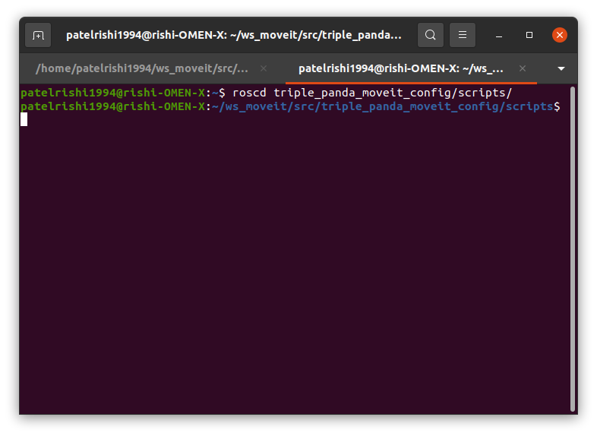

* Then enter the following command to check if the file is executable or not:

ls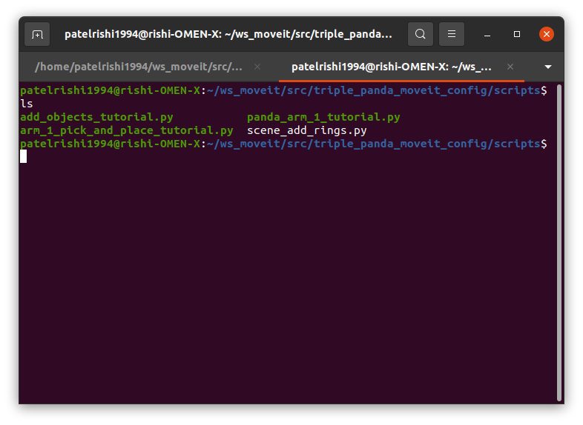

* + If the “scene_add_rings.py” shows written in white as shown in the figure above:
  + Enter the following commands to make the file executable:

chmod +x scene_add_rings.py

ls

* You should see the following screen: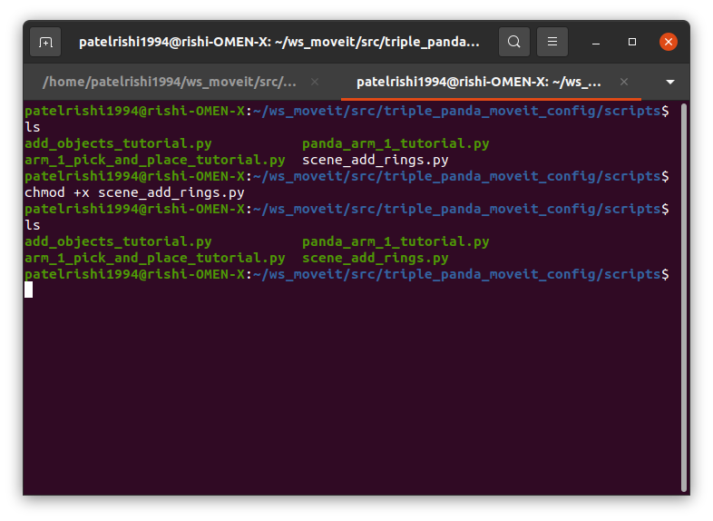
* Now, we are going to run the python script to add rings into the workspace by entering the following command:

rosrun triple_panda_moveit_config scene_add_rings.py

* You should see the nine green solid rings as shown in the image below: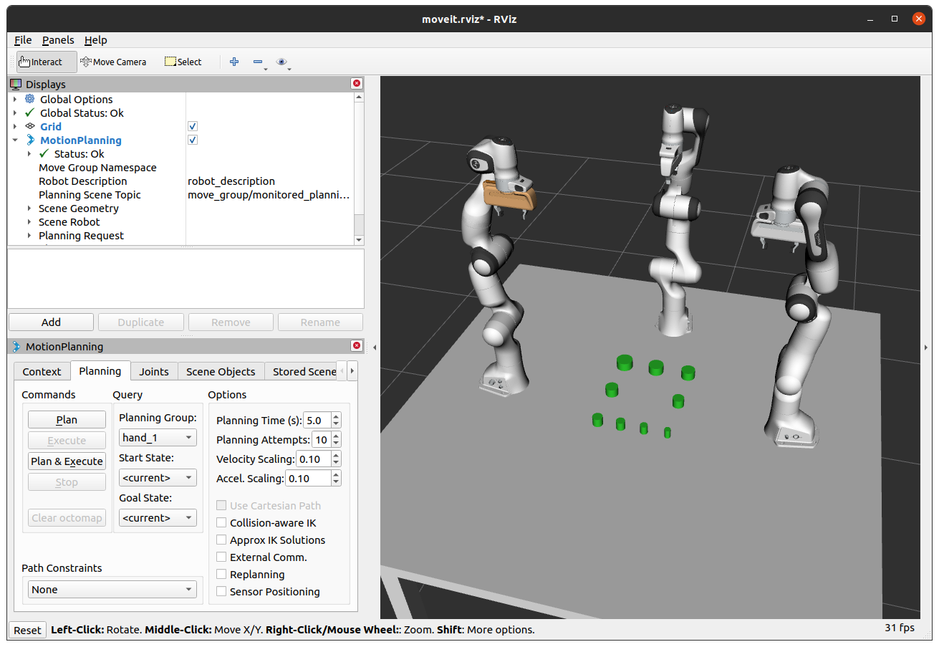

## Run the Merge-Sort approach to complete ring stack task

* We need to create a python script that uses three arms to stack the nine rings.
* We’ll randomly distribute the rings in three equal parts so each arm gets assigned at least three rings to stack.
* Then we’ll use the “Merge Sort” sorting algorithm to sort the three rings assigned to each object so that rings don't get placed out of order.
* To do so, you’ll need to copy the following code in to a text editor and save it as **“merge_sort.py”** inside the *“scripts”* folder of the *“triple_panda_moveit_config”* ROS package:

#!/usr/bin/env python3

from __future__ import print_function

from six.moves import input

import sys

import copy

import rospy

import moveit_commander

import moveit_msgs.msg

import geometry_msgs.msg

import random

try:

from math import pi, tau, dist, fabs, cos

except: # For Python 2 compatibility

from math import pi, fabs, cos, sqrt

tau = 2.0 * pi

def dist(p, q):

return sqrt(sum((p_i - q_i) ** 2.0 for p_i, q_i in zip(p, q)))

from std_msgs.msg import String

from moveit_commander.conversions import pose_to_list

def all_close(goal, actual, tolerance):

if type(goal) is list:

for index in range(len(goal)):

if abs(actual[index] - goal[index]) > tolerance:

return False

elif type(goal) is geometry_msgs.msg.PoseStamped:

return all_close(goal.pose, actual.pose, tolerance)

elif type(goal) is geometry_msgs.msg.Pose:

x0, y0, z0, qx0, qy0, qz0, qw0 = pose_to_list(actual)

x1, y1, z1, qx1, qy1, qz1, qw1 = pose_to_list(goal)

# Euclidean distance

d = dist((x1, y1, z1), (x0, y0, z0))

# phi = angle between orientations

cos_phi_half = fabs(qx0 * qx1 + qy0 * qy1 + qz0 * qz1 + qw0 * qw1)

return d <= tolerance and cos_phi_half >= cos(tolerance / 2.0)

return True

moveit_commander.roscpp_initialize(sys.argv)

rospy.init_node("multiple_move_group_stack_objects_node", anonymous=True)

robot = moveit_commander.RobotCommander()

scene = moveit_commander.PlanningSceneInterface()

def plan_cartesian_path(group, posegoal):

move_group = moveit_commander.MoveGroupCommander(group)

waypoints = []

wpose = move_group.get_current_pose().pose

wpose.position.x = posegoal[0]

wpose.position.y = posegoal[1]

wpose.position.z = posegoal[2]

waypoints.append(copy.deepcopy(wpose))

(plan, fraction) = move_group.compute_cartesian_path(

waypoints, 0.01, 0.0 # waypoints to follow # eef_step

) # jump_threshold

return plan, fraction

def execute_plan(group, plan):

move_group = moveit_commander.MoveGroupCommander(group)

move_group.execute(plan, wait=True)

def wait_for_state_update(

box_is_known=False, box_is_attached=False, timeout = 4,ring = "ring_1"

):

start = rospy.get_time()

seconds = rospy.get_time()

box_name = ring

while (seconds - start < timeout) and not rospy.is_shutdown():

# Test if the box is in attached objects

attached_objects = scene.get_attached_objects([box_name])

is_attached = len(attached_objects.keys()) > 0

# Test if the box is in the scene.

# Note that attaching the box will remove it from known_objects

is_known = box_name in scene.get_known_object_names()

# Test if we are in the expected state

if (box_is_attached == is_attached) and (box_is_known == is_known):

return True

# Sleep so that we give other threads time on the processor

rospy.sleep(0.1)

seconds = rospy.get_time()

# If we exited the while loop without returning then we timed out

return False

## END_SUB_TUTORIAL

def attach_box(arm,grasping_hand, ring):

timeout=4

# To assign move group (hand)

move_group = moveit_commander.MoveGroupCommander(arm)

# To get end effector panda_1_link8/ panda_2_link8/ panda_3_link8

eef_link = move_group.get_end_effector_link()

# To assign hand for the particular arm

grasping_group = grasping_hand # hand_1/hand_2/hand_3

box_name = ring

touch_links = robot.get_link_names(group=grasping_group)

scene.attach_box(eef_link, box_name, touch_links = touch_links)

return wait_for_state_update(box_is_attached=True, box_is_known=False, timeout=timeout,ring = ring)

def detach_box(arm,grasping_hand, ring):

timeout=4

# To assign move group (hand)

move_group = moveit_commander.MoveGroupCommander(arm)

# To get end effector panda_1_link8/ panda_2_link8/ panda_3_link8

eef_link = move_group.get_end_effector_link()

# To assign hand for the particular arm

grasping_group = grasping_hand # hand_1/hand_2/hand_3

box_name = ring

scene.remove_attached_object(eef_link, name=box_name)

return wait_for_state_update(box_is_known=True, box_is_attached=False, timeout=timeout,ring = ring)

def go_to_hand_pose_goal(hand,hand_joint_goal):

group_hand_name = hand

group_hand = moveit_commander.MoveGroupCommander(group_hand_name)

group_hand.go(hand_joint_goal, wait=True)

group_hand.stop()

hand_current_joints = group_hand.get_current_joint_values()

return all_close(hand_joint_goal, hand_current_joints, 0.01)

# To plan and execute cartesian motion

def goal(group, posegoal):

cartesian_plan, fraction = plan_cartesian_path(group, posegoal)

execute_plan(group,cartesian_plan)

# Arm positions(x,y,z) to place arms in.....

# Pose over rings, Pose to pick, Pose to place.

ring_1_pose=[[-0.250000, -0.150000, 1.450000], [-0.250000, -0.150000, 1.161000], [-0.050000, 0.000000, 1.161000]]

ring_2_pose=[[-0.250000, 0.000000, 1.450000], [-0.250000, 0.000000, 1.161000], [-0.050000, 0.000000, 1.201000]]

ring_3_pose=[[-0.250000, 0.150000, 1.450000], [-0.250000, 0.150000, 1.161000], [-0.050000, 0.000000, 1.241186]]

ring_4_pose=[[-0.050000, -0.150000, 1.450000], [-0.050000, -0.150000, 1.161000], [-0.050000, 0.000000, 1.281421]]

ring_5_pose=[[-0.050000, 0.150000, 1.450000], [-0.050000, 0.150000, 1.161000], [-0.050000, 0.000000, 1.321670]]

ring_6_pose=[[0.150000, -0.150000, 1.450000], [0.150000, -0.150000, 1.161000], [-0.050000, 0.000000, 1.361863]]

ring_7_pose=[[0.150000, -0.050000, 1.450000], [0.150000, -0.050000, 1.161000], [-0.050000, 0.000000, 1.402115]]

ring_8_pose=[[0.150000, 0.050000, 1.450000], [0.150000, 0.050000, 1.161000], [-0.050000, 0.000000, 1.442280]]

ring_9_pose=[[0.150000, 0.150000, 1.450000], [0.150000, 0.150000, 1.161000], [-0.050000, 0.000000, 1.482462]]

# Pose of arm over place position

pose_over_place = [-0.050000, 0.000000, 1.600000]

# List of arm poses to move around with rings

poses = [ring_1_pose, ring_2_pose, ring_3_pose, ring_4_pose, ring_5_pose, ring_6_pose, ring_7_pose, ring_8_pose, ring_9_pose]

# Home poses for arms to rest

home_arm1 = [0, -0.45, 1.6]

home_arm2 = [0, 0.45, 1.6]

home_arm3 = [-0.5, 0, 1.6]

# Arm hand poses to open and close gripper

hand_close = [0.002, 0.002]

hand_open = [0.04, 0.04]

# Lists of objects names

rings = ["ring_1", "ring_2", "ring_3", "ring_4", "ring_5", "ring_6", "ring_7", "ring_8", "ring_9"]

# To pick and place using arm_1, arm_2 and arm_3

def arm_pick_and_place_ring(arm, ring, hand, ring_pose):

# To open the gripper

go_to_hand_pose_goal(hand, hand_open)

# To move arm over the ring

goal(arm, ring_pose[0])

# To move arm near object to pick

goal(arm, ring_pose[1])

# To close the gripper

go_to_hand_pose_goal(hand, hand_close)

# To attach object

attach_box(arm, hand, ring)

# To move arm over the ring

goal(arm, ring_pose[0])

# To move arm over place position

goal(arm, pose_over_place)

# To move arm to place position to place object

goal(arm, ring_pose[2])

# To open hand

go_to_hand_pose_goal(hand, hand_open)

# To detach object

detach_box(arm, hand, ring)

# To retract arm in z position back to "over place" position

goal(arm, pose_over_place)

# Merge sort algorithm to sort the object's array and assigned objects' array to each arms.

def merge(arr, l, m, r):

n1 = m - l + 1

n2 = r - m

# arrays to split given array into two parts

left = [0] * n1

right = [0] * n2

# Copy data to temp arrays left[] and right[]

for i in range(0, n1):

left[i] = arr[l + i]

for j in range(0, n2):

right[j] = arr[m + 1 + j]

# Merge the temp arrays back into arr[l..r]

i = 0 # Initial index of first subarray

j = 0 # Initial index of second subarray

k = l # Initial index of merged subarray

# Sort and merge the arrays

while i < n1 and j < n2:

if left[i] <= right[j]:

arr[k] = left[i]

i += 1

else:

arr[k] = right[j]

j += 1

k += 1

# Copy the remaining elements of left[]

while i < n1:

arr[k] = left[i]

i += 1

k += 1

# Copy the remaining elements of right[]

while j < n2:

arr[k] = right[j]

j += 1

k += 1

# l is for left index and r is right index of the sub-array of arr to be sorted

def mergeSort(arr, l, r):

if l < r:

# Same as (l+r)//2, but avoids overflow for

# large l and h

m = l+(r-l)//2

# Sort first and second halves

mergeSort(arr, l, m)

mergeSort(arr, m+1, r)

merge(arr, l, m, r)

# A variable to keep count of objects

count = 0

# A variable to iterate over each arm's assigned objects list

l = 0 # Initial index of arm_1_objects

r = 0 # Initial index of arm_2_objects

m = 0 # Initial index of arm_3_objects

# Method to stack objects in the center of the table

def stack_rings():

global count, l, r, m

# Check if arm 1 is to be moved and if it has not yet moved for three arms.

if l < 3 and arm_1_objects[l] == rings[count]:

rospy.loginfo(f"\n\nMoveing Panda_Arm_1 to pick and place object: {arm_1_objects[l]}\n")

# Pick and place object using panda_arm_1 and hand_1

arm_pick_and_place_ring("panda_arm_1", rings[count], "hand_1", poses[count])

# To put arm_1 in rest position

goal("panda_arm_1", home_arm1)

# To increase count and l by 1 to track number of objects

count = count + 1

l = l + 1

if r < 3 and arm_2_objects[r] == rings[count]:

rospy.loginfo(f"\n\nMoveing Panda_Arm_2 to pick and place object: {arm_2_objects[r]}\n")

# Pick and place object using panda_arm_2 and hand_2

arm_pick_and_place_ring("panda_arm_2", rings[count], "hand_2", poses[count])

# To put arm_2 in rest position

goal("panda_arm_2", home_arm2)

# To increase count and r by 1 to track number of objects

count = count + 1

r = r + 1

if m < 3 and arm_3_objects[m] == rings[count]:

rospy.loginfo(f"\n\nMoveing Panda_Arm_3 to pick and place object: {arm_3_objects[m]}\n")

# Pick and place object using panda_arm_3 and hand_3

arm_pick_and_place_ring("panda_arm_3", rings[count], "hand_3", poses[count])

# To put arm_3 in rest position

goal("panda_arm_3", home_arm3)

# To increase count and m by 1 to track number of objects and assigned objects.

count = count + 1

m = m + 1

if count == 9:

rospy.loginfo("========== Object Stacking Demo Complete ==========")

rospy.signal_shutdown("Stacking Complete")

# To shuffle list

random.shuffle(rings)

print(f"\n\nShuffled array is {rings}\n")

# To assign three objects to each arm

arm_1_objects = [rings[0], rings[1], rings[2]]

arm_2_objects = [rings[3], rings[4], rings[5]]

arm_3_objects = [rings[6], rings[7], rings[8]]

# Length of the given array

n = len(rings)

# Printing given array

print(f"Assigned objects to arm_1 are {arm_1_objects}\nAssigned objects to arm_2 are {arm_2_objects}\nAssigned objects to arm_3 are {arm_3_objects} ")

# Running Merge sort on the given arrays to sort them.

mergeSort(rings, 0, n-1)

mergeSort(arm_1_objects, 0, 2)

mergeSort(arm_2_objects, 0, 2)

mergeSort(arm_3_objects, 0, 2)

# Printing the sorted array

print(f"\n\nSorted array is {rings}\n")

print(f"Sorted objects of arm_1 are {arm_1_objects}\nSorted objects of arm_2 are {arm_2_objects}\nSorted objects of arm_3 are {arm_3_objects}\n\n")

while not rospy.is_shutdown():

# input("=========== Press 'Enter' to start stacking rings ===========")

stack_rings()

print("-------")

rospy.sleep(0.1)

* Now, run the following commands in the terminal to navigate to the *“triple_panda_moveit_config/scripts”* directory and make the **“merge_sort.py”** executable:

cd triple_panda_moveit_config/scripts

ls

chmod +x merge_sort.py

ls

* You should see the following screen: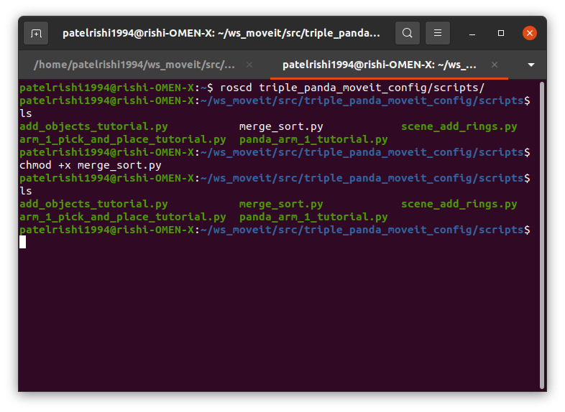
* Once we have confirmed that the file is executable, we are now ready to run the *“merge_sort.py”* python script, to run it enter following command in to the terminal:

rosrun triple_panda_moveit_config merge_sort.py

* You should see the following information printed in the terminal: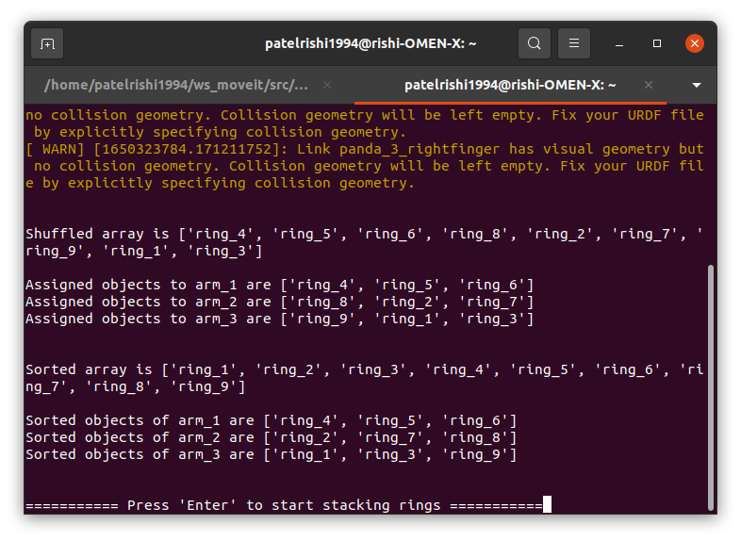
* **Note:** The list of object is shuffled, and the generated list has been printed first:

Shuffled array is ['ring_4', 'ring_5', 'ring_6', 'ring_8', 'ring_2', 'ring_7', 'ring_9', 'ring_1', 'ring_3']

* Then, the shuffled list has been split into three equal parts and assigned to each arm:

Assigned objects to arm_1 are ['ring_4', 'ring_5', 'ring_6']

Assigned objects to arm_2 are ['ring_8', 'ring_2', 'ring_7']

Assigned objects to arm_3 are ['ring_9', 'ring_1', 'ring_3']

* Then using the “Merge Sort” sorting algorithm, all the arrays are sorted from left to right:

Sorted array is ['ring_1', 'ring_2', 'ring_3', 'ring_4', 'ring_5', 'ring_6', 'ring_7', 'ring_8', 'ring_9']

Sorted objects of arm_1 are ['ring_4', 'ring_5', 'ring_6']

Sorted objects of arm_2 are ['ring_2', 'ring_7', 'ring_8']

Sorted objects of arm_3 are ['ring_1', 'ring_3', 'ring_9']

Once you hit “Enter” you should see following sequences to stack objects in Rviz:

* First **arm 3** moves to pick and place **“ring_1”**
  + Panda arm 3 moves to position itself above “ring_1”:

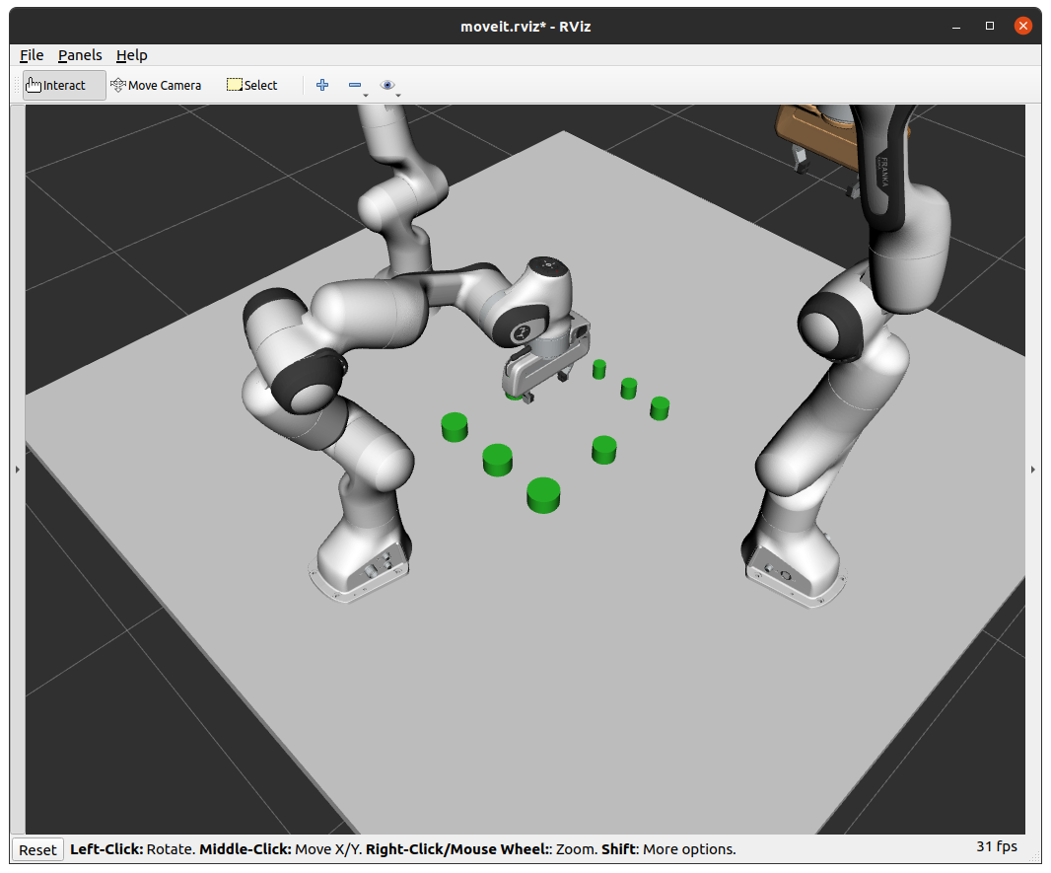

* + Arm 3 moves closer to the “ring_1” and close the gripper:

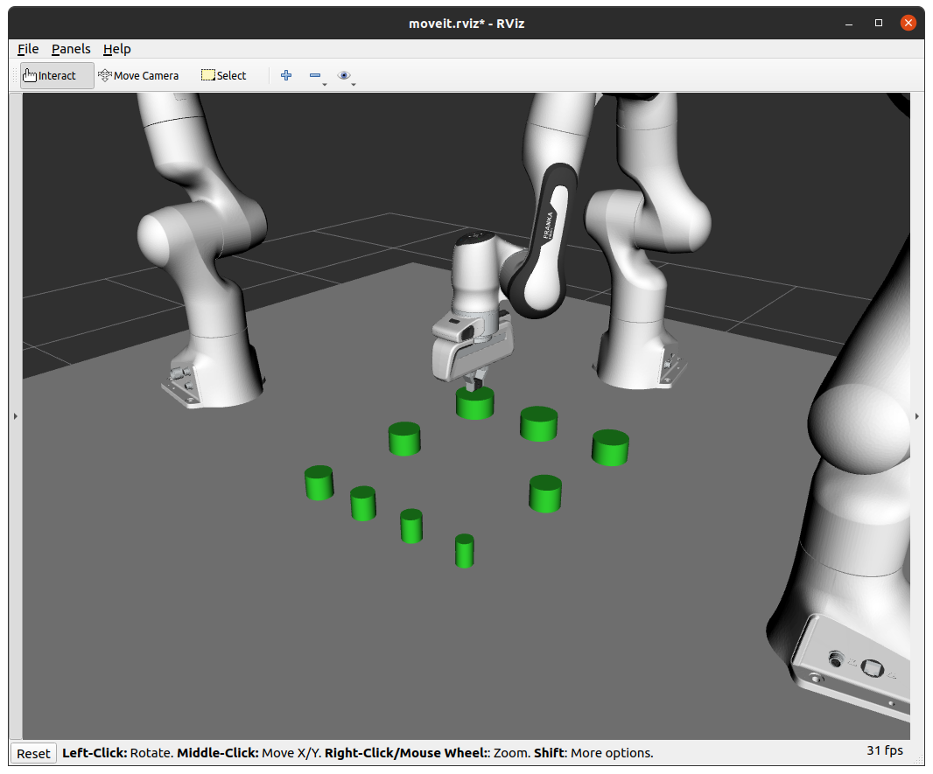

* + “Ring_1” gets attached to arm 3 and changes it’s color:

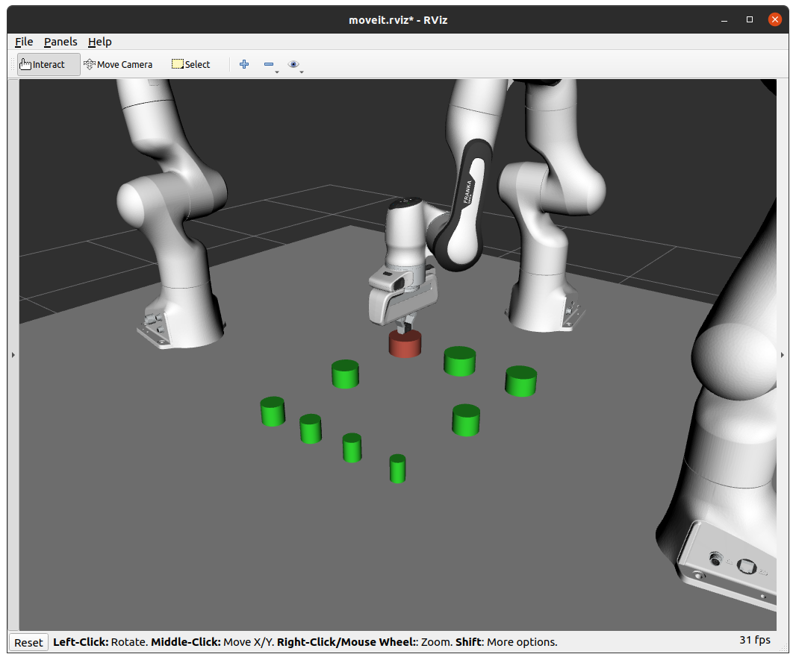

* + Arm 3 picks up ring_1 from the table:

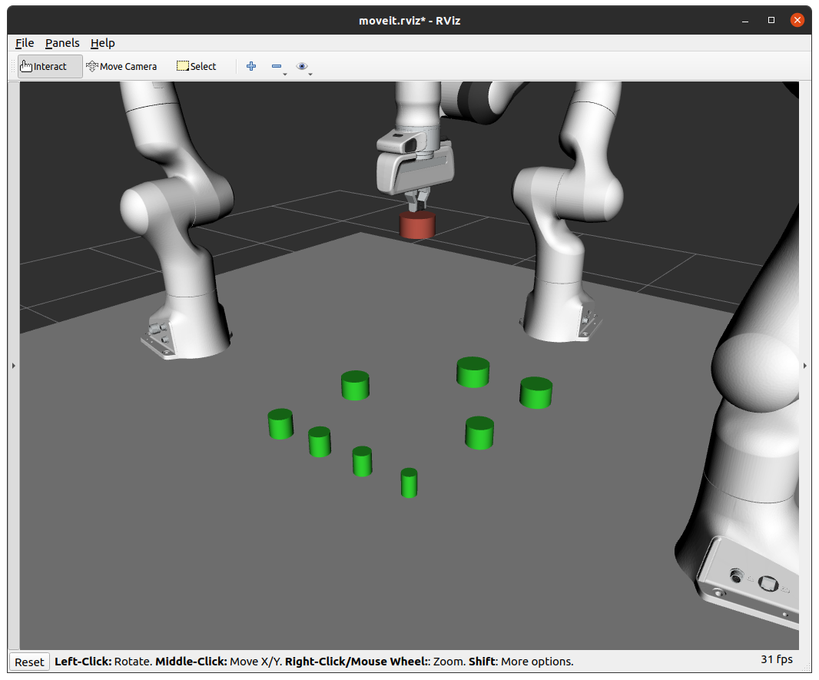

* + Arm 3 moves to position itself over the place position:

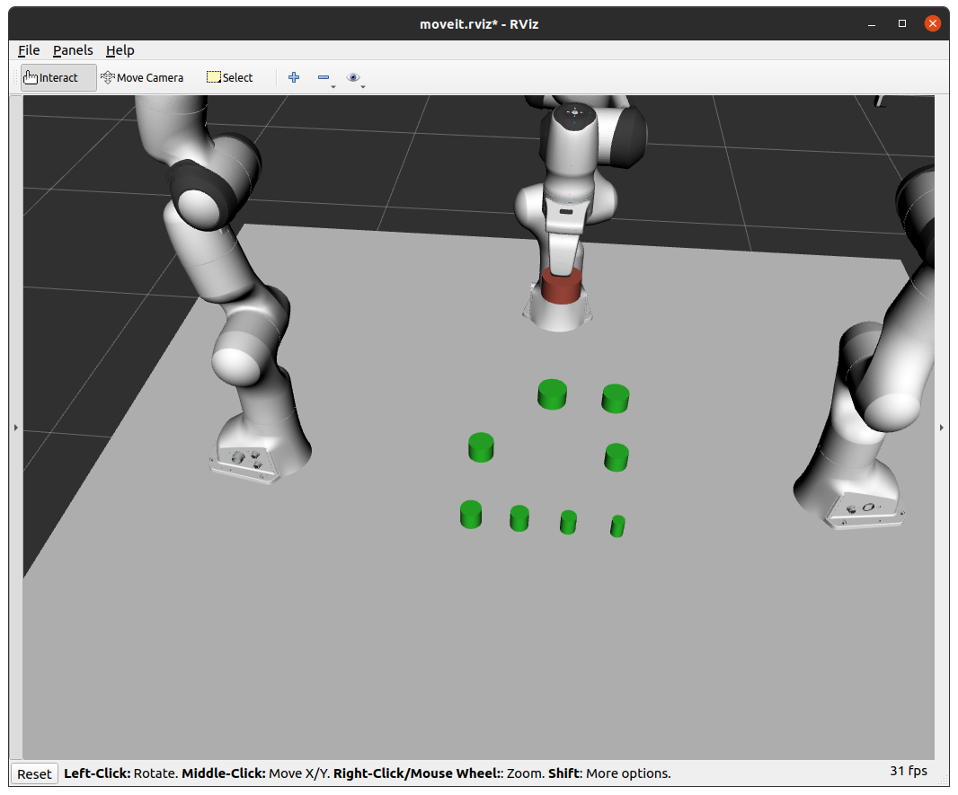

* + Arm 3 moves down to place the “ring_1” on the table:

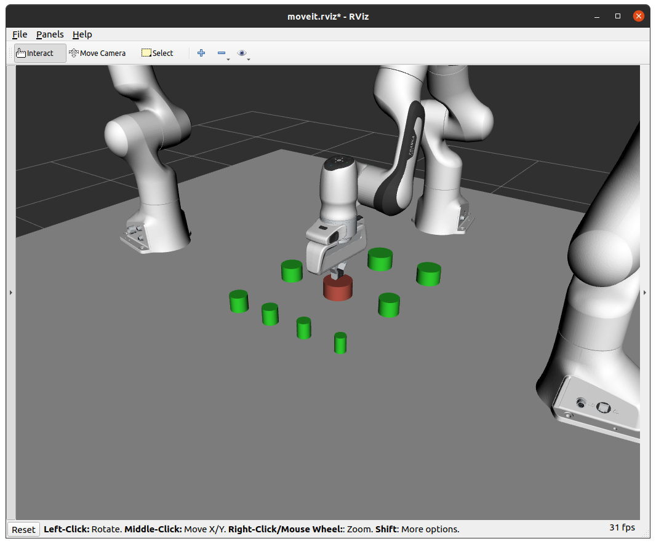

* + Arm 3 opens the gripper:

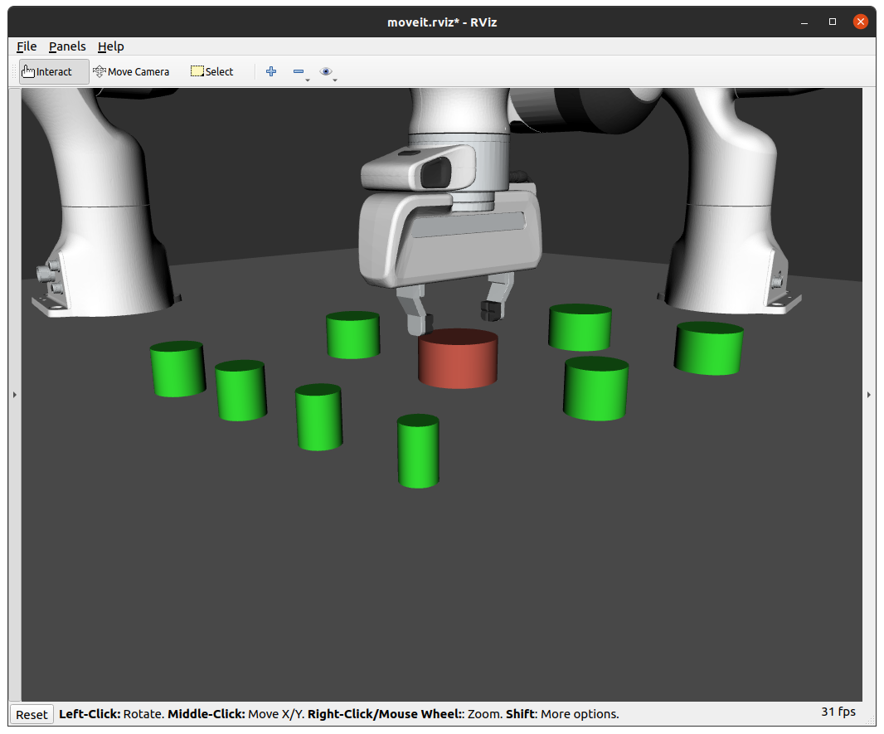

* + “Ring_1” gets detached from the arm 3 and changes the color back to green:

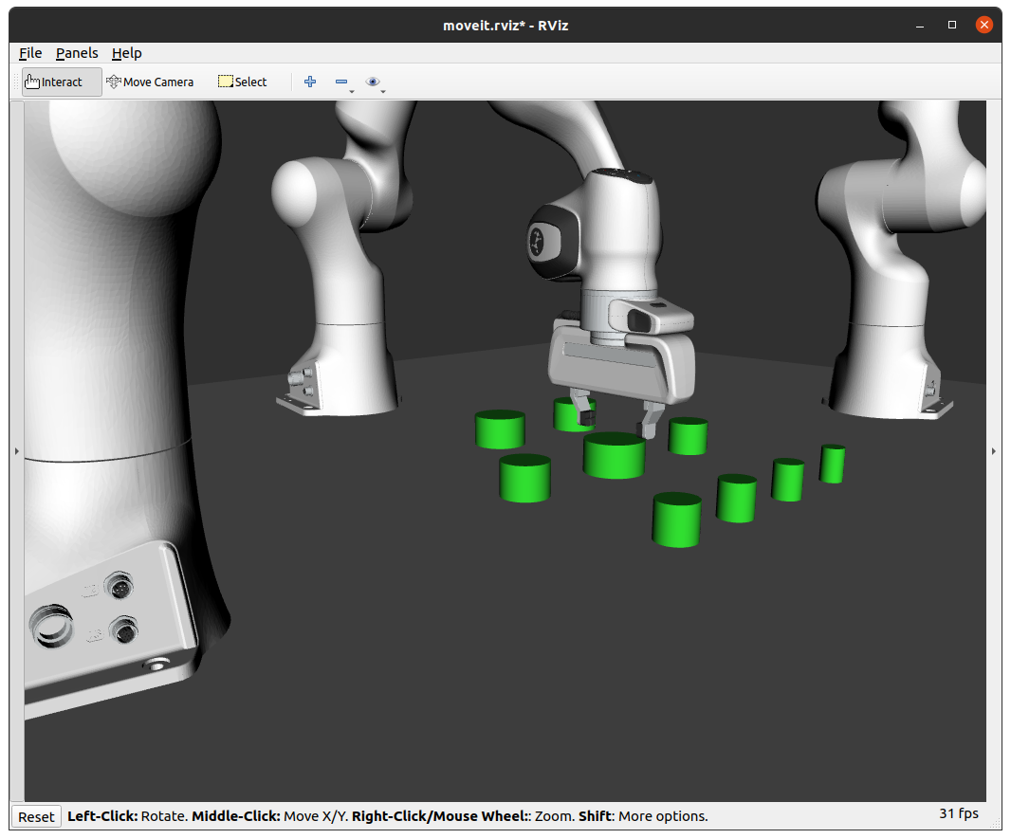

* + Arm 3 moves up and away from the “ring_1” into rest position the way it does not interfere in other arms’ activity:

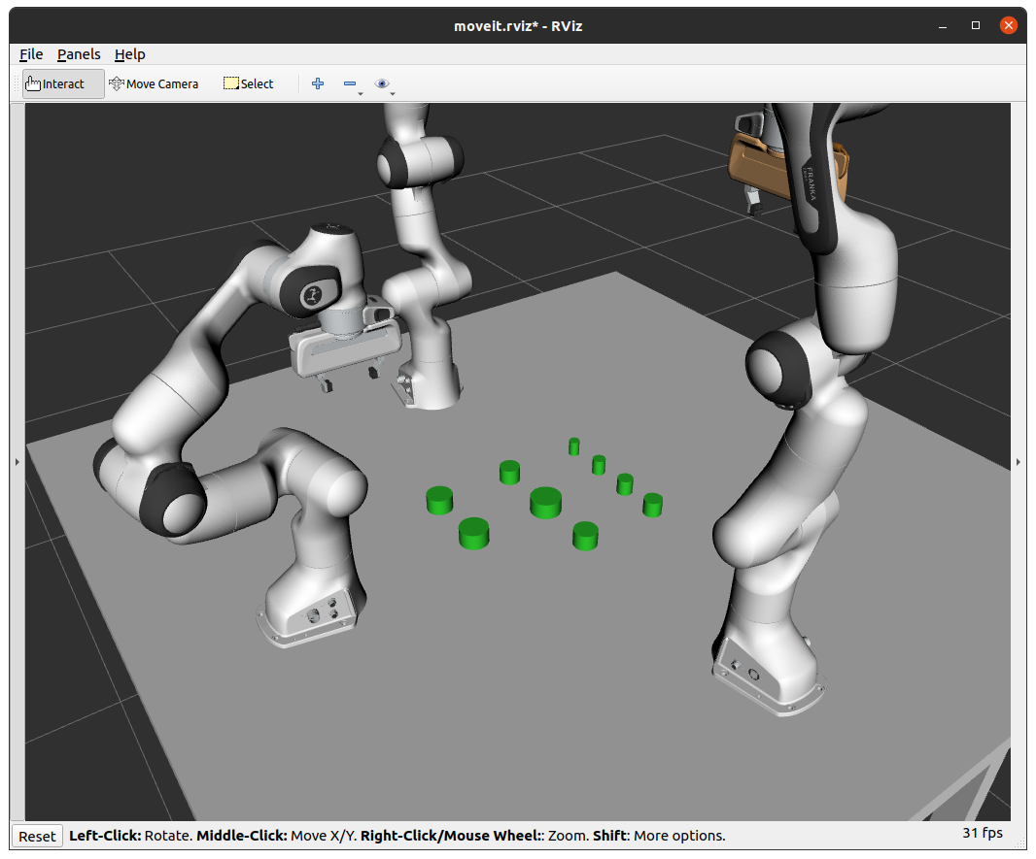

* Next, **arm 2** moves to pick and place **“ring_2”** on top of ring_1
  + Panda arm 2 moves to position itself above “ring_2”:

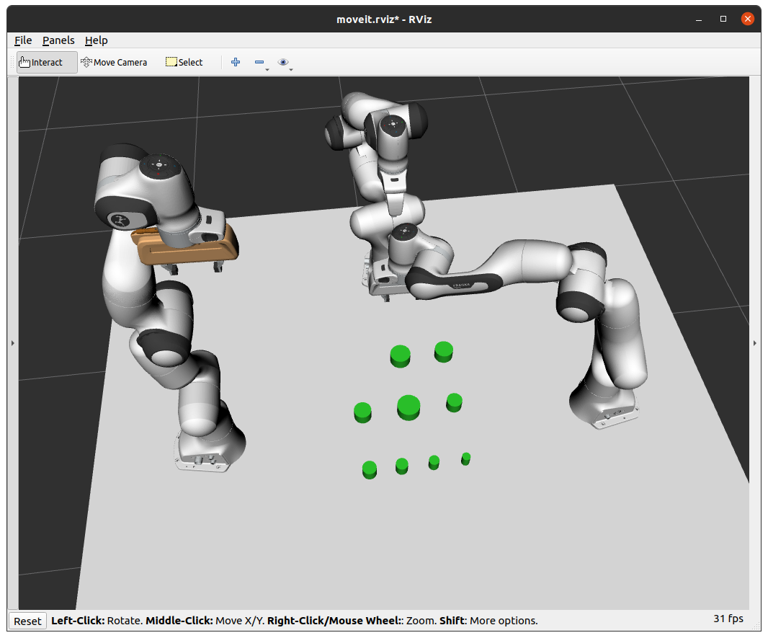

* + Arm 2 moves closer to the “ring_2” and close the gripper:

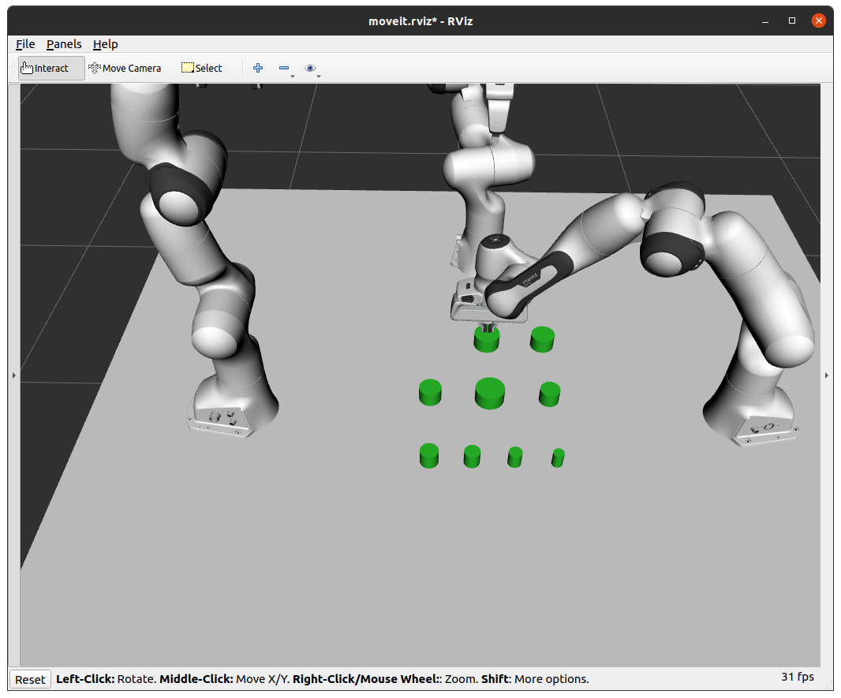

* + “Ring_2” gets attached to arm 2 and changes it’s color:

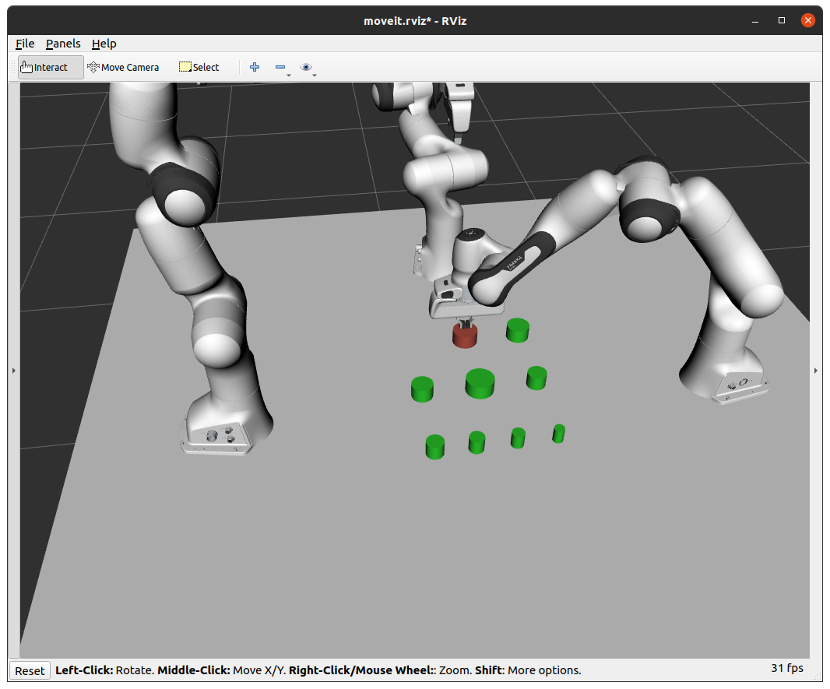

* + Arm 2 picks up ring_2 from the table:

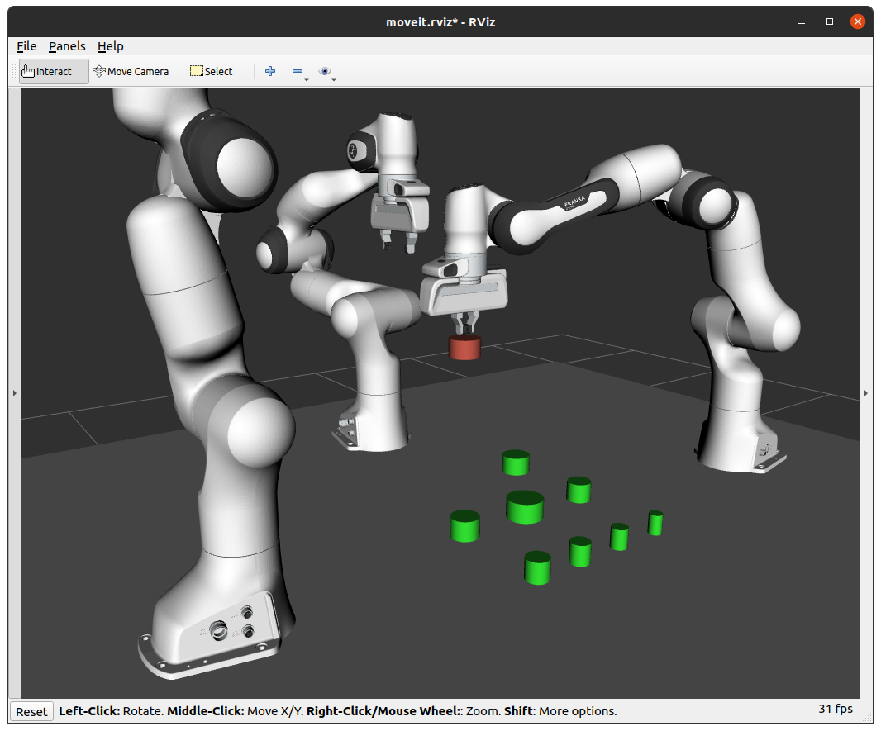

* + Arm 2 moves to position itself over the place position:

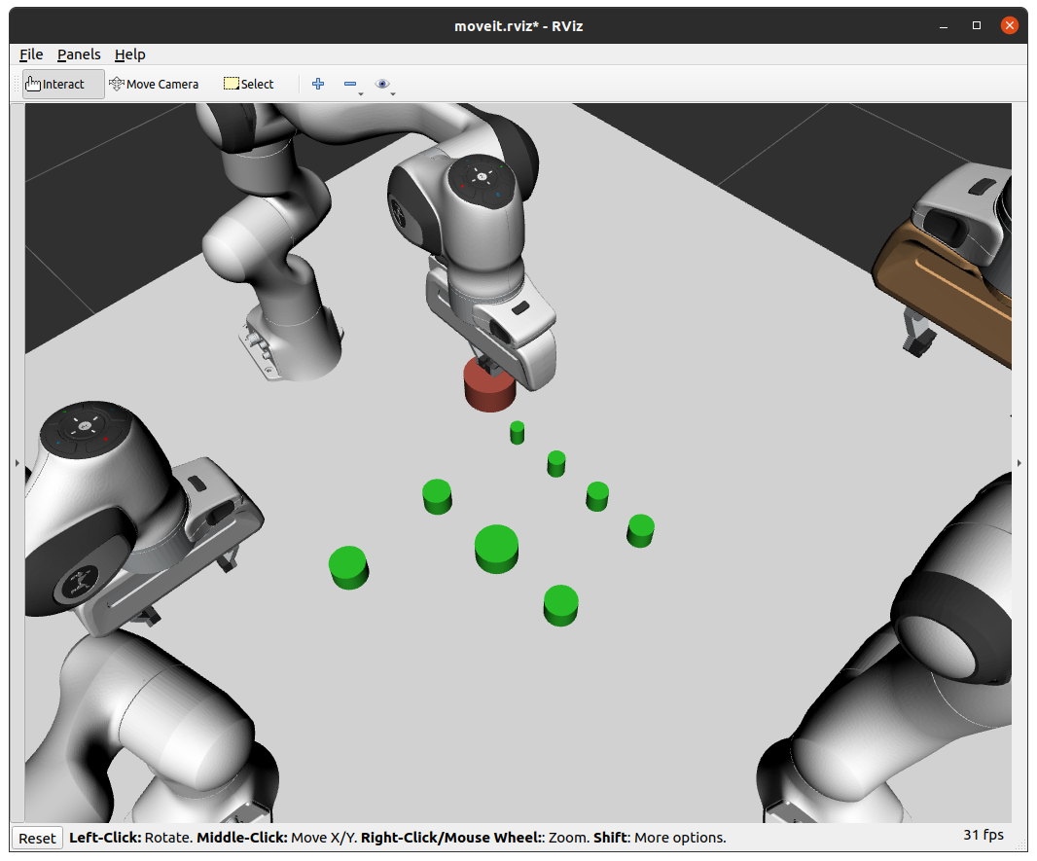

* + Arm 2 moves down to place the “ring_2” on “ring_1”.

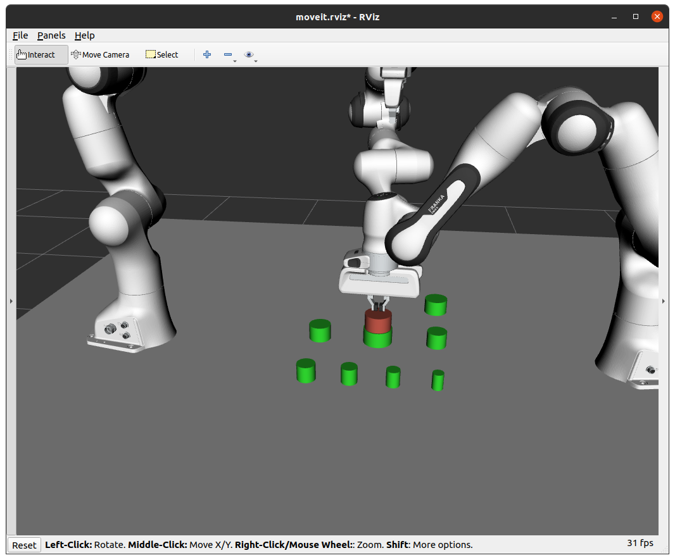

* + Arm 2 opens the gripper:

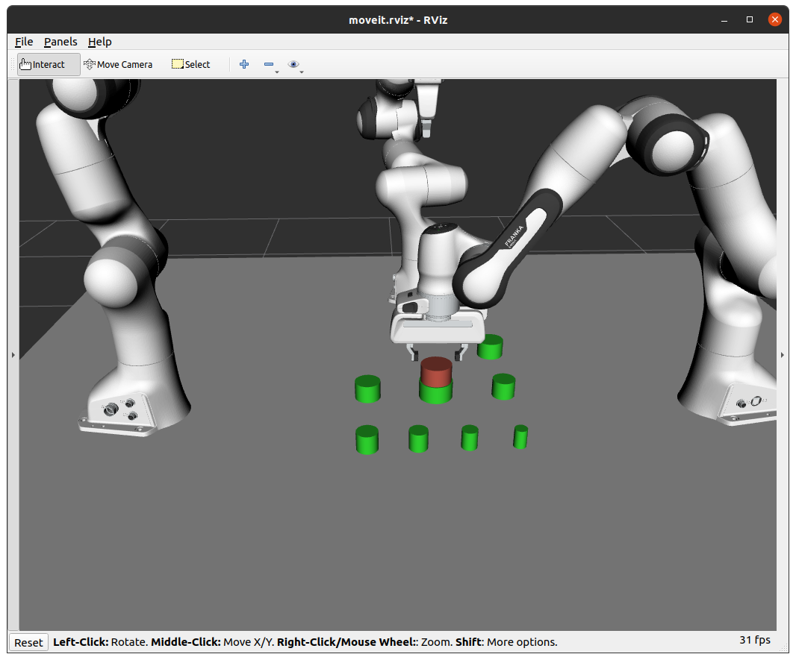

* + “Ring_2” gets detached from the arm 2 and changes the color back to green:

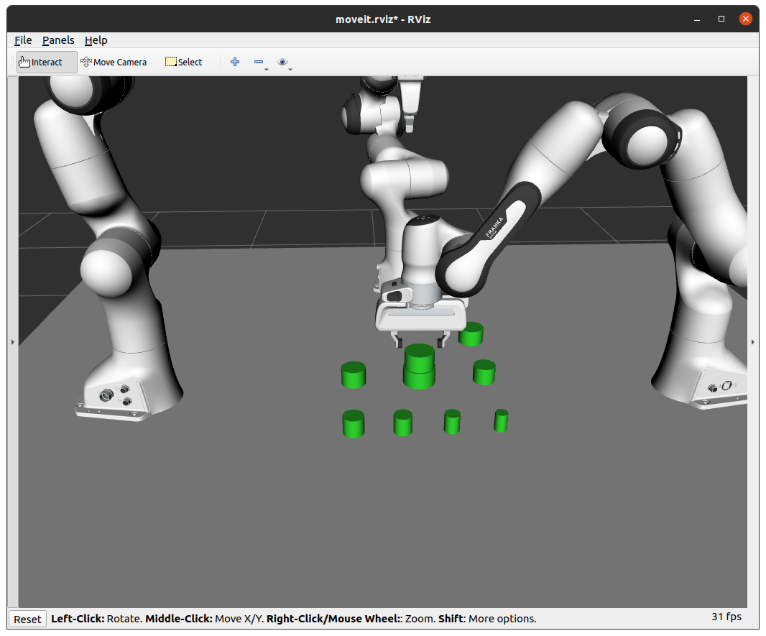

* + Arm 2 moves up and away from the “ring_2” into rest position the way it does not interfere in other arms’ activity:

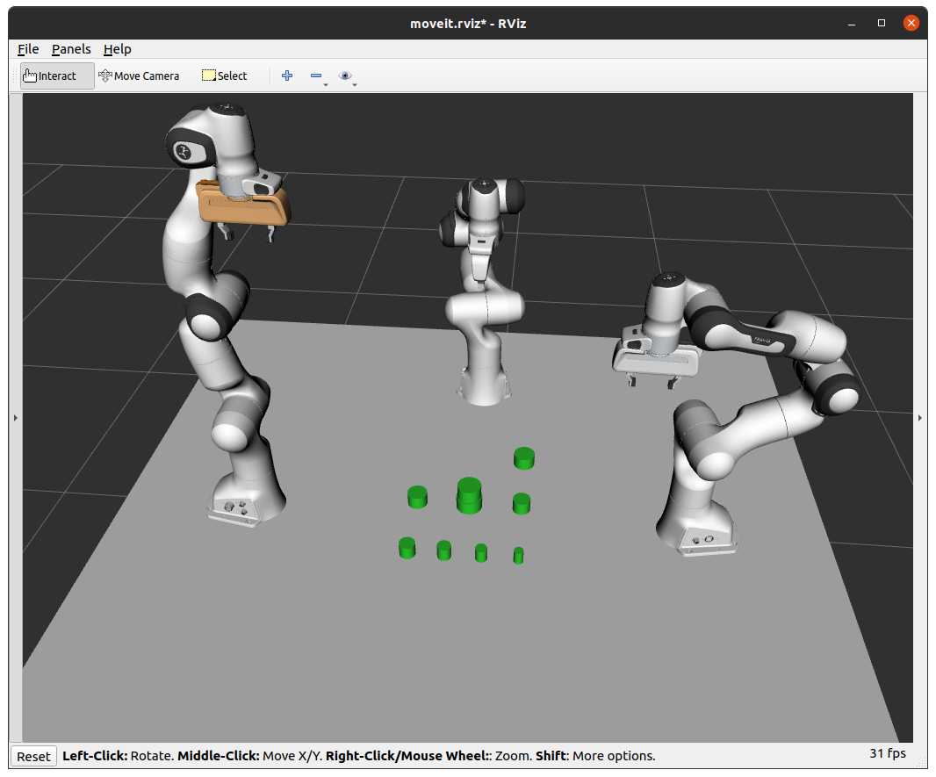

* Then, **arm 3** moves to pick and place **“ring_3”** on top of “ring_2”
  + Panda arm 3 moves to position itself above “ring_3”:

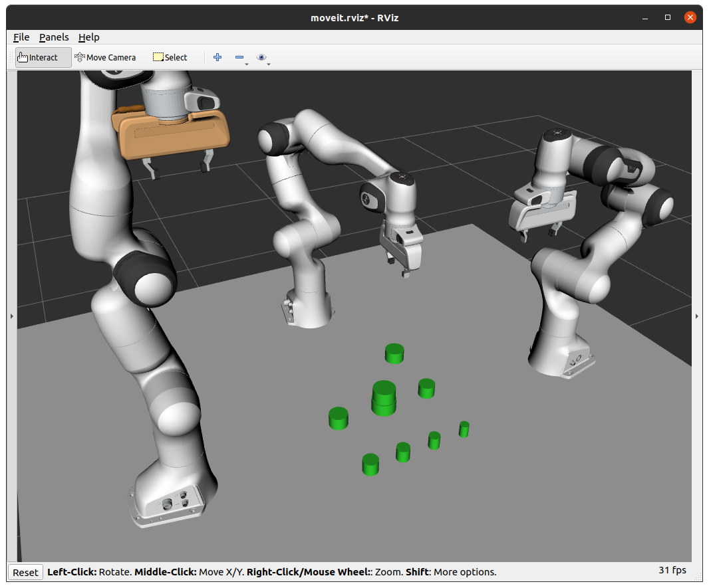

* + Arm 3 moves closer to the “ring_3” and close the gripper:

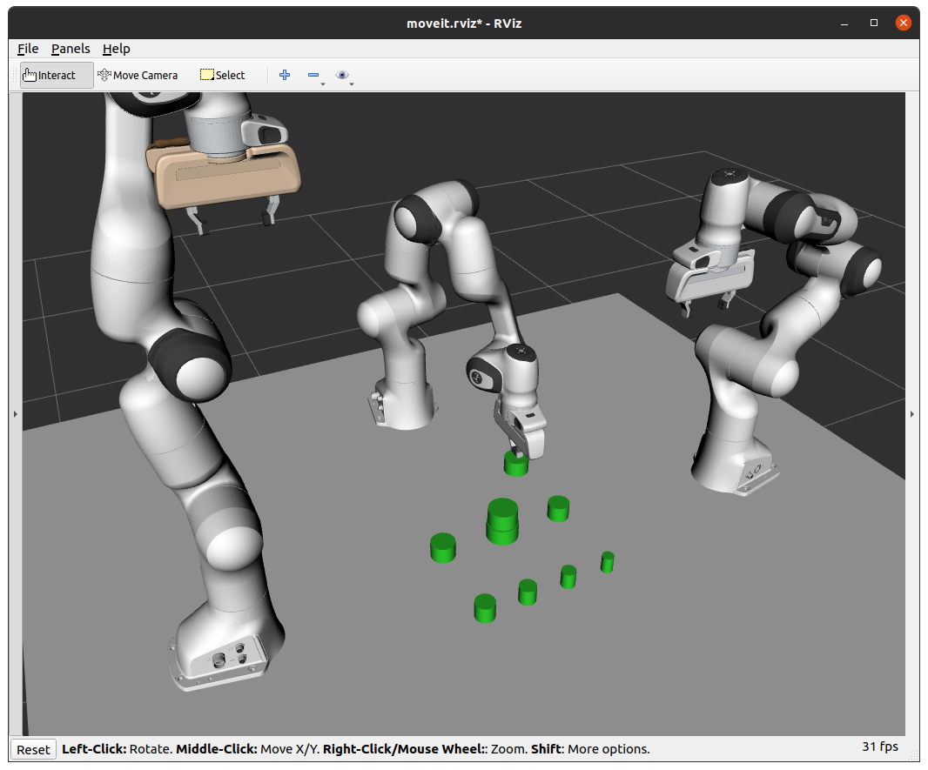

* + “Ring_3” gets attached to arm 3 and changes it’s color:

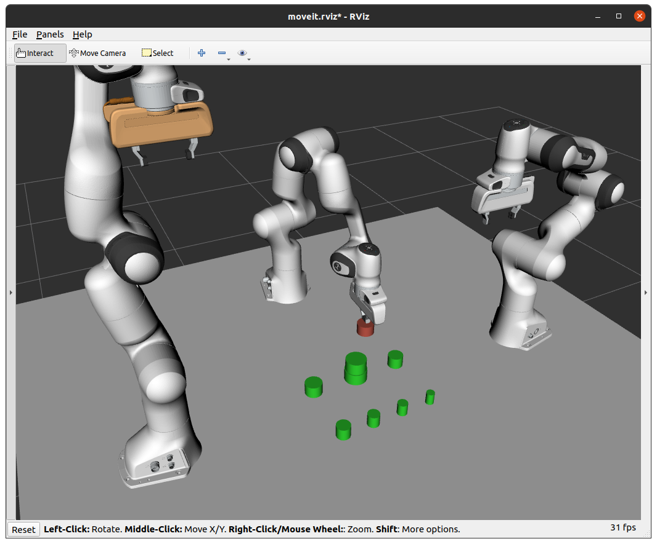

* + Arm 3 picks up ring_3 from the table:

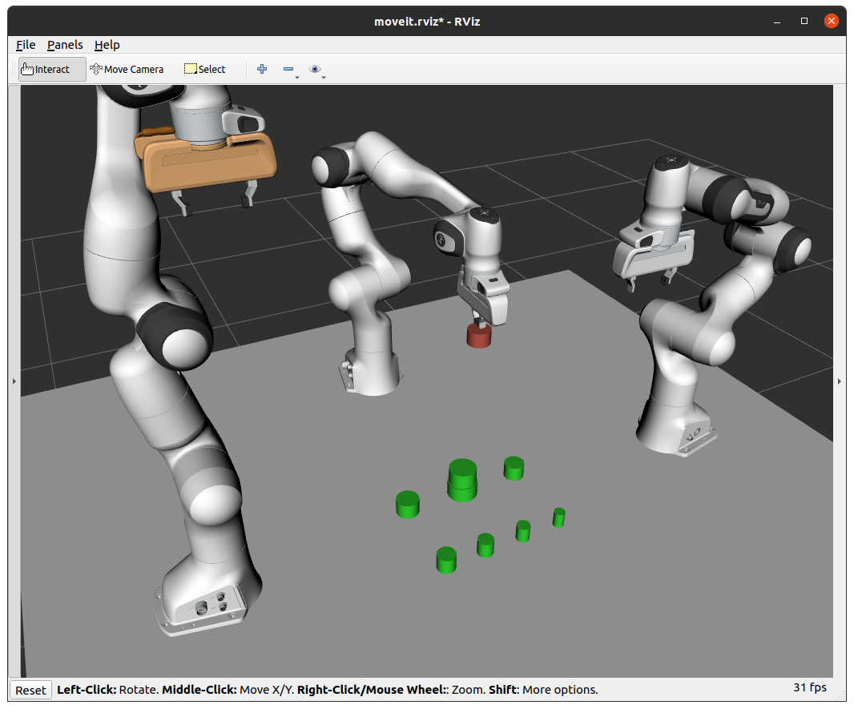

* + Arm 3 moves to position itself over the place position:

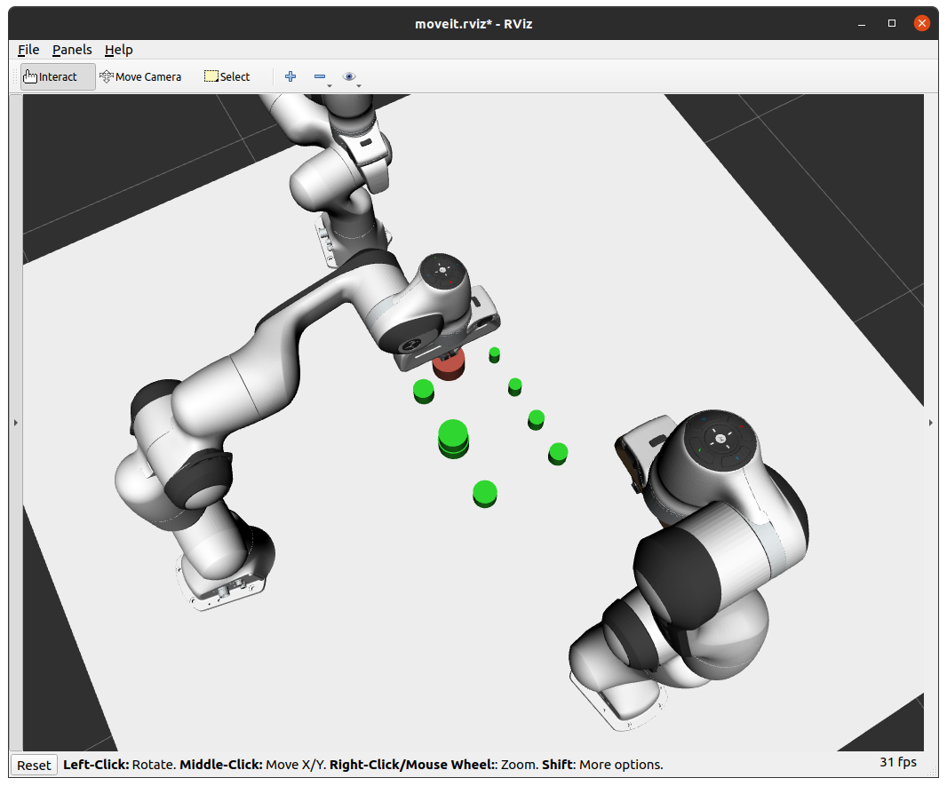

* + Arm 3 moves down to place the “ring_3” on “ring_2”:

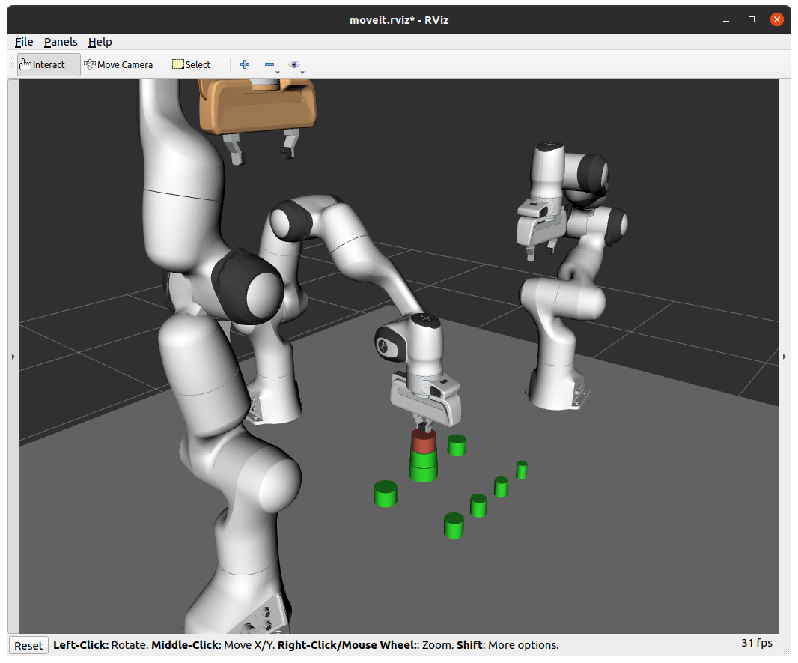

* + Arm 3 opens the gripper:

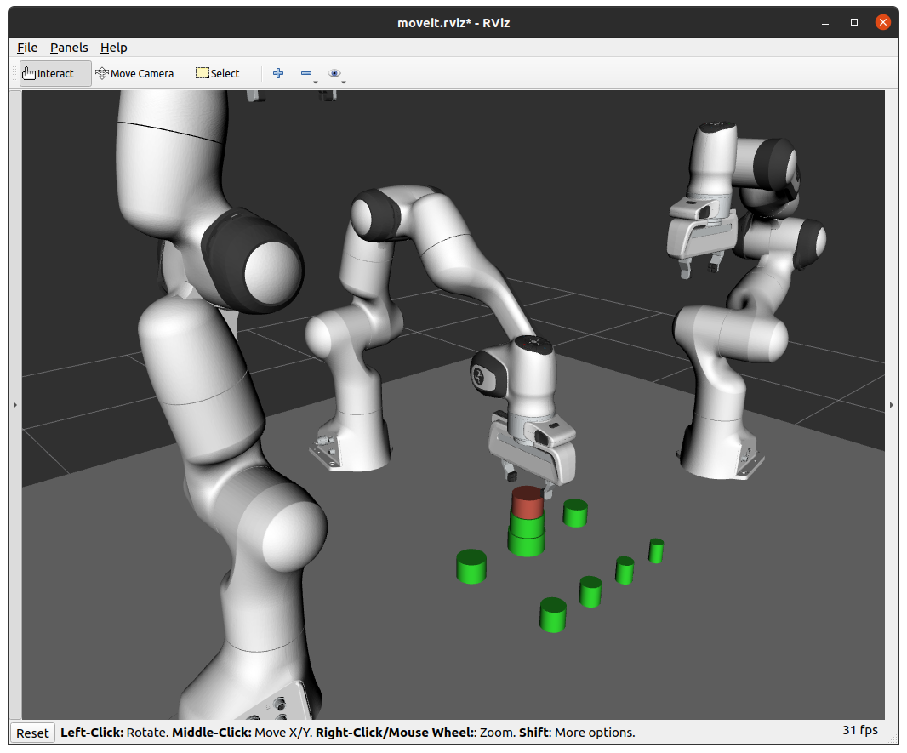

* + “Ring_3” gets detached from the arm 3 and changes the color back to green:

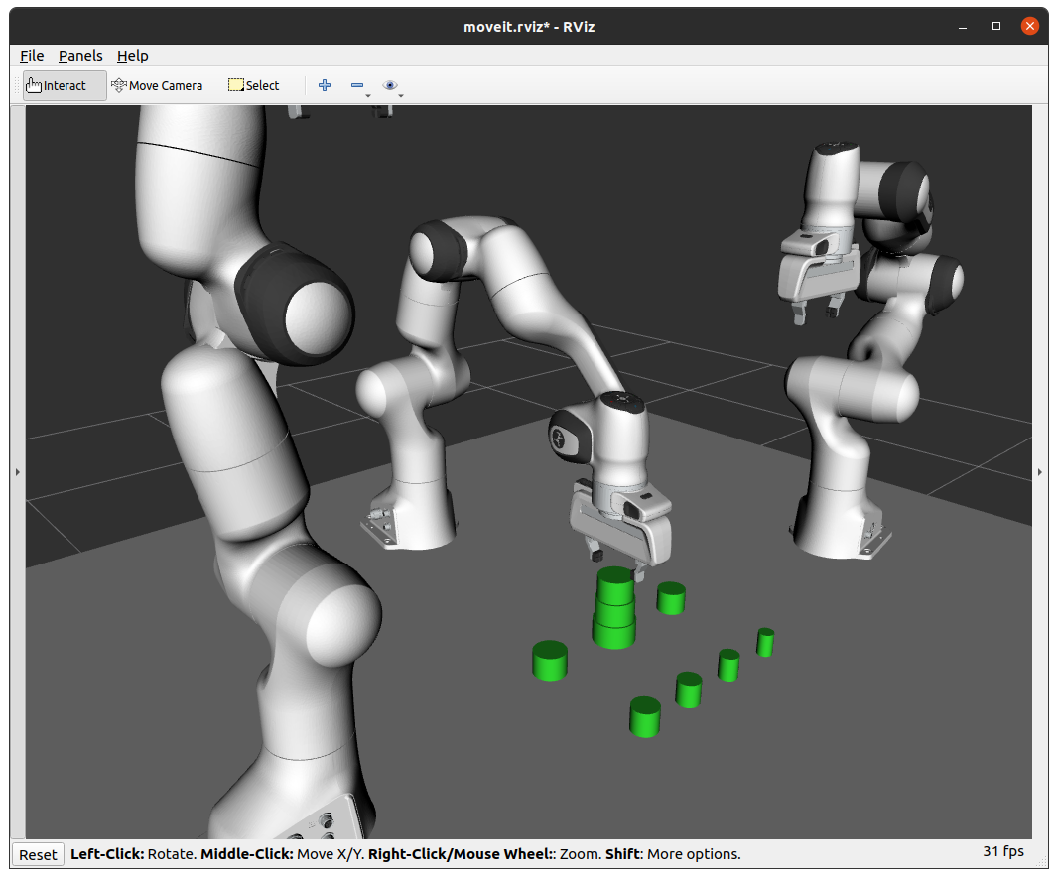

* + Arm 3 moves up and away from the “ring_3” into rest position the way it does not interfere in other arms’ activity:

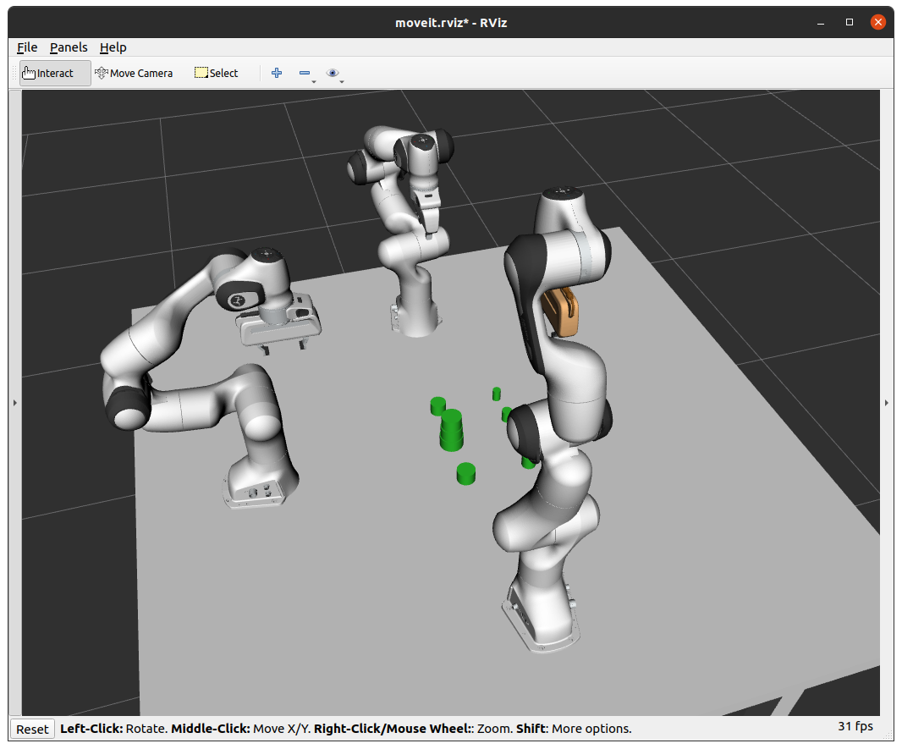

* Then, **arm 1** moves to pick and place **“ring_4”** on top of “ring_3”
  + Panda arm 1 moves to position itself above “ring_4”:

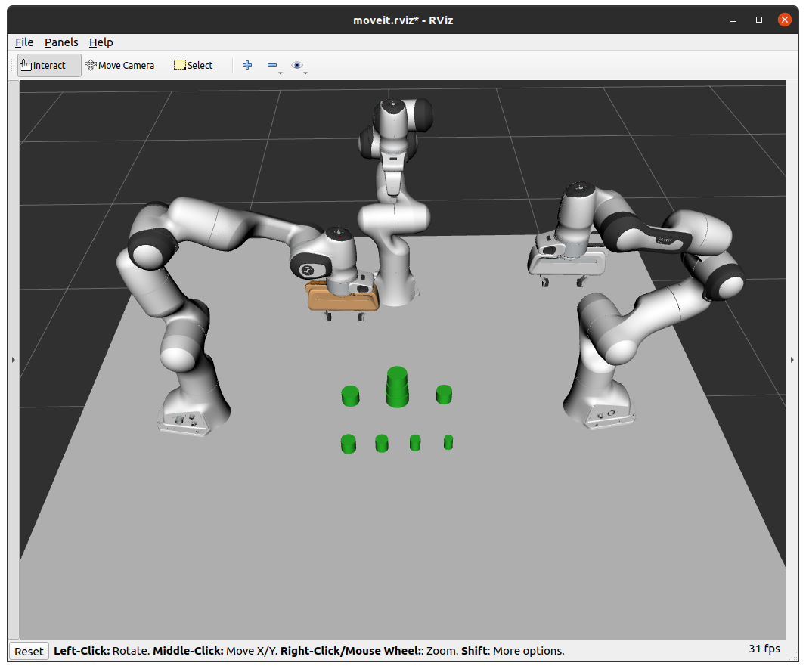

* + Arm 1 moves closer to the “ring_4” and close the gripper:

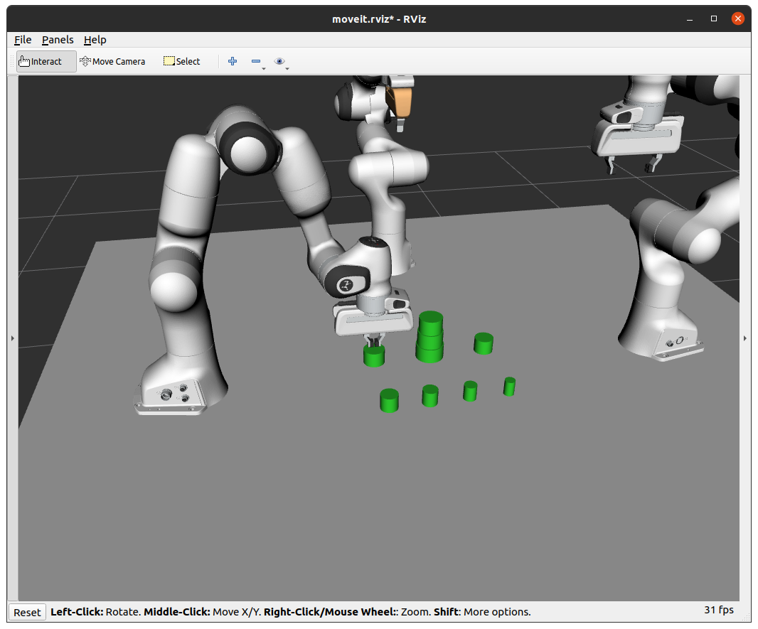

* + “Ring_4” gets attached to arm 1 and changes it’s color:

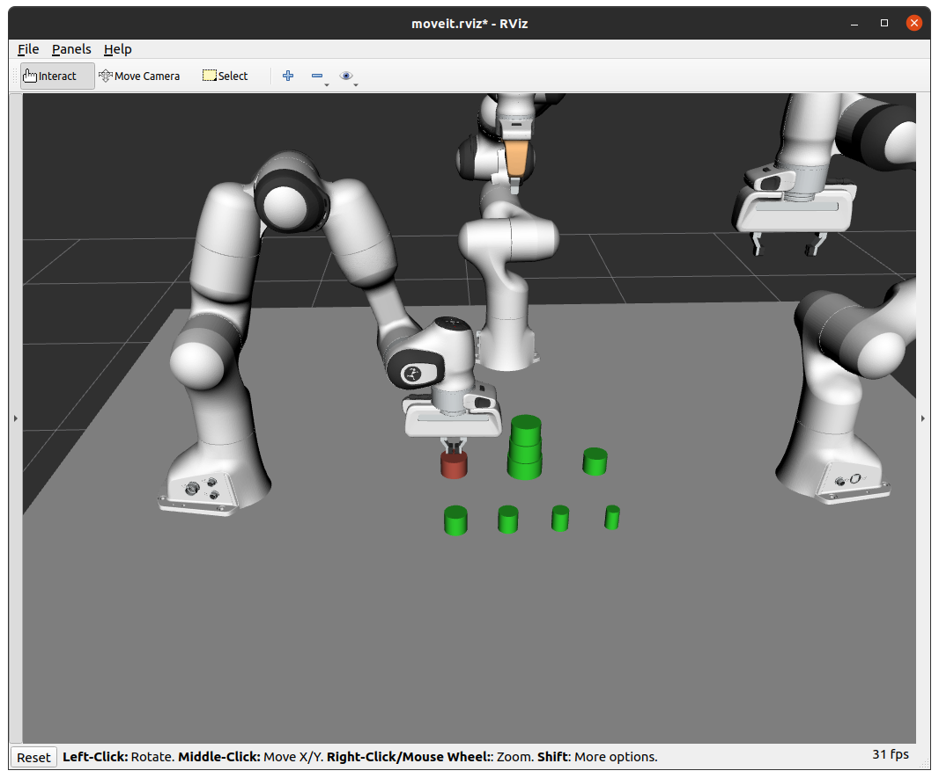

* + Arm 1 picks up ring_4 from the table:

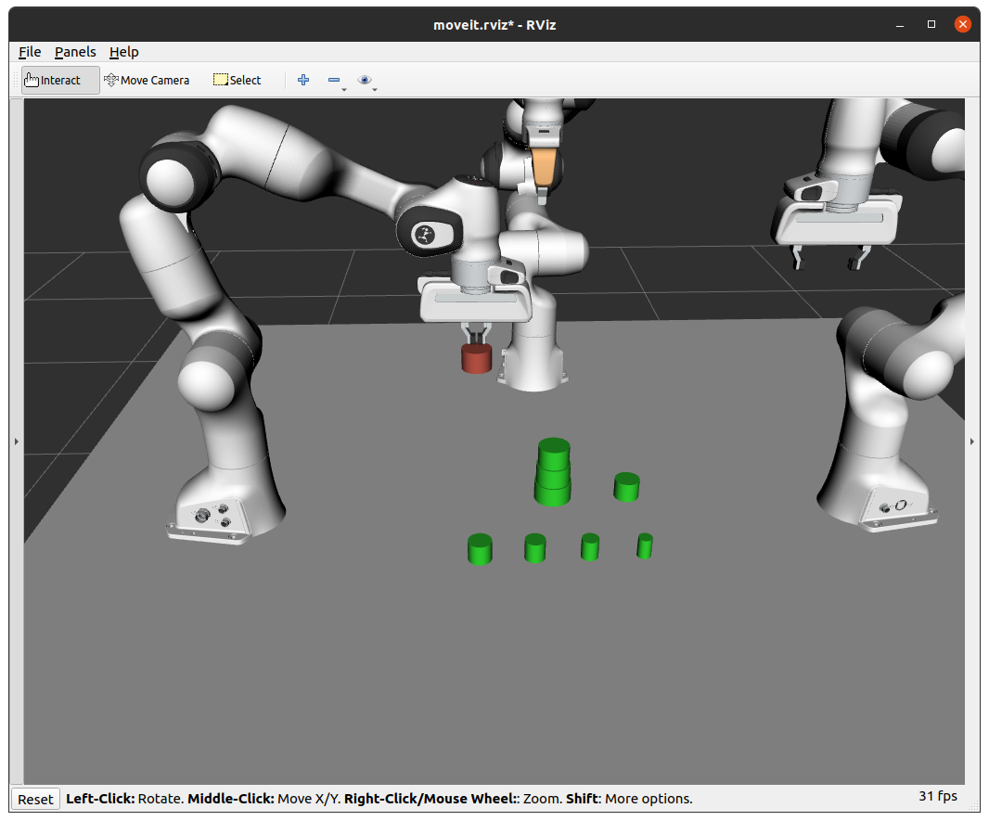

* + Arm 1 moves to position itself over the place position:

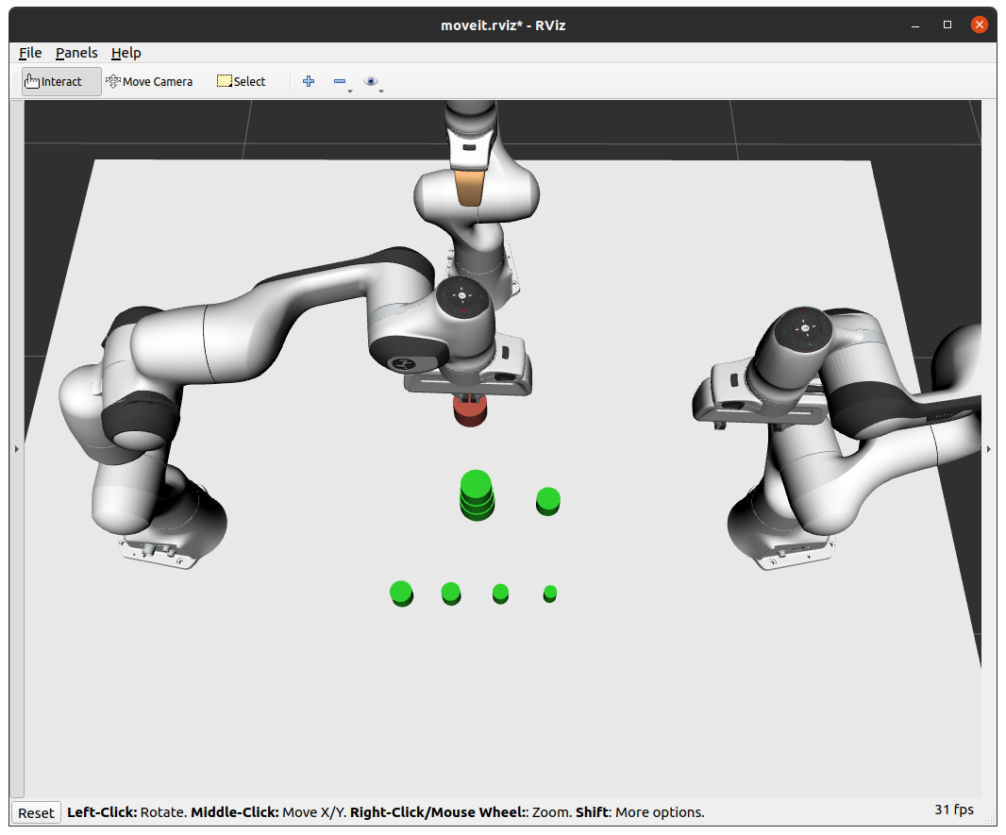

* + Arm 1 moves down to place the “ring_4” on “ring_3”:

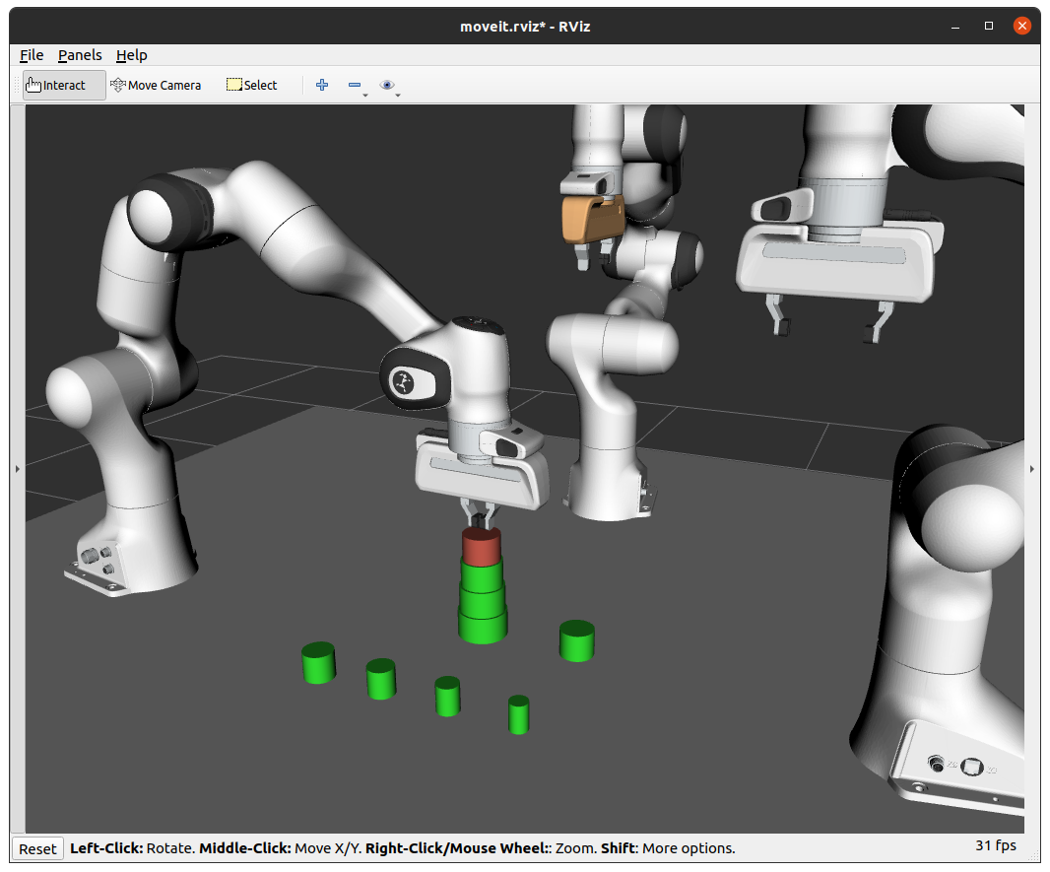

* + Arm 1 opens the gripper:

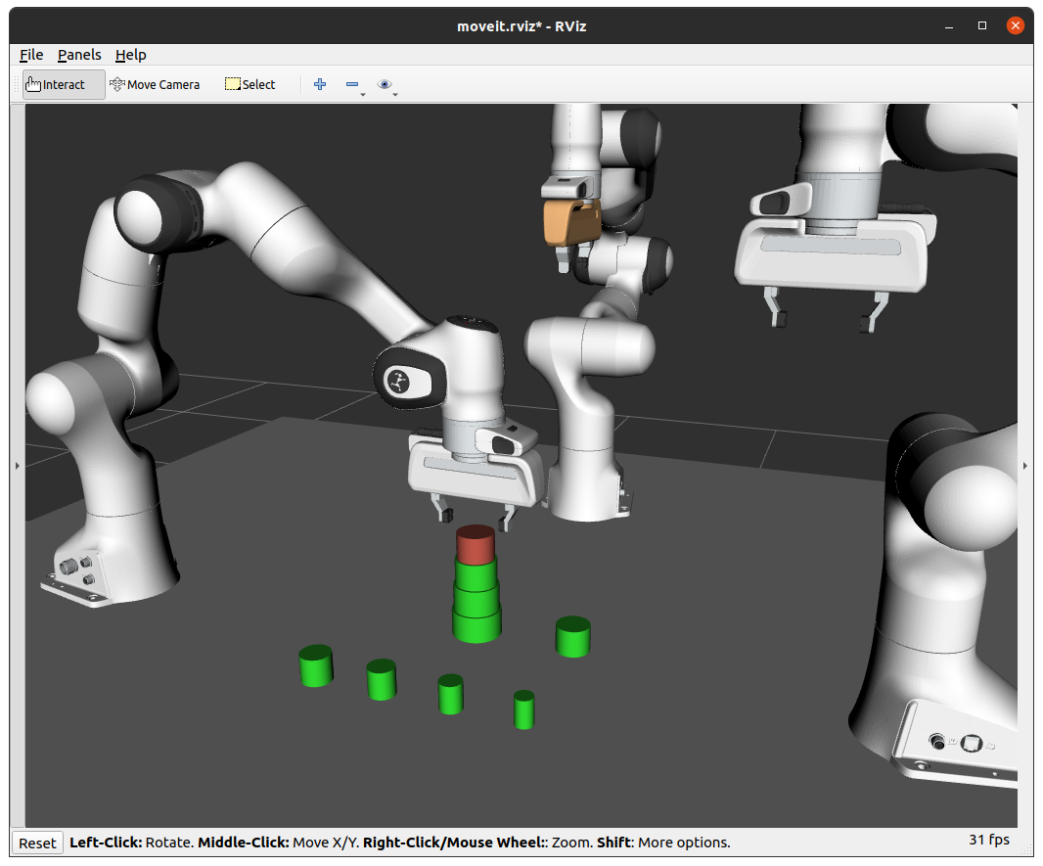

* + “Ring_4” gets detached from the arm 1 and changes the color back to green:

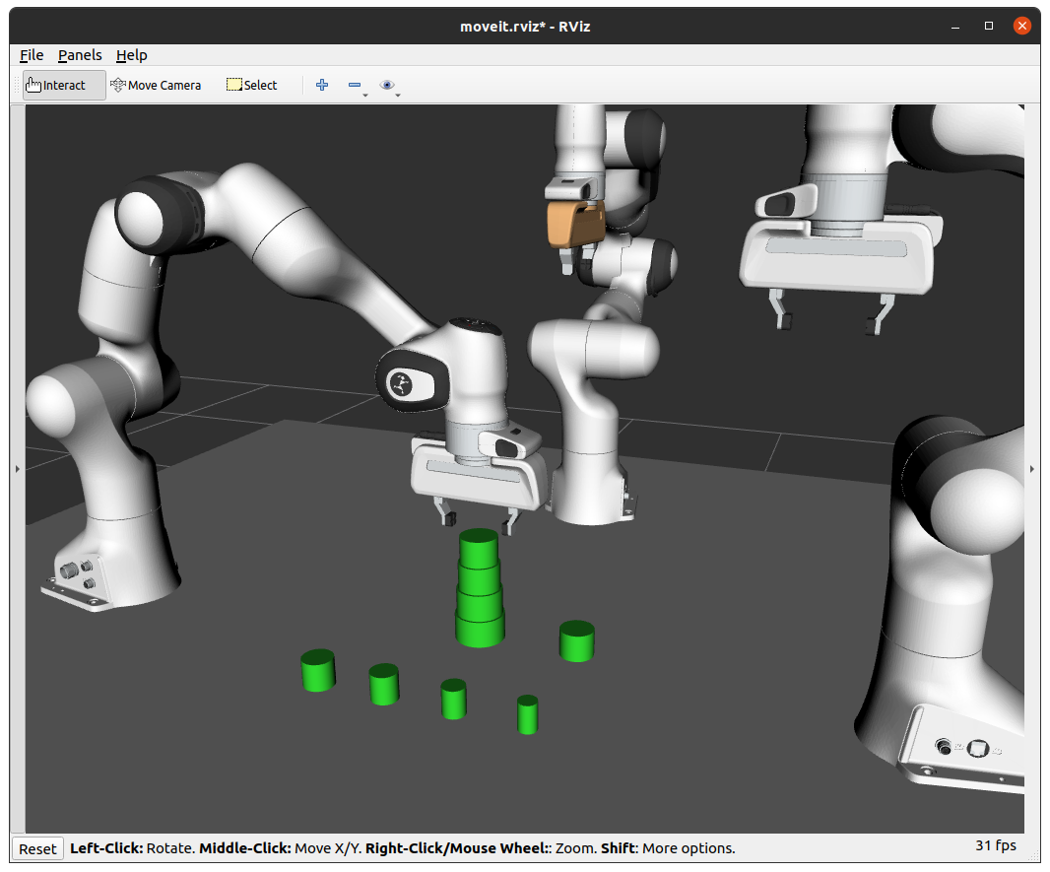

* + Arm 1 moves up and away from the “ring_4” into rest position the way it does not interfere in other arms’ activity:

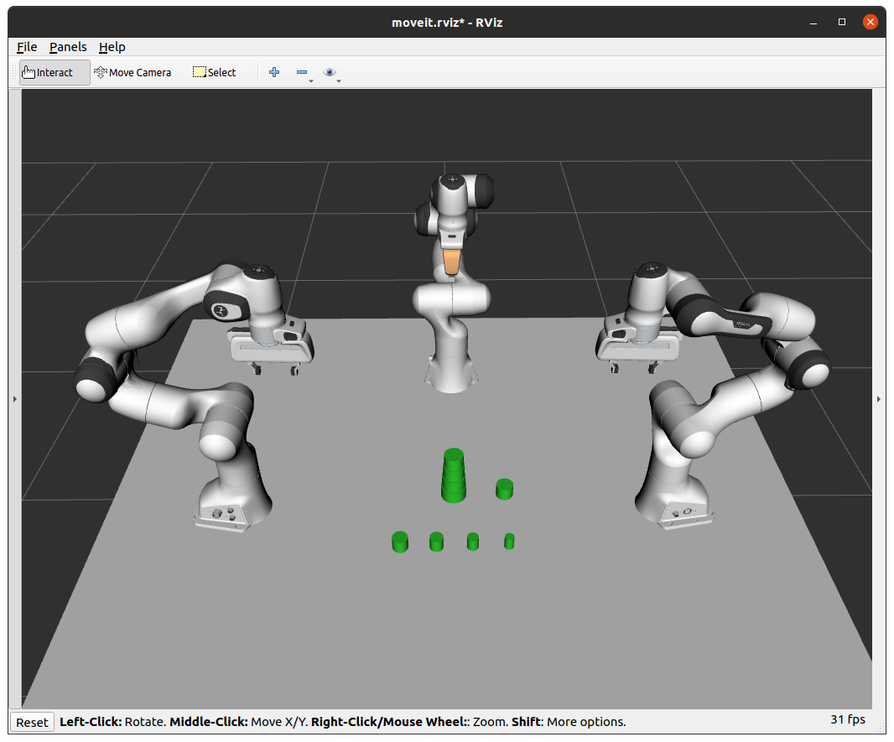

* Again, **arm 1** moves to pick and place **“ring_5”** on top of “ring_4”:

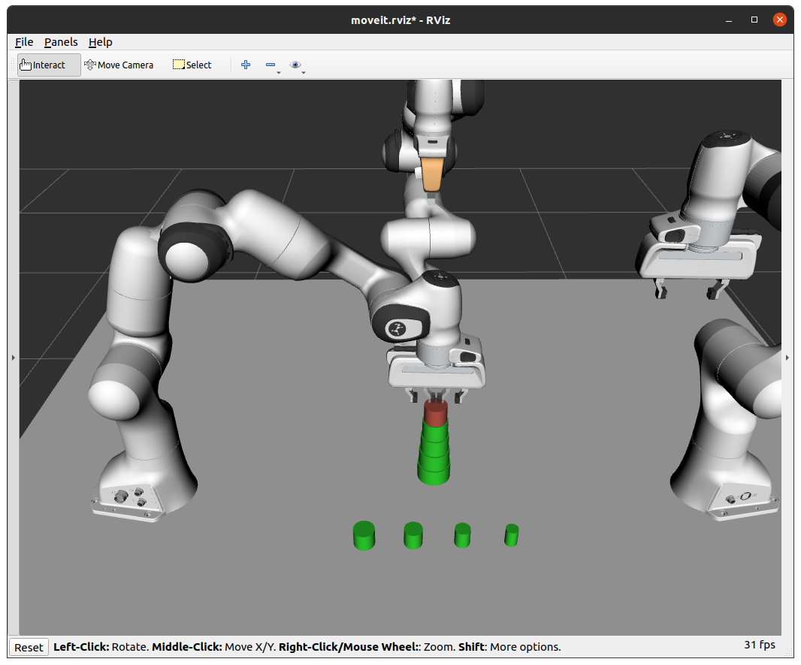

* Again, **arm 1** moves to pick and place **“ring_6”** on top of “ring_5” in similar manner:

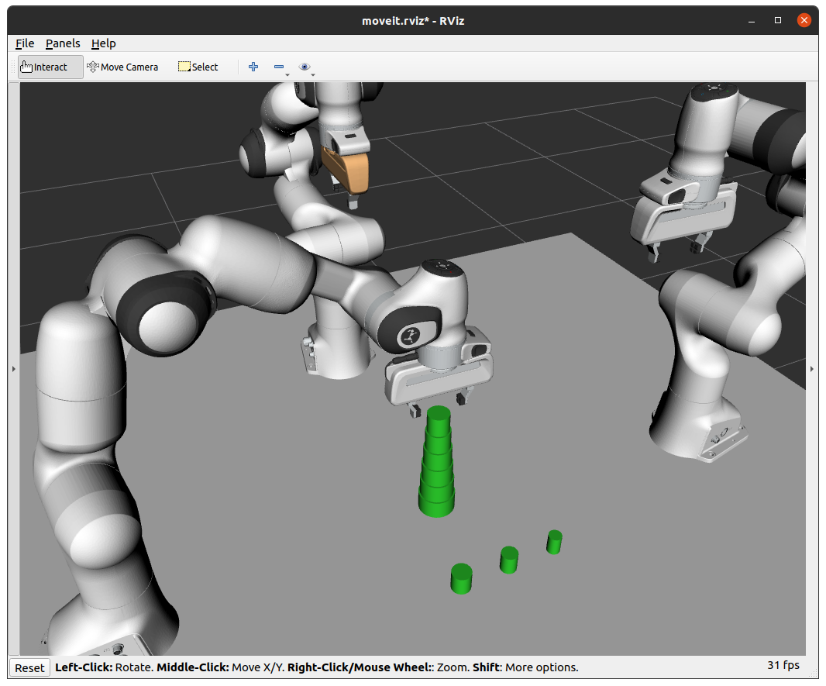

* Then, **arm 2** moves to pick and place **“ring_7”** on top of “ring_6”:

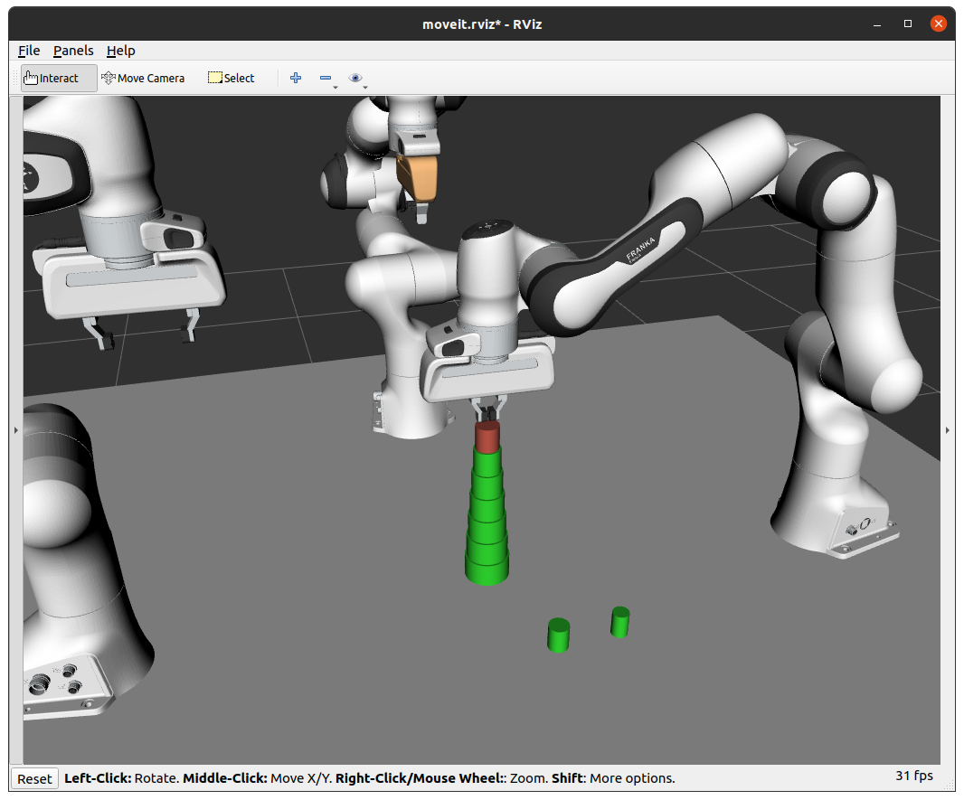

* Then, **arm 2** moves to pick and place **“ring_8”** on top of “ring_7”:

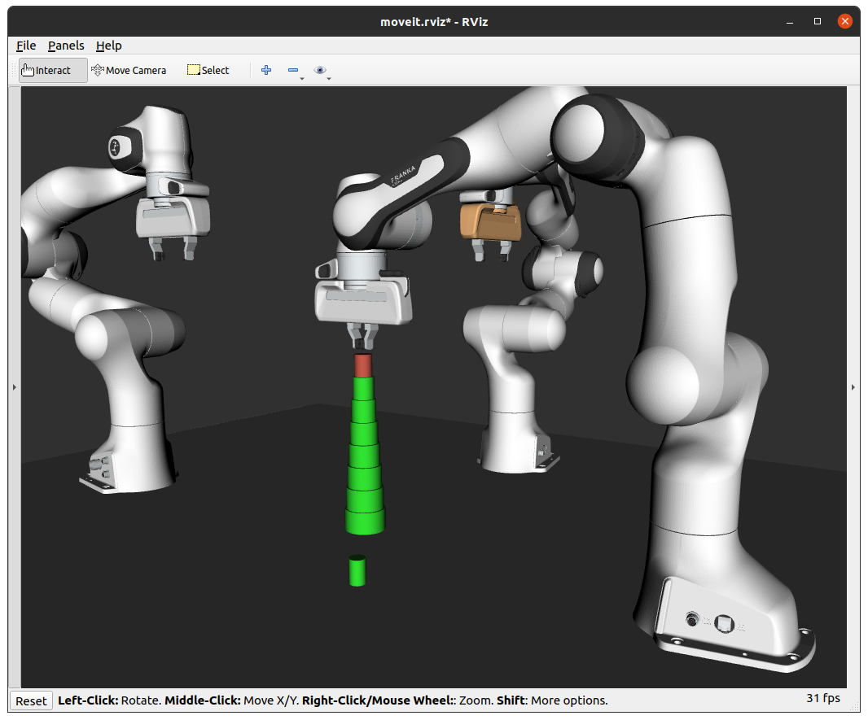

* Then, **arm 3** moves to pick and place **“ring_9”** on top of “ring_8”:

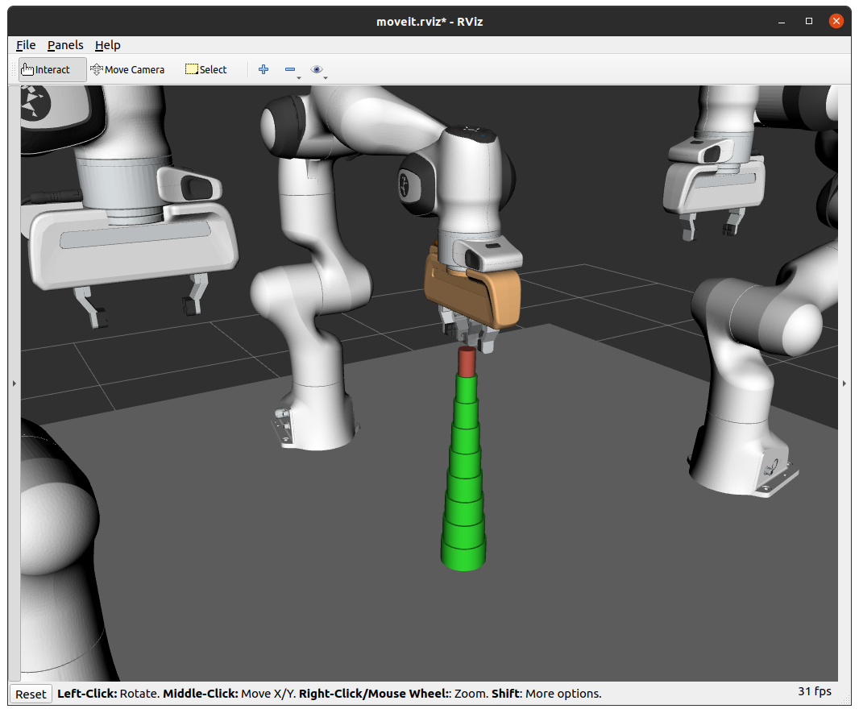

* So once the three robot arms have finished stacking all nine objects, you should be able to see 9 rings stacked in the center of the table between three panda arm robots and the arm robots will be in the rest position as shown in the image below:

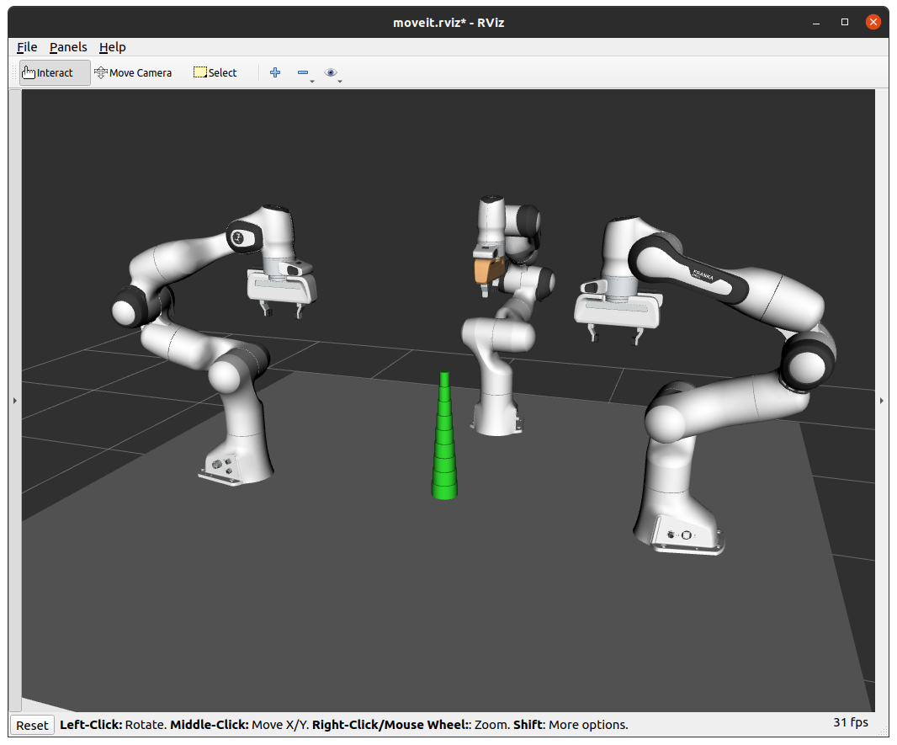

* This concludes the implementation of the “Merge-Sort” sorting algorithm in python script to sort objects to stack using three panda arm robots.

## Additional Information

### Edit Arm’s facing direction

* Arms facing towards the middle of the table.
* To do so, I added **rpy="0 0 ${pi/2}"** for *“panda_arm_1”* and **rpy="0 0 ${-pi/2}"** for *“panda_arm_2”* in “*triple_panda_arm_with_table_top_example.urdf.xacro*” file and the results can be seen in the picture below.

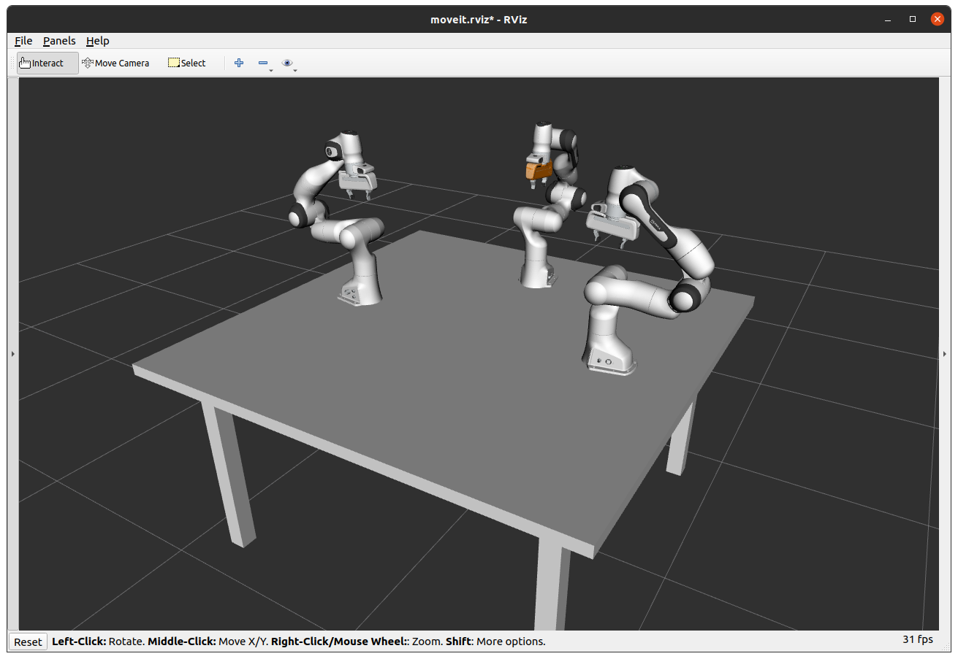

### Master’s Project - ROS Packages.zip

* The zip file contains two packages, *“3_panda_arms_moveit_config”* and *“Triple_panda_moveit_config”.*
* ***“3_panda_moveit_config/robots”*** directory contains all the **‘urdf’** and **‘urdf.xacro’** files.
* **“Triple_panda_moveit_config”** is the main package for this project that contains all the python scripts under the *‘scripts’* directory.
* Thank you for taking the time to read this material, I hope it helped.